

Anthology Payroll for Microsoft Dynamics 365 Finance

Anthology Payroll User Guide for US Localization QuickStart

Date: March 2025
www.anthology.com

Table of Contents
1 Document Revision History 7
2 Introduction 9
2.1 Conventions and Definitions 9
2.2 Prerequisites and Conditions 10
2.3 Set User Preferences 10
3 Hiring Workers 12
3.1 Hire a New Worker 12
3.1.1 Create a new position record 12
3.1.2 Create a new worker record and assign the position 13
3.1.3 Add the worker to Anthology Payroll 16
3.1.4 Add additional payroll information for the worker 21
3.1.4.1 Add benefit/deductions 21
3.1.4.2 Add calculation variables 22
3.1.4.3 Add direct deposit accounts 23
3.1.4.4 Add starting vacation balance 25
3.1.4.5 Set Pay Statement Password 26
3.2 Rehire a Worker 27
3.2.1 Reactivate the worker's past worker record 27
3.2.2 Create or reactivate the worker's position 28
3.2.3 Validate the worker's existing position record 30
3.2.4 Validate the worker's additional payroll information 31
4 Maintaining Worker Data 32
4.1 Manage Position Data 32
4.1.1 Modify Position Data 32
4.1.2 Change Positions 33
4.1.3 Change Pay Group 34
4.2 Manage Demographic Data 35
4.2.1 Manage Addresses 35
4.3 Manage Payroll Data 36
4.3.1 Manage Account (Direct Deposit) Information 37
4.3.2 Manage One-Time Deductions 38
4.3.3 Manage Worker Allowances 38
4.3.4 Manage Calculation Variables 40
4.3.5 Import Wage Increments 41
4.3.5.1 Set up a Wage Increment Code 41
4.3.5.2 Import Wage Increments 42
4.3.5.3 Review or Change Wage Increments 43
4.3.5.4 Apply Wage Increments 44
4.3.6 Generate Wage Increment Steps 45
4.3.6.1 Set up a Wage Increment Code 45
4.3.6.2 Generate Wage Increments 46
4.3.6.3 Review or Change Wage Increments 47
4.3.6.4 Apply Wage Increments 47
4.3.7 Manage Pay Advances 47
4.3.7.1 Issue Pay Advance 47
4.3.7.2 Schedule an Advance Recovery 48
4.3.7.3 Modify an Existing Advance or Recovery Schedule 49
4.3.8 Manage Entitlements 50
4.3.8.1 Adjust Entitlements 50
4.3.8.2 Add Rolling Entitlements 51
4.3.8.3 Adjust Rolling Entitlements 54
4.3.8.4 Import Cross-Company Transactions for Rolling Entitlements 55
4.3.8.5 Import Cross-Pay Group Transactions for Rolling Entitlements 57
4.3.9 Assign Worker Garnishments 58
4.3.9.1 View Garnishment Calculations 60
4.3.10 Configure Worker Compensation 62
4.3.10.1 Set up Fixed Compensation Plans 62
4.3.10.2 Set up Variable Compensation Plans 63
5 Process Pay 64
5.1 Regular Pay Processing Tasks 64
5.1.1 Create Time from Rotation 64
5.1.2 Enter Time for a Worker 65
5.1.3 Approve Time 68
5.1.4 Create Earnings from Time Records 69
5.1.5 Enter Earnings Manually 70
5.1.5.1 Enter Expenses 71
5.1.6 Update Entitlements, Accumulators, and Generated Earnings 72
5.1.7 Check accumulated amounts 73
5.1.8 Assess Local Taxes 74
5.1.8.1 Set Accounting Information for Local Tax Benefit/deductions 76
5.1.9 Generate Payments 77
5.1.10 Print Pay Register 78
5.1.11 Approve Payments 80
5.1.11.1 Create Bank Information 80
5.1.11.2 Prepare Pay Statements 81
5.1.11.3 Print Payments for a Pay Group 83
5.1.11.4 Approve Selected Payments 84
5.1.12 Download Files to Local Network 86
5.1.13 Export Pay Statements 87
5.1.14 Generate Entitlements 88
5.1.15 Post Payments, Liability, Benefits, and AP Invoice 88
5.1.16 Approve Postings 89
5.1.17 Post to Project 90
5.1.18 Approve Project Postings 92
5.1.19 Close Pay Period 93
5.2 Occasional Pay Processing Tasks 93
5.2.1 Issue a Manual (Off-Cycle) Payment 94
5.2.2 Import Time and Shift Information 97
5.2.3 Adjust Time or Earnings after Pay is Processed 100
5.2.4 Import and Process Bonus Earnings 103
5.2.5 Correct Direct Deposit Errors 105
5.2.6 Import and Commit Benefit/Deduction Amounts 106
5.2.7 Revise Past Payments 109
5.2.8 Issue Gross-up Payments 110
5.2.8.1 Import Gross-up Payment Amounts 110
5.2.8.2 Commit Imported Gross-up Payment Amounts 111
5.2.8.3 Issue Gross-up Payments to a Single Worker or a Worker Group 112
5.2.9 Correcting Address Information 113
5.2.10 Process Retroactive Pay 114
5.2.10.1 Set up a Retroactive Run 114
5.2.10.2 Generate Retroactive Earning Records 116
5.2.10.3 Review and Accept Retroactive Earning Records 116
5.2.11 Modify Posting Transactions 117
5.2.12 Modify Project Posting Transactions 118
5.2.13 Create Trial Payments 119
6 Year-End Tasks 122
6.1 Import Statutory Deductions 122
7 Reporting 123
7.1 Create 940 Annual Federal Unemployment Report 123
7.2 Create 941 Quarterly Federal Tax Return 124
7.2.1 Generate 941 Worksheet 1 Amounts 124
7.2.2 Create 941 XML File 126
7.3 Create SUTA Quarterly State Unemployment Report 127
7.4 Create W-2s 128
7.4.1 Create W-2 Listing Report 129
7.4.2 Create W-2 Submission 129
7.5 View Certified Payroll Projects Report 130
7.6 Create Local Taxes Reports 132
7.6.1 Report Monthly Local Taxes 132
7.6.2 Report Quarterly Local Taxes 133
7.6.3 Report Year-end Local Taxes 134
7.7 Greenshades Tax Filing Center 136
7.7.1 Change E-File Storage Location 136
7.7.2 Upload XML Submission Files 137
7.7.3 Review and Submit 940s 138
7.7.4 Review and Submit 941s 139
7.7.5 Review and Submit SUTA Reports 141
7.7.6 Submit and Distribute W-2s 142
8 Terminating Workers 149
8.1 Check for Earnings after Termination Date 149
8.2 Terminate the Worker 150
8.3 Pay Out Entitlements 150
8.4 Enter Severance Pay 153
8.5 Process Final Payment 153
9 Appendices 155
9.1 Appendix A: List of Benefit/deductions 155
9.2 Appendix B: List of Calculation Variables 159
9.3 Appendix C: List of Earnings Import File Fields 162
9.4 Appendix D: List of Time Import File Fields 163
9.5 Appendix E: List of Benefit/deduction Amounts Import Fields 165
9.6 Appendix F: List of Wage Increment Import Fields 166
9.7 Appendix G: List of Gross-up Payment Amount Import Fields 167

1 Document Revision History
Version | Changes
1.0 | Initial release version

2 Introduction
This document details the processes and procedures for payroll administration in the US localization of Anthology Payroll for Microsoft Dynamics 365 Finance. This document is specifically tailored towards the data contained within the US localization of the QuickStart database. These procedures are specific to payroll procedures in the US and include the following sections:

2.1 Conventions and Definitions
This document uses the following conventions:
bold | Refers to form names, field names, and clickable hyperlinks.
italics | Refers to specific data items and selectable options in form fields.
NOTES | Important details about the current procedure that may affect the expected outcome.
This document assumes the following definitions:
base payroll | The basic functionality of Anthology Payroll not including any localised content.
dialog | A popup window that contains a minimal number of fields to manipulate. Is usually meant as confirmation with continuing with a process. Typically contains OK and Cancel buttons.
form | A page where data records can be viewed and manipulated. Usually contains an Overview tab where all records can be viewed and a General tab where all the fields of a single record can be viewed.
inquiry | A page where data records can only be viewed and not manipulated. Records can still be filtered.
journal | A page where data records can be viewed and manipulated in relation to other data records. Typically used for manual data entry or adjustment processes.
list | A viewing pane of all records of a particular type, such as Workers, Positions, or Pay groups. Usually, a record can be double-clicked to open its specific form.
navigation pane | The expandable list of hyperlinks located on the left side of the AX application window intended for navigation.
pane | A frame or segmented area of any window. Is usually accompanied by a descriptor. Also appears on the right side of the browser window to perform certain functions.
report | A printable, exportable view of specific data records that opens in a browser window.
ribbon | The toolbar at the top of the application window containing multiple tabs with clickable icons.
maintain effective date entries | A functional pane in most forms where data records can be edited with respect to effective dating. A change to existing records in the Maintain effective date entries pane creates a new copy of the record dated on the session date while the old record is expired one day prior. In previous versions of Anthology Payroll, this was called the Split view pane.
For a reference of shortcut keys in Microsoft Dynamics, refer to this Microsoft article:
https://docs.microsoft.com/en-us/dynamics365/unified-operations/fin-and-ops/get-started/shortcut-keys

2.2 Prerequisites and Conditions
The following conditions are required before you can begin using the United States localization of Anthology Payroll for Microsoft Dynamics 365 Finance:
- Microsoft Dynamics 365 Finance must be licensed and installed
- Anthology Payroll for Microsoft Dynamics 365 Finance must be licensed and installed
- US country extension for Anthology Payroll must be licensed and installed
- US QuickStart database has been implemented according to appropriate documentation
- Latest Statutory Deductions Spreadsheet for US must be imported
- Anthology Payroll has been set up according to the Anthology Payroll United States Localization Configuration Guide

2.3 Set User Preferences
In Microsoft Dynamics 365 Finance, you can set your preferences for the initial view mode of forms and your language and date formats. The language setting is important depending on the localization of Anthology Payroll you are using as it allows labels on forms to appear correctly in the format of your localization.
It is also recommended to set your default view mode to Edit mode as it reduces the number of steps during operation and mimics behavior in older versions of Dynamics. This guide is written in the context of already being in Edit mode on forms.
To set your user preferences:
- In Microsoft Dynamics 365, click Settings > User options in the top-right corner of the page to open the Options page.
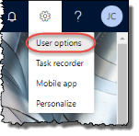

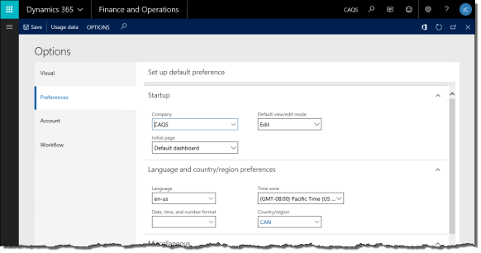
- Click the Preferences tab.
- Set your Default view/edit mode to Edit. This is optional, but recommended.
- You can set your default Company to open upon logging in as well as the Initial page to display.
- Set your Language, Date, time, and number format and Country/region to your specific local settings. You may choose to set your Time zone as well.
- Click Save to save your changes.
- Refresh your browser (F5) to enable your language and region preferences.

3 Hiring Workers
This section contains procedures on hiring and rehiring a worker.

3.1 Hire a New Worker
To hire a new worker, you must complete the following steps:
- Create a new position record.
- Create a new worker record and assign the position.
- Add the worker to Anthology Payroll.
- Add additional payroll information for the worker.
- Add US worker information.
Ensure you are in the appropriate company in Microsoft Dynamics 365 Finance.

3.1.1 Create a new position record
To create a new position:
- In the navigation pane, click Common > Positions to open the Positions list.
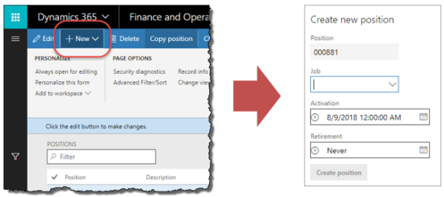
- Click the New button on the ribbon to open the Create new position dialog.
NOTE: If you click anywhere outside the dialog, it will close without saving.
- Enter the Job that this position is based on. The Position identifier is automatically generated.
- Specify the position's Activation date if it is different from the current date. This can be a date in the future. Specify a Retirement date if there is one.
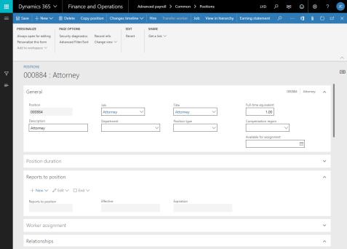
- Click the Create position button to create the position. The Positions form for this position automatically opens.
- In the General section of the position, specify the position's Department.
- Expand the Financial dimension section of the Positions form.
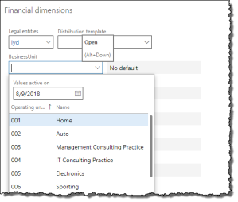
- Specify any default financial dimensions that the worker in this position may have.
- Click Save to save your changes.

3.1.2 Create a new worker record and assign the position
To create a new worker record:
- In the navigation pane, click Common > Workers to open the Workers list. Click the New button on the ribbon to open the Create new worker pane.
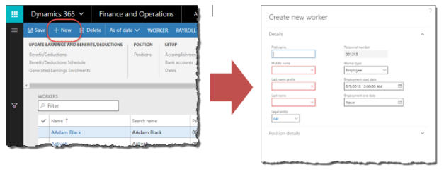
- Enter the worker's First name, Middle name, Last name prefix and Last name, as applicable.
- Verify that you are creating the worker in the correct Legal entity (company). Change as needed.
- If the worker is a contractor, set the Worker type to Contractor.
- Specify the worker's Employment start date if it is different from the current date. Specify an Employment end date if there is one.
- Expand the Position details tab and check the Assign a position checkbox.
- Specify the Position that was created in section 3.1.1.
- Specify an Assignment start date if it is different from the current date. This can be a date in the future.
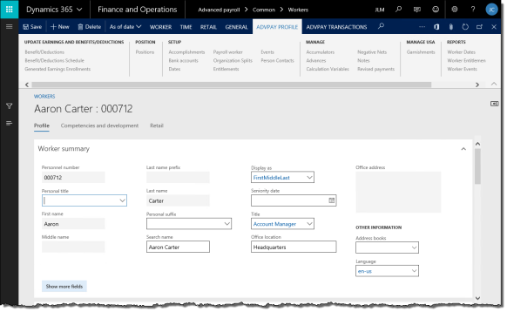
- Click the Hire new worker button to create this worker in Microsoft Dynamics 365 Finance and assign the position to them. The worker's Worker form automatically opens.
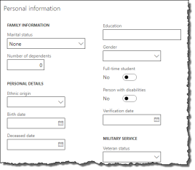
- On the Worker form, verify the worker's Personal title, First name, Middle name, Last name prefix, and Last name.
- Expand the Personal information section and enter the worker's Marital Status, Birth date and Gender, as needed.
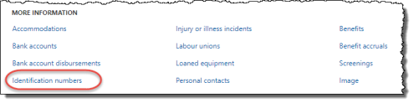
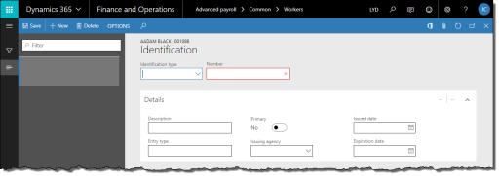
- In the Personal information section, click Identification numbers to open the Identification form.
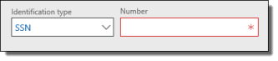
- Select SSN for Identification type and enter the worker's social security number into the Number field.
- Click Save to save your changes. Close the Identification form.
- Add additional information as required for your implementation, such as Addresses and Contact information.
- To add an address, expand the Addresses section and click Add to open the New address pane. Enter the following information:
  - Name or description: name of the address (e.g.: Home, Office, etc.). If your implementation is set for US local tax withholding, the worker must have a Home address.
  - Purpose: select the type of address
  - Country/region
  - ZIP/postal code
  - Street: enter the worker's street address. Avoid entering any blank lines.
  - City
  - State
  - County: optional
  - Primary: check this box if this is the worker's primary (home) address
- If your implementation emails direct deposit pay statements to workers, they must have an email address set up in the Contact information tab. The Description of this email address must match the configuration of the Direct deposit email default email communication parameter on the General definitions form.
- Click OK to save the address.
- Click Save to save your changes.

3.1.3 Add the worker to Anthology Payroll
Adding the worker to Anthology Payroll involves creating and updating a Worker positions record.
To add the worker to Anthology Payroll:
- In the navigation pane, click Common > Workers to open the Workers list. Select the worker in the list. If the worker's start date is in the future, click Human resources > Common > Pending Workers to open the Pending workers list instead.
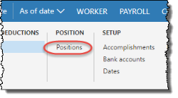
- On the ribbon, click Anthology Payroll Profile tab > Positions to open the Worker positions form.
- On the General tab of the Worker positions form, specify the following fields:
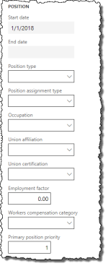
  - Occupation: specify however often your pay period is. This field is optional depending on your implementation requirements. Occupations can drive earning, benefit/deduction, time and entitlement rules. In the QuickStart database, all occupation codes are associated with the standard rules.
  - Union affiliation: specify however often your pay period is. This defines the worker's standard work hours and days.
- Specify the following fields:
NOTE: you may not need to specify the rule group fields if your rules are controlled by the occupation code. This is specific to your implementation requirements.
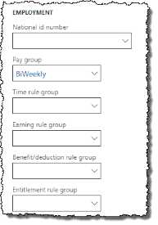
  - Pay group: specify however often your pay period is
  - Time rule group: specify Standard time rules
  - Earning rule group: specify Standard earn calcs
  - Benefit deduction rule group: specify Standard ded'n rules
  - Entitlement rule group: specify Standard entitlement or No entitlement, as required
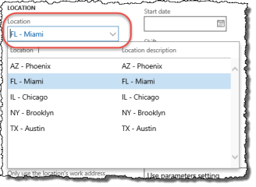
- If your implementation includes withholding for US local taxes, the worker's work address for this position must be recorded. Specify the Location where the worker works. If your implementation does not use locations (i.e.: you use projects or tasks), you can skip this step.
- Specify whether to Only use the location's work address if a task or project is entered for the worker. By default, this option is disabled and the address for the task or project is used for the worker for the purposes of calculating local taxes. Enable this option to override the task or project address with the location's address.
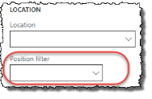
- Specify the Position filter. This is the region where the worker works.
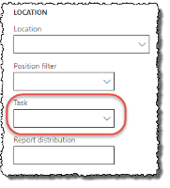
- If your implementation uses projects and tasks, enter the Task assigned to this worker's position.
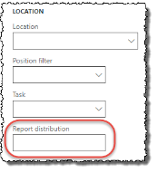
- Enter the Report distribution field, if desired. This determines the order and grouping of the worker's pay statements when they are printed.
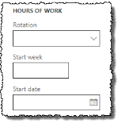
- Enter the Rotation, Start week, and Start date fields as needed. These are used to automatically generate shifts for this position's worked days.
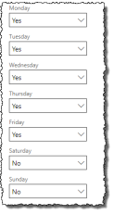
- Enter the appropriate days in which the worker works in the Hours of work section. These days are used in allocating salary earnings and generating shifts based on the rotation.
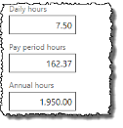
- If the worker is hourly, enter their Daily, Pay period, and Annual hours worked. These amounts are optional. These hours override the defaults from the worker's Union affiliation.
- If your implementation of Dynamics uses compensation plans in the HR module to store worker wage information, skip this step. See section 4.3.10 for details on configuring worker compensation. If your implementation of Dynamics records worker wage information together with their position in Anthology Payroll, enter the worker's wage information. Enter one of these (not both):
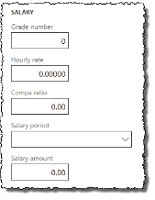
  - Hourly rate: specify the worker's hourly pay rate.
  - Salary period and Salary amount: specify the worker's salary amount and the periodicity of the amount.
- If the worker resides in a state that differs from where they are employed, enter the worker's State of residence in the State/local taxes section.
- If the worker's hire date is in the future, set the Active date to the appropriate date. Note that for future-dated records, you must select the Future view flag on the Overview tab to be able to see them.
- Click Save to save your changes.

3.1.4 Add additional payroll information for the worker
After creating and assigning the position record and adding the worker to Anthology Payroll, you must add additional payroll information for the worker. Additional payroll information includes:
- Benefits and deductions
- Calculation variables
- Starting vacation balances (entitlements), if applicable

3.1.4.1 Add benefit/deductions
To add benefit/deductions to the worker:
- In the navigation pane, click Common > Anthology Payroll workers to open the Anthology Payroll workers list. Select the desired worker.
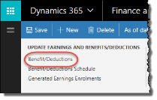
- On the ribbon, click AthPay Profile tab > Benefit/Deductions to open the Worker benefit/deductions form.
- On the Evaluate tab of the Worker benefit/deductions form, enter the worker's position assignment date in the Context date field, if it is not the current date. This can be a date in the future.
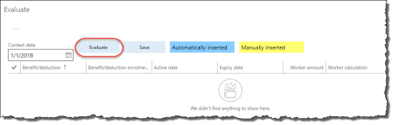
- Click the Evaluate button to generate the worker's default list of benefits and deductions.
- Modify the Benefit deduction enrolment for some of the added benefit/deductions. For a new worker:
  - Enrol the worker in their appropriate state tax and enrollment as required.
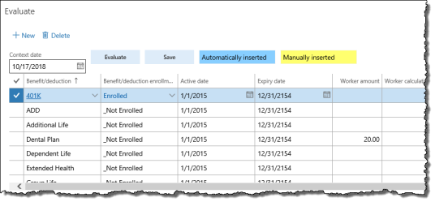
  - Select the appropriate enrollment for the worker's federal tax (USA FIT).
  - Enroll the worker in Medicare and 401k accordingly.
  - If the worker resides in one state and works in another and they have a reciprocity agreement filed for the state they work in, ensure that the state tax benefit/deductions for both states are assigned to them.
  - Enrol the worker in any additional benefit/deductions as appropriate for your implementation. See 9.1 Appendix A: List of Benefit/deductions for a list of the configured benefit/deductions in your implementation.
- Click the Save button in the Evaluate section to save your changes.

3.1.4.2 Add calculation variables
Calculation variables represent US payroll elements such as 401k contribution percentage, W-4 allowances, and personal exemptions.
To add calculation variables to the worker:
- In the navigation pane, click Common > Anthology Payroll workers to open the Anthology Payroll workers list. Select the worker in the list.
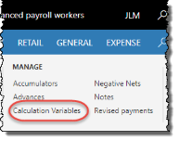
- On the ribbon, click AthPay Profile tab > Calculation variables to open the Worker calculation variables form.
- On the Evaluate tab of the Worker calculation variables form, enter the worker's position assignment date in the Context date field, if it is not the current date. This can be a date in the future.
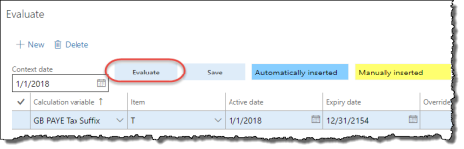
- Click the Evaluate button to generate the worker's default list of calculation variables, if any. To add a new calculation variable, click New.
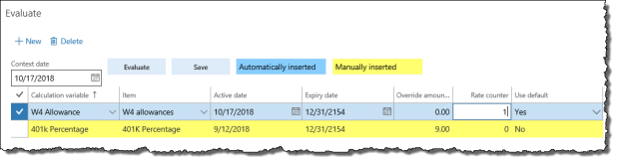
- Add the W4 Allowance Calculation variable and select the W4 allowances Item. Enter the number of allowances the worker is claiming into the Rate counter field.
- If the worker is contributing to 401k, add the 401k Percentage Calculation variable and 401k Percentage Item. Enter the Override amount/rate of the worker's contribution as a percentage (between 1 and 100). If the worker is eligible for 401k catch-up, add the 401k Extra Age Amt Calculation variable and Catch Up Limit Item. Enter the worker's personal catch-up contribution limit into the Override amount/rate field.
- Depending on the state (or states) that the worker works in, you may need to add dependent amounts and/or personal exemption amounts as calculation variables.
- Repeat for additional calculation variables that the worker may require according to your implementation. See 9.2 Appendix B: List of Calculation Variables for a list of the configured calculation variables in your implementation.
- Click Save to save your changes.

3.1.4.3 Add direct deposit accounts

If you have configured Anthology Payroll to integrate with HR worker bank accounts, you can skip this section.
To add a direct deposit account for the worker:
- In the navigation pane, click Common > Anthology Payroll workers to open the Anthology Payroll workers list. Select the worker in the list.
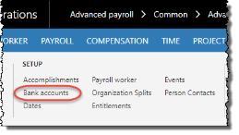
- On the ribbon, click AthPay Profile tab > Bank accounts to open the Worker bank accounts form.
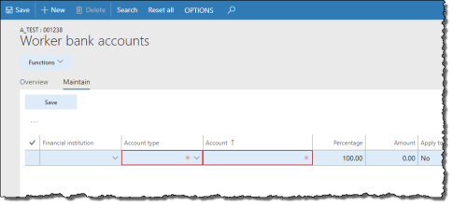
- On the Maintain tab of the Worker bank accounts form, click New to create a new record.
- Specify the worker's Financial institution. This includes the 9-digit routing transit number. If the worker's branch does not appear in the list, complete the following procedure before proceeding further:
  - In the navigation pane, click Setup > Tables > Financial institutions > Financial institutions to open the Financial institutions form.
  - On the Overview tab, click New to create a new record.
  - On the General tab, enter the following:
    - Financial institution name: 3-digit identifier, followed by a dash, followed by the 5-digit branch number, or any identifying name. E.g: 123-10203
    - Financial institution description: name of the financial institution. E.g.: Bank of America.
    - Short code: abbreviated description. E.g.: BoA
    - Bank number: branch number
    - Transit number: routing transit number
  - Specify an Active date and Expiry date.
  - Click Save to save your changes
- Select the Account type.
- Enter the worker's bank Account number.
- If this worker has multiple accounts, enter a value for the Percentage of the worker's pay that is distributed to this account, or an Amount to specify a flat amount per pay statement that is distributed to this account. One account should have the Apply to remainder field set to Yes (and Percentage set to 0.00) such that all remaining pay beyond the percentage or amount is deposited into that account.
- Select Yes for Prenotified?.
- If the worker's hire date is in the future, set the Active date to the appropriate date. Note that for future-dated records, you must select the Future view flag on the Overview tab to be able to see them.
- Click Save to save your changes.
- Repeat to add additional accounts or close the form.

3.1.4.4 Add worker organization splits

Organization splits enable you to define a default division of worker-related GL postings between more than one department and dimension set and/or project. You also control what fraction of the whole is allocated to each of the divisions you define.
To add an organization split for the worker:
- In the navigation pane, click Common > Anthology Payroll workers to open the Anthology Payroll workers list. Select the worker in the list.
- On the ribbon, click AthPay Profile tab > Organization Splits to open the Worker organization splits form.
- On the Maintain tab of the Worker organization splits form, click New to create a new split.
- For each split,
Specify the Percentage of this split. The sum of the percentages for all of your splits must be 100.
If you want the split to define the default department and financial dimensions for the worker’s transactions, then
- Specify the worker's Department
- Specify the Financial dimensions by open the Financial dimension pane at the bottom of the form and select the dimension values there.
If you want the split to define default project attributes for the worker’s transactions, then
- Select a Project ID
- Specify an Hours category for any salary or hours-based earnings and related burden
- Specify an Expense category for any amount-based or unit-based earnings and related burden
- Specify an Activity number (optional)
- Verify that the Active date and Expiry date are correct and shared by all of these records.
- Verify that the sum of the Percentage values for all rows is 100.
- Click Save to save your changes.

3.1.4.5 Add starting vacation balance

To add a starting vacation balance:
- In the navigation pane, click Common > Anthology Payroll workers to open the Anthology Payroll workers list. Select the worker in the list.
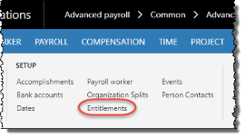
- On the ribbon, click Anthology Payroll Profile tab > Entitlements to open the Worker entitlements form.
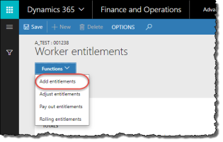
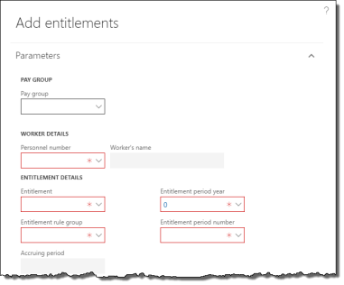
- On the Worker entitlements form, click Functions > Add entitlements to open the Add entitlements pane.
- On the Add entitlements pane, specify the Pay group and select the worker in the Personnel number field. If the worker does not appear in the field, make sure the worker was properly added to the pay group in section 3.1.3.
- Select the Standard entitlement Entitlement rule group.
- Select the Vacation Entitlement.
- Specify the current year in the Entitlement period year field. Enter 1 as the Entitlement period number.
- Enter a starting vacation balance in hours in the Accrued hours field. For example, to give someone 10 days of vacation, enter 75 hours (7.5 hours/day).
- Specify an Addition reason code of Initial setup.
- Click OK to set an initial balance on accrued vacation for this worker.
- Close the Worker entitlements form.

3.2 Rehire a Worker
Rehiring a worker is largely the same process as hiring a new worker, except the worker record already exists in Anthology Payroll. Your task involves validating and updating the past information against the worker's new sign-on package.
The steps to rehire a worker are:
- Reactivate the worker's past worker record and validate existing data.
- Create a new position and assign it to the worker or reactivate and reassign past position to the worker.
- Validate the worker's existing payroll records.
- Validate the worker's additional payroll information.

3.2.1 Reactivate the worker's past worker record
To reactivate the worker's past worker record:
- In the Human resources navigation pane, click Workers > Past workers to open the Past workers list.
- Locate the worker in the list and double-click their record to open the Worker form.
- Verify and update the following information:
  - Name
  - Personal title
  - Addresses
  - Contact information
  - Birth date
  - Gender
  - Government-issued identification
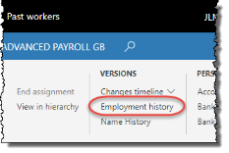
- On the ribbon, click Worker tab > Employment history to open the Employment history form.
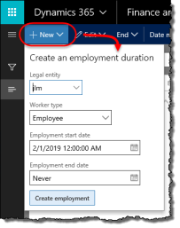
- In the Employment history form, click the New button to open the Create an employment duration dialog.
- Specify the appropriate Legal entity.
- Specify the worker's Employment start date if it is different from the current date. Specify an Employment end date if there is one.
- Click Create employment to reactivate the worker's employment record.
- Click Save and close the Employment history form.

3.2.2 Create or reactivate the worker's position
You can choose to create a new position and assign it to the worker or reactivate the worker's previous position. To create a new position, refer to section 3.1.1.
After creating a new position, to assign it to the existing worker:
- In the Human resources navigation pane, click Workers > Past workers to open the Past workers list. Select the worker in the list.
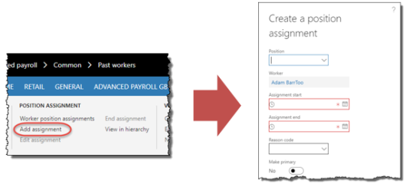
- On the ribbon, click Worker tab > Add assignment to open the Create a position assignment pane.
- Specify the Position.
- Specify an Assignment start date if it is different from the current date.
- Specify an Assignment end date if there is one.
- Click Create position assignment to assign the position to the worker.
To reactivate the worker's past position:
- In the navigation pane, click Common > Workers to open the Workers list. Select the worker in the list.
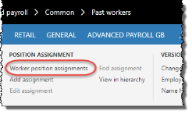
- On the ribbon, click Worker position assignments to open the Position assignments form.
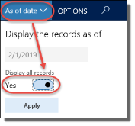
- In the Position assignments form, click the As of date button to open the Display the records as of dialog. Check Display all records and click Apply. All of the worker's past positions appear in the list.
- Select the position that you want to reactivate to open it. Click in the Position column of the Position assignments form to open the Position form.
- If the position was retired previously:
  - Expand the Position duration section of the Position form and click New to open the Create a position duration dialog.
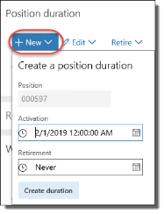
  - Specify the position's Activation date if it is different from the current date. Specify a Retirement date if there is one.
  - Click Create duration to reactivate the position.
- Expand the Worker assignment section of the position and click New to open the Create a worker assignment pane.
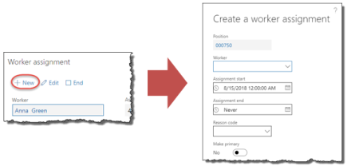
- Select the rehired Worker.
- Specify an Assignment start date if it is different from the current date. Specify an Assignment end date if there is one.
- Select Make primary if this position is the worker's primary or only position.
- Click Create worker assignment to assign the position to the worker.
- Expand the Financial dimensions section and verify the information there.
- Close the form.

3.2.3 Validate the worker's existing position record
To validate the worker's existing payroll record:
- In the navigation pane, click Common > Anthology Payroll workers to open the Anthology Payroll workers list. Select the worker in the list.
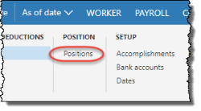
- On the ribbon, click Anthology Payroll Profile tab > Positions to open the Worker positions form.
- On the Positions form, click the General tab and verify the following information:
  - Pay group: specify however often your pay period is
  - Time rule group: specify Standard time rules
  - Earning rule group: specify Standard earn calcs
  - Benefit deduction rule group: specify Standard ded'n rules
  - Entitlement rule group: specify Standard entitlement or No entitlement, as required
  - Position filter: specify the region where the worker works
  - Hourly rate: specify the worker's hourly pay rate.
  - Salary period and Salary amount: specify the worker's salary amount and how often they are paid this amount.
NOTE: You cannot specify both an Hourly rate and a Salary amount.
- Click Save to save your changes.

3.2.4 Validate the worker's additional payroll information
Validating the worker's additional payroll information involves viewing the appropriate forms and validating the information currently found there. These procedures are the same as the ones outlined in section 3.1.4. See that section for steps on viewing and modifying additional payroll information.

4 Maintaining Worker Data
This section describes procedures on modifying and maintaining worker data. This data includes:
- Position data, such as the position filter and worker wages
- Demographic data, such as addresses, and contact information
- Payroll data, such as benefit/deductions and calculation variables

4.1 Manage Position Data
Worker position data must be updated when workers change occupations or receive pay increases. All position information is contained in a single form—the Worker positions form. The data that you may modify includes:
- Occupation
- Position filter, type, assignment type
- Wage rate
- Union affiliation
- Rule groups

4.1.1 Modify Position Data
To modify position data for a worker:
- In the navigation pane, click Common > Anthology Payroll workers to open the Anthology Payroll workers list. Select the worker in the list.
- On the ribbon, click Anthology Payroll Profile tab > Positions to open the Worker positions form.
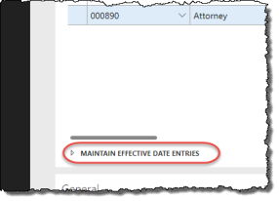
- On the Overview tab, expand the Maintain effective date entries pane.
- On the Effective dates tab of the Maintain effective date entries pane, click New to create a new record. This new position record is a copy of the previous record with a new Active date. Change this date to the date that the new policy takes effect. The previous record is automatically adjusted to expired one day before this date.
- On the General tab of the Maintain effective date entries pane, modify any of the following information as required (see section 3.1.3 or the Anthology Payroll Help System for descriptions of the fields):
  - Occupation
  - Position filter
  - Position type
  - Position assignment type
  - Wage rate or salary information
  - Union affiliation
  - Rule groups
  - Location
  - State of residence
- Click Save to save your changes.

4.1.2 Change Positions
Occasionally, a worker may change positions due to a lateral move or a promotion. In these cases, you must:
- End the worker's old position.
- Create a new position and assign it to the worker.
- Update their position data.
You may also need to update the worker's payroll data if the new position belongs to a different pay group or if the worker is now eligible for additional benefits.
To end a worker's position:
NOTE: before ending the worker's position, ensure that the worker has no unprocessed earnings in the current pay period.
- In the navigation pane, click Common > Workers to open the Workers list. Select the worker.
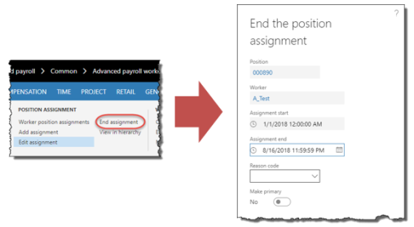
- On the Worker tab of the ribbon, click the End assignment button to open the End the position assignment pane.
- Specify an Assignment end date if it is not the current date.
- Select a Reason code for the position ending.
- Click Retire worker assignment to end the worker's position.
To create a new position and assign it to the worker, refer to section 3.1.1 and the first procedure in section 3.2.2.
To update the worker's position data, refer to section 3.1.3.
To update the worker's payroll data, refer to section 4.3 for the different types of payroll data.

4.1.3 Change Pay Group
You can change a worker's pay group for any position on a specified effective date provided there are no outstanding transactions pending for that worker on and following that date. It is recommended to do this at the beginning of a new pay period before any new earnings are transacted.
If there are outstanding transactions that are to be carried over from the worker's old pay group to the new one, you must take note of the existing transactions, clear them, and recreate them for the worker after changing their pay group. Before a worker's pay group can be changed, the following conditions must apply on and following the effective date of the change:
- no advances or negative nets to recover
- no earning transactions
- no remaining entitlement bank amounts
- no pending time or earning imports
- no pending payments to approve
- no remaining prepaid benefit amounts
- no pending retroactive earnings
- no pending revised payment refunds or recoveries
- no time transactions
When a worker's pay group is changed, all their assigned worker benefit/deductions are also reassigned to the new pay group as of the effective date of the pay group change.
To change a worker's pay group:
- In the navigation pane, click Common > Anthology Payroll workers to open the Anthology Payroll workers list. Select the worker in the list.
- On the ribbon, click AthPay Profile tab > Position section > Positions to open the Worker positions form. Select the position to change the pay group for.
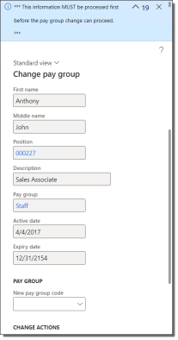
- Click Links > Functions > Change pay group to open the Change pay group dialog. An alert shows you a summary of any outstanding processing for the worker. If there are outstanding items, they must be resolved before you can proceed with the pay group change.
- In the Change pay group dialog, specify the New pay group code for the worker's position to change to.
- Specify the Active date for new pay group. The worker's position is updated with this effective date. This date defaults to one day after the date of the worker's last processed earning on the current pay group.
- If the worker has multiple positions in the same pay group and you want to change the pay group for all of them, check the Replace all the worker's positions with this new pay group checkbox. Otherwise, leave it unchecked.
- Click Change pay group to change the worker's pay group for this position.

4.2 Manage Demographic Data
Currently, demographic data only includes worker addresses.

4.2.1 Manage Addresses
To add a new address, refer to section 3.1.2.
To change a worker's address:
- In the navigation pane, click Common > Anthology Payroll workers to open the Anthology Payroll workers list. Double-click the worker in the list to open the Worker form.
- On the Worker form, expand the Addresses section.
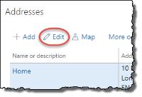
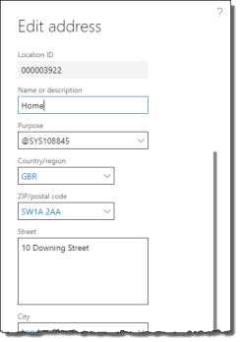
- Select the address to modify and click the Edit button to open the Edit address pane.
- On the Edit address pane, update the worker's address as desired.
NOTE: if you process local taxes, ensure that the worker's home address is marked as Primary.
- Click OK to save your changes. Close the form.

4.3 Manage Payroll Data
Payroll data refers to worker data that relates specifically to how the worker is paid. In terms of the US localization of Anthology Payroll, this includes:
- Bank Accounts
- Benefits and deductions
- Calculation variables
- One-time deductions
- Wage increments

4.3.1 Manage Account (Direct Deposit) Information

If you have configured Anthology Payroll to integrate with HR worker bank accounts, you can skip this section.
Worker account information can be modified to correct existing account information that is incorrect, or to make an effective-dated change to the worker's account information if they changed accounts and banks.
To add a new account, see section 3.1.4.3.
To correct a worker's account information:
- In the navigation pane, click Common > Anthology Payroll workers to open the Anthology Payroll workers list. Select the worker in the list.
- On the ribbon, click Anthology Payroll Profile tab > Bank accounts to open the Worker bank accounts form.
- Select the worker's account to correct and click the Maintain tab.
- Modify any of the following fields:
  - Financial institution name: 3-digit identifier, followed by a dash, followed by the 5-digit branch number (example)
  - Account type: Checking or Savings
  - Account: worker's 8-digit account number
  - Percentage: amount per payment to deposit to this account. Used in account splits.
  - Apply to remainder: deposit any remaining payment amount after account splits to this account.
- Click Save to save your changes. Close the form.
To make an effective-dated change to a worker's account information:
- In the navigation pane, click Common > Anthology Payroll workers to open the Anthology Payroll workers list. Select the worker in the list.
- On the ribbon, click Anthology Payroll Profile tab > Bank accounts to open the Worker bank accounts form.
- Select the worker's current bank account to change and expand the Maintain effective date entries pane.
- In the Maintain effective date entries pane, select the current, active bank account and click New to create a new effective-dated record. This opens the Maintain tab on the Worker bank accounts form and creates a new record with identical attributes as the selected record with an Active date of the current date.
- Modify any of the following fields on this new record:
  - Financial institution name: 3-digit identifier, followed by a dash, followed by the 5-digit branch number (example)
  - Account type: Checking or Savings
  - Account: worker's 8-digit account number
  - Percentage: amount per payment to deposit to this account. Used in account splits.
  - Apply to remainder: deposit any remaining payment amount after account splits to this account.
  - Active date: date when the new account is to take effect. This can be a date in the future. The current worker account record is automatically set to expire one day before this date.
- Click Save to save your changes. Close the form.

4.3.2 Manage One-Time Deductions
Some deductions are one-time deductions and are assigned to workers on an individual basis as needed.
To assign a one-time deduction to a worker:
- In the navigation pane, click Common > Anthology Payroll workers to open the Anthology Payroll workers list. Select the worker in the list.
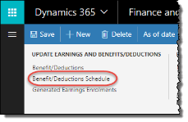
- On the ribbon, click Anthology Payroll Profile tab > Benefit/Deductions Schedules to open the Worker benefit/deduction schedules form.
- On the Overview tab, click New to create a new record.
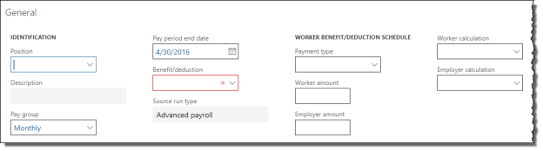
- On the General tab, specify the desired Benefit/deduction code.
- Specify the Worker amount. This is the amount deducted from the worker. This amount can be negative, resulting in an additional payment to the worker.
- Specify a Pay period end date. This defines the pay period when the amount is to be deducted. For the current pay period, leave the default date.
- If the benefit/deduction is associated with a benefit/deduction sequence, you can choose to override the Calculation sequence number and Depletion sequence for the deduction to determine when during processing the deduction is calculated and depleted from the worker's pay respective to other deductions. These overrides are typically used for court-ordered wage garnishments that have specific priorities.
- Click Save to save your changes.
The deduction is automatically taken from the worker's next (or future) payment.

4.3.3 Manage Worker Allowances
Worker allowances are special benefit earnings that your company may give to workers on a regular basis, such as car allowances or gym memberships. Your implementation may be configured to display these as earnings on the worker's pay statement.
In Anthology Payroll, allowances are generally configured as generated earnings, which are earnings based on other earnings. There are two types of generated earnings: enrolled and non-enrolled. Non-enrolled generated earnings are automatically awarded to all workers with the appropriate rule group, while enrolled generated earnings must be assigned to individual workers before they receive them.
To manage a worker's generated earning enrollments:
- In the navigation pane, click Common > Anthology Payroll workers to open the Anthology Payroll workers list. Select the worker in the list.
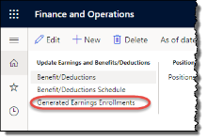
- On the ribbon, click Anthology Payroll Profile tab > Generated Earnings Enrollments to open the Generated earning enrollments form.
- On the Overview tab, click New to create a new record.
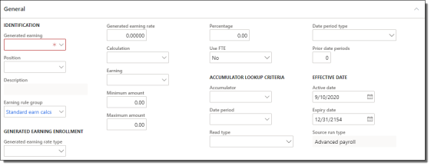
- On the General tab, specify the desired Generated earning code for the allowance.
- If the worker has multiple positions and this allowance is specific to one of their positions, specify the Position field.
- Verify the worker's Earning rule group. The rule group determines how the allowance amount is calculated.
- Specify the Generated earning rate type. Amount for dollar amounts or Hours for hour amounts that are later multiplied against a rate.
- To override the default configuration of the allowance for this worker's enrollment specify any of the following, as desired:
  - Generated earning rate: multiplier rate or flat amount of the generated earning. Hours-based earnings are multiplied by this rate and amount-based earnings use this rate as the flat amount.
  - Calculation: calculation code that calculates the amount of the generated earning
  - Earning: earning code to be generated. Depending on configuration, this code appears on the worker's pay statement.
  - Minimum amount: minimum amount for the worker to be paid each time this earning is generated
  - Maximum amount: maximum amount for the worker to be paid each time this earning is generated
  - Percentage: percentage multiplier against the Calculation, if the worker is only to receive a portion of the calculated amount. Default is 100%.
  - Use FTE: Yes to apply the worker's full-time equivalency value to give only a portion of the generated earning. No, otherwise.
- Set the Active date to when the allowance takes effect, usually the worker's hire date.
- Click Save to save your changes.

4.3.4 Manage Calculation Variables
To add new calculation variables for a worker, see section 3.1.4.2.
Refer to 9.2 Appendix B: List of Calculation Variables for a listing of all calculation variables and descriptions of their use.
Existing calculation variables that you may want to change are:
- Taxable benefits
- Non-standard vacation accrual rates
- Personal tax credits
To modify a worker's existing calculation variables:
- In the navigation pane, click Common > Anthology Payroll workers to open the Anthology Payroll workers list. Select the worker in the list.
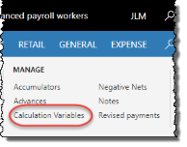
- On the ribbon, click Anthology Payroll Profile tab > Calculation variables to open the Worker calculation variables form.
- On the Overview tab, select the calculation variable to modify. Expand the Maintain effective date entries pane.
- On the Effective dates tab of the Maintain effective date entries pane, click New to create a new record. This new record is a copy of the previous record with a new Expiry date. The previous record is automatically expired on current date.
- On the General tab of the Maintain effective date entries pane, modify any of the following fields as required (refer to aforementioned appendix):
  - Item: calculation variable item name
  - Override amount: value for the variable if non-default
  - Use default: if No, the calculation variable uses the Override amount
  - Expiry date
- To expire a calculation variable, modify only the Expiry date.
- Click Save to save your changes.

4.3.5 Import Wage Increments
Wage increments are predetermined pay increases that occur at a defined time. There are two methods to manage wage increments for workers:
- creating a spreadsheet of wage increments and importing them
- generating wage increment steps from a predefined set of criteria
Both methods require setup of a wage increment code prior to importing or generating the wage increments. This section details the method of importing wage increments.
Wage increments are individual transaction records that record a change to a worker's salary or hourly rate. Whether they are imported or generated, they must then be applied to workers or their positions to enact the effective-dated change.

4.3.5.1 Set up a Wage Increment Code
All wage increments must be associated with a wage increment code, regardless of whether they are generated or imported.
To set up a wage increment code:
- In the navigation pane, click Setup > Tables > Salary > Wage increments to open the Wage increments form.
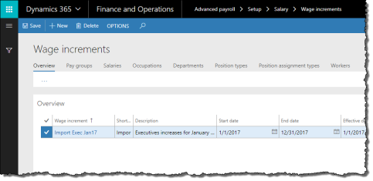
- On the Overview tab, click New to create a new record.
- On the General tab, enter the Wage increment name and Description. The Short code defaults to the first five characters of the name.
- Enter the Start date and End date of the wage increment. Workers and positions must be active within this date range to be considered for eligibility.
- Enter the Minimum amount and Maximum amount. These amounts are annualized (hourly and salary) outer boundaries of the wage increment amount. Wage increments that fall outside these boundaries are still generated, but not automatically applied.
- Select the Salary type of the workers to be considered for this wage increment.
- Set any of the following run parameters:
  - Use import file only: Yes/No whether you import wage increments for this code. Set to Yes to indicate this wage increment code is for imported wage increments. This disables certain fields on this form as they are not used for imported wage increments.
  - Terminated: Yes/No whether workers or positions that terminate within the date range are considered for the wage increment
- Specify an Effective date. All wage increment changes use this date as their active date.
- Further refine the eligibility criteria of the wage increment on the following tabs:
  - Pay groups: only workers in the selected pay groups are eligible
  - Salaries: only workers with the selected salary codes are eligible
  - Occupations: only workers in the selected occupations are eligible
  - Departments: only workers in the selected departments are eligible
  - Position types: only workers with the selected Position types on their Worker positions form are eligible
  - Position assignment types: only workers with the selected Position assignment types on their Worker positions form are eligible
  - Workers: only selected workers are eligible
- Click Save to save your changes.

4.3.5.2 Import Wage Increments
You may import wage increments from a CSV, TXT or DAT file into Anthology Payroll. The import file must follow strict specifications, which are defined in 9.6 Appendix F: List of Wage Increment Import Fields. Before importing wage increments, ensure that you have set up the wage increment code you are importing for (section 4.3.5.1). You can only import for one code at a time.
After importing the wage increment records, you must commit the records to Anthology Payroll.
To import wage increments from an import file:
- In the navigation pane, click Periodic > Other > Wage increments > Import wage increments to open the Import wage increments pane.
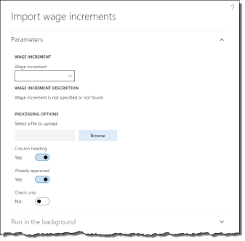
- Specify the Wage increment code you are importing for. Verify the Wage increment description is what you are importing for.
- Browse and select the import file.
- Select or deselect any processing options:
  - Column heading: deselect if the first row in the import file is not column headings
  - Already approved: deselect if imported wage increment records must be approved/reviewed before applying to workers and positions. This requires a separate process (see section 4.3.5.3).
  - Check only: select to verify the import file only. No wage increment records are imported.
- Click OK to import the file. An alert appears with a summary of the import process.
To commit imported wage increments:
- In the navigation pane, click Periodic > Other > Wage increments > Commit import wage increments to open the Wage increment imports journal.
- Specify the Wage increment code that wage increments were imported for. Uncommitted, imported wage increment records appear in the list. Note any records that state No for the Valid field.
- Review the list of imported wage increments to verify that the data imported correctly. Modify any wage increment records as required. Ensure to resolve the wage increment records that state No for the Valid field. These records cannot be committed until they are revalidated.
- Select any records that you have modified and click Revalidate to check their validity.
- When all desired wage increment records are valid, select the records you want to commit and click Commit wage increments to commit them to Anthology Payroll. An alert appears to verify the procedure.

4.3.5.3 Review or Change Wage Increments
After generating or importing/committing wage increments, you must review them and manually select which wage increments to apply. If you imported wage increments and selected the Already approved flag during the import process, you do not need to review the wage increments further, but you may still choose to.
After reviewing/changing wage increment records, you can apply them and create the appropriate effective-dated changes on worker and worker position records.
To review or change wage increments:
- In the navigation pane, click Periodic > Other > Wage increments > Review/change wage increments to open the Review/change wage increments journal.
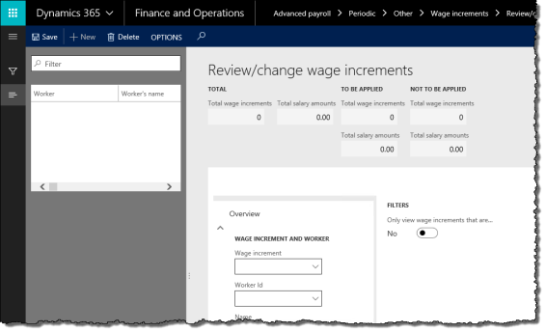
- Specify the Wage increment code of the wage increments to review or change. If desired, specify a Worker Id to view only that worker's wage increments.
- Change any of the following fields as desired. You can only change wage increments that have not yet been applied:
  - New effective date
  - New salary
  - New step number
  - New salary period
  - New salary amount
  - New hourly rate
- Review the list of wage increments and determine which you would like to apply. Set the Apply flag to Yes for these wage increments.
- Click Save to save your changes.

4.3.5.4 Apply Wage Increments
After you are satisfied with the wage increments and have verified them, you can apply them to worker and position records and enact the effective-dated changes.
To apply wage increments:
- In the navigation pane, click Periodic > Other > Wage increments > Apply wage increments to open the Apply wage increments pane.
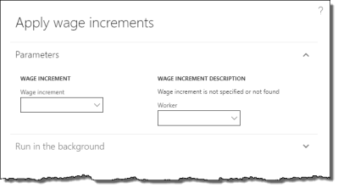
- Specify the Wage increment code of the wage increments to apply. Verify the Wage increment description corresponds to the desired wage increment.
- If desired, specify a Worker to apply only wage increments for that worker.
- Click OK to apply wage increment changes to workers and worker positions. An alert appears with a summary of the application process.

4.3.6 Generate Wage Increment Steps
Wage increments are predetermined pay increases that occur at a defined time. There are two methods to manage wage increments for workers:
- creating a spreadsheet of wage increments and importing them
- generating wage increment steps from a predefined set of criteria
Both methods require setup of a wage increment code prior to importing or generating the wage increments. This section details the method of generating wage increment steps.
Wage increments are individual transaction records that record a change to a worker's salary or hourly rate. Whether they are imported or generated, they must then be applied to workers or their positions to enact the effective-dated change.

4.3.6.1 Set up a Wage Increment Code
All wage increments must be associated with a wage increment code, regardless of whether they are generated or imported.
See section 4.3.5.1 for additional details.
To set up a wage increment code:
- In the navigation pane, click Setup > Tables > Salary > Wage increments to open the Wage increments form.
- On the Overview tab, click New to create a new record.
- On the General tab, enter the Wage increment name and Description. The Short code defaults to the first five characters of the name.
- Enter the Start date and End date of the wage increment. Workers and positions must be active within this date range to be considered for eligibility.
- Enter the Minimum amount and Maximum amount. These amounts are annualized (hourly and salary) other boundaries of the wage increment amount. Wage increments that fall outside these boundaries are still generated, but not automatically applied.
- Select the Salary type of the workers to be considered for this wage increment.
- Set any of the following run parameters:
  - Next step: Yes/No whether workers or positions associated with salary grids are to advance to the next step as a result of this wage increment. Workers currently at the top step of their salary grids are not affected by wage increments.
  - Terminated: Yes/No whether workers or positions that terminate within the date range are considered for the wage increment
  - Use import file only: Yes/No whether you import wage increments for this code. Set this to No to indicate that this wage increment code is for generated wage increments.
  - Usage period type: Yes/No whether to follow usage periods when considering workers or positions to advance to the next step in a salary grid. Usage periods are predefined lengths of time that workers must remain in a salary step before advancing to the next.
- Enter one of:
  - Percentage amount: increment or decrement wages by a percentage
  - Hourly rate and/or Salary period and Salary amount: new rates and amounts for hourly workers or salaried workers or both
- Specify an Effective date. All wage increment changes use this date as their active date.
- Further refine the eligibility criteria of the wage increment on the following tabs:
  - Pay groups: only workers in the selected pay groups are eligible
  - Salaries: only workers with the selected salary codes are eligible
  - Occupations: only workers in the selected occupations are eligible
  - Departments: only workers in the selected departments are eligible
  - Position types: only workers with the selected Position types on their Worker positions form are eligible
  - Position assignment types: only workers with the selected Position assignment types on their Worker positions form are eligible
  - Workers: only selected workers are eligible
- Click Save to save your changes.

4.3.6.2 Generate Wage Increments
Wage increments may be generated at any time, provided you have set up the wage increment code (section 4.3.5.1). Generating wage increments is separate from importing wage increments (section 4.3.5.2). You cannot generate and import wage increments for the same wage increment code.
To generate wage increments:
- In the navigation pane, click Periodic > Other > Wage increments > Generate wage increments to open the Generate wage increments pane.
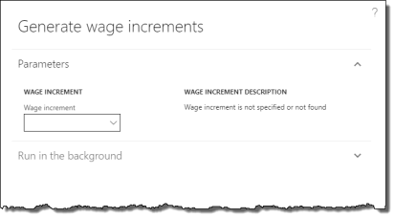
- Select the Wage increment code to generate.
- Click OK to generate the wage increments.

4.3.6.3 Review or Change Wage Increments
See section 4.3.5.3.

4.3.6.4 Apply Wage Increments
See section 4.3.5.4.

4.3.7 Manage Pay Advances
Pay advances can be issued to workers and then scheduled to be recovered at a later date.

4.3.7.1 Issue Pay Advance
To issue a pay advance to a worker:
- In the navigation pane, click Common > Anthology Payroll workers to open the Anthology Payroll workers list. Select the worker in the list.
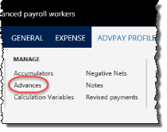
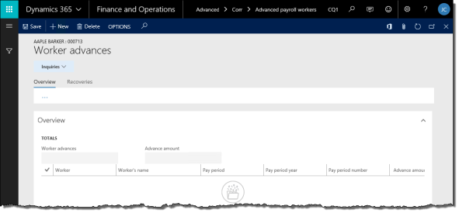
- On the ribbon, click Anthology Payroll Profile tab > Advances to open the Worker advances form.
- On the Overview tab, click New to create a new record.
- On the General tab, select the Pay period, Pay period year, and Pay period number representing when the pay advance is issued. Verify the worker's Pay group.
- Specify the Advance amount to be paid.
- Specify whether the advance is Recovered outside of the system. If Yes, the Recovered field automatically changes to Yes.
- Specify whether the advance was Issued outside of the system.
- If the advance is not recovered outside of the system, the form will prompt you to schedule an advance recovery before closing it (next section).
When the pay advance is created, Anthology Payroll will automatically pick it up as the worker's earnings to be paid in the next regular payment. Alternatively, you may issue a manual payment (5.2.1) to the worker and select the appropriate payment type (i.e.: Off-cycle) to pick up the pay advance. Pay advances appear in their own section on the Benefits/deductions tab of the Manual payment entry journal.

4.3.7.2 Schedule an Advance Recovery
If a pay advance is not recovered outside of Anthology Payroll (i.e.: manually), you must schedule a recovery period in which Anthology Payroll will recover the pay advance. Pay advances are treated the same as benefit/deductions, in which they are recovered automatically from regular payment.
To schedule an advance recovery:
- On the Worker advances form, select the advance to recover and click the Recoveries tab.
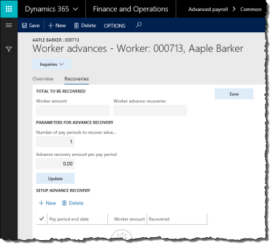
- The Worker amount shows the amount to be recovered. One advance recovery record is created by default with the full amount of the advance. If the advance recovery record does not appear, click Update to create it.
- To specify the number of pay periods over which to recover the advance amount and calculate the recovery amount per pay period:
  - Enter 0 for Advance recovery amount per pay period.
  - Enter the Number of pay periods to recover advance.
  - Click Update to generate the advance recovery schedule.
- To specify the recovery amount per pay period and calculate the number of pay periods required:
  - Enter 0 for Number of pay periods to recover advance.
  - Enter the Advance recovery amount per pay period.
  - Click Update to generate the advance recovery schedule.
- To specify both the recovery amount per pay period and the number of pay periods and calculate the resulting Worker amount:
  - Enter the Number of pay periods to recover advance.
  - Enter the Advance recovery amount per pay period.
  - Click Update to generate the advance recovery schedule.
NOTE: you will receive an alert if Worker amount is less than the amount to be recovered
- If required, modify the Pay period end dates in the recovery schedule table to change the date of each recovery.
- Click Save to commit the advance recovery schedule.
- Close the form.

4.3.7.3 Modify an Existing Advance or Recovery Schedule
You can modify an advance or its recovery schedule provided it is not already marked as recovered.
To modify an existing advance or recovery schedule:
- On the Worker advances form, select the advance to modify.
- On the General tab, adjust the data fields as desired. Click Save to save your changes.
- To modify the recovery schedule, click the Recoveries tab and select the recovery periods in the table to modify.
- Change recovery fields as desired. To delete records, select them and click Delete.
- Click Save and you will be returned to the Overview tab.
- Click Save to save your changes.

4.3.8 Manage Worker Organization Splits

Worker organization splits can be modified to correct an existing split that is incorrect, or to make an effective-dated change to the worker's organization split configuration to reflect a change in responsibilities.
To add a new organisation split, see section 3.1.4.4.
To correct a worker's organization split configuration:
- In the navigation pane, click Common > Anthology Payroll workers to open the Anthology Payroll workers list. Select the worker in the list.
- On the ribbon, click Anthology Payroll Profile tab > Organization splits to open the Worker organization splits form.
- Select one row of the set of splits that need to be corrected and click the Maintain tab.
- Modify any of the following fields on any row:
  - Department
  - Financial dimension: after selecting a row to be changed in the upper list, open the Financial dimension list below to access the editable fields. Changes in the lower pane will be reflected in the Organization split field in the upper list.
  - Percentage
  - Project ID
  - Hours category
  - Expense category
  - Activity number
- Click Save to save your changes. Close the form.
To make an effective-dated change to a worker's account information:
- In the navigation pane, click Common > Anthology Payroll workers to open the Anthology Payroll workers list. Select the worker in the list.
- On the ribbon, click Anthology Payroll Profile tab > Organization splits to open the Worker organization splits form.
- Select one row of the active split rows to change and expand the Maintain effective date entries pane.
- In the Maintain effective date entries pane, select the current row and click New to create a new effective-dated record. This opens the Maintain tab on the Worker organization splits form and creates a new set of splits with identical attributes as the previous set of splits, and they all have an Active date of the current date.
- Modify any of the following fields the new records in the Maintain tab:
  - Department
  - Financial dimension: after selecting a row to be changed in the upper list, open the Financial dimension list below to access the editable fields. Changes in the lower pane will be reflected in the Organization split field in the upper list.
  - Percentage
  - Project ID
  - Hours category
  - Expense category
  - Activity number
  - Active date: date when the new account is to take effect. This can be a date in the future. The current set of worker organization split records will automatically have their Expiry dates set to one day before this date.
- Click Save to save your changes. Close the form.

4.3.9 Manage Entitlements
Entitlements are worker banks of time or earnings that can accrue and consume during their employment. Entitlement banks grow as a result of time worked or in periodic increments, and decrease as result of time or earnings taken, expiration, or being paid out. Workers may have multiple entitlement banks that accumulate and deplete according to different policies.
This section contains procedures for managing a worker's entitlements during their employment. For paying out a worker's accrued time (vacation, overtime, etc.) upon their termination, see section 8.3.

4.3.9.1 Adjust Entitlements
You may adjust a worker's entitlement balance as required provided you have not yet updated entitlements (section 5.1.6) in the current pay period. If you have started the pay process, any adjustments to entitlements may impact the worker's payment.
To adjust a worker's entitlement bank balance:
- In the navigation pane, click Common > Anthology Payroll workers to open the Anthology Payroll workers list. Select the worker.
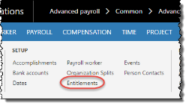
- On the ribbon, click Anthology Payroll Profile tab > Entitlements to open the Worker entitlements form.
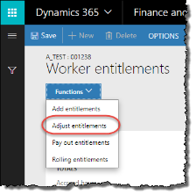
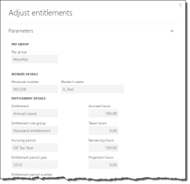
- On the Worker entitlements form, select the entitlement to adjust and click Functions > Adjust entitlements to open the Adjust entitlements pane.
- Change the Accrued hours, Taken hours, or both as desired.
- Specify an Adjustment reason code of Correction or alternative as appropriate.
- Click OK to adjust the entitlement bank.

4.3.9.2 Add Rolling Entitlements
Rolling entitlements are entitlements that are configured with a rolling taking period. The taking period is a moving window of time that replenishes according to how much time has lapsed since the bank was last decremented according to a context date, which is usually the current date. Typically, rolling entitlements have an initial bank amount.
For example, a worker may have a bank of 15 days to consume over a rolling period of one year. If the worker takes 5 consecutive days out of the bank starting from January 5th, 2014, the worker will have a remaining balance of 10 days until January 6th, 2015. On that date, he or she will have a balance of 11 days. On January 7th, 2015, the worker will have 12 days, and so on until the bank returns to a full balance of 15 days on January 10th, 2015, presuming the worker has not taken additional days from the bank during the rolling period.
To add a rolling entitlement bank to a worker and give them a starting balance:
- In the navigation pane, click Common > Anthology Payroll workers to open the Anthology Payroll workers list. Select the worker.
- On the ribbon, click Anthology Payroll Profile tab > Entitlements to open the Worker entitlements form.
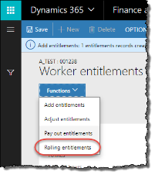
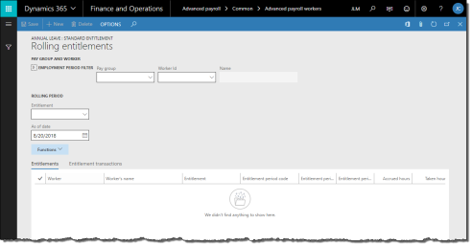
- On the Worker entitlements form, click Functions > Rolling entitlements to open the Rolling entitlements form.
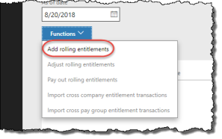
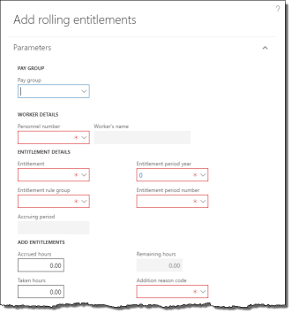
- On the Rolling entitlements form, re-enter the Worker Id and Pay group.
- Click Functions > Add rolling entitlements to open the Add rolling entitlements pane.
- On the Add rolling entitlements pane, specify the Pay group and select the worker in the Personnel number field.
- Select the Entitlement to add.
- Select the worker's Entitlement rule group that contains the rules for this particular entitlement.
- Specify the Entitlement period year and Entitlement period number in which the starting balances should appear. The Accruing period will automatically populate.
- Enter a starting entitlement balance in the Accrued field. The unit (hours, days, etc.) may differ according to the entitlement.
- Select an Addition reason code appropriate for the addition (e.g.: Initial setup).
- Click OK to add the entitlement for the worker.
- Close the form.
After an entitlement bank has been granted to a worker, its attributes can no longer be modified. Be sure all selected attributes are correct before granting the entitlement. Only the entitlement balance can be adjusted after the entitlement is granted.

4.3.9.3 Adjust Rolling Entitlements
To adjust the balance of a worker's rolling entitlement:
- In the navigation pane, click Common > Anthology Payroll workers to open the Anthology Payroll workers list. Select the worker.
- On the ribbon, click Anthology Payroll Profile tab > Entitlements to open the Worker entitlements form.
- On the Worker entitlements form, click Functions > Rolling entitlements to open the Rolling entitlements form.
- On the Rolling entitlements form, enter the worker's Pay group, Entitlement to adjust and the As of date (current date).
- On the Entitlements tab, select the entitlement to adjust and click Functions > Adjust rolling entitlements to open the Adjust rolling entitlements pane.
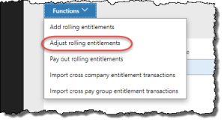
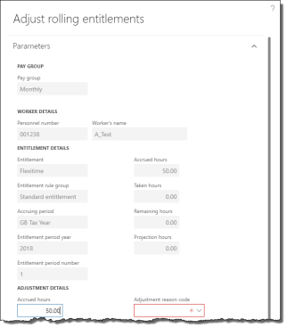
- On the Adjust rolling entitlements pane, change the Accrued and Taken fields as required. The unit (hours, days, etc.) may differ according to the entitlement. To specify a negative balance if the entitlement allows, the Taken amount must be greater than the Accrued.
- Specify an Adjustment reason code appropriate for the adjustment (e.g.: Correction).
- Enter the Transaction date of the entitlement adjustment. The adjustment takes place on this date and is required for rolling entitlements.
- Click OK to complete the adjustment.

4.3.9.4 Import Cross-Company Transactions for Rolling Entitlements
When a worker changes companies in your organization or if they hold positions in multiple companies, you may need to import their entitlement transactions from one company to another, provided that those companies use the same rolling entitlement bank. When that worker takes time from their entitlement bank, the transaction should be imported to other companies to reflect the worker's current entitlement balance.
NOTES: the same entitlement bank must already exist in both companies for the import process to succeed.
To import entitlement transactions from one company to another:
- Ensure you are in the company you want to import transactions to (destination).
- In the navigation pane, click Common > Anthology Payroll workers to open the Anthology Payroll workers list. Select the worker.
- On the ribbon, click Anthology Payroll Profile tab > Entitlements to open the Worker entitlements form.
- On the Worker entitlements form, click Functions > Rolling entitlements to open the Rolling entitlements form.
- On the Rolling entitlements form, re-enter the Worker Id and Pay group.
- Enter the As of date (context date) to view the worker's rolling entitlements. The balances of rolling entitlements are affected by this date. Select the worker's rolling entitlement for which to import transactions.
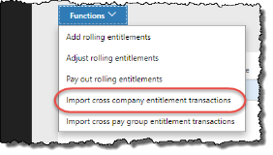
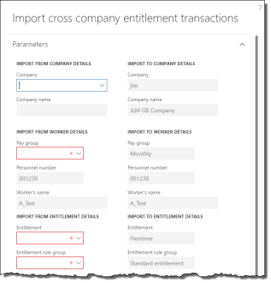
- Click Functions > Import cross company entitlement transactions to open the Import cross company entitlement transactions pane.
- On the Import cross company entitlement transactions pane, select the Company to import transactions from (source).
- Select the Pay group to import from. The entitlement rules for the rolling entitlement must be set up for this pay group in both the source and destination companies.
- Select the Entitlement rule group and the Entitlement to import.
- Specify the Entitlement period year and Entitlement period number of the entitlement to import. The Accruing period will automatically populate. All transactions within this period are imported to the destination company for the worker.
- Click OK to import the entitlement transactions.
When transactions are imported, any payment and earning references on those transactions are automatically removed and the reason code is set to a system-generated reason indicating which company it was imported from.

4.3.9.5 Import Cross-Pay Group Transactions for Rolling Entitlements
When a worker changes pay groups in your organization or if they hold positions in multiple pay groups in the same company, you may need to import their entitlement transactions from one pay group to another, provided that those pay groups use the same rolling entitlement bank. When that worker takes time from their entitlement bank, the transaction should be imported to other pay groups to reflect the worker's current entitlement balance.
To import entitlement transactions from one pay group to another:
- In the navigation pane, click Common > Anthology Payroll workers to open the Anthology Payroll workers list. Select the worker.
- On the ribbon, click Anthology Payroll Profile tab > Entitlements to open the Worker entitlements form.
- On the Worker entitlements form, click Functions > Rolling entitlements to open the Rolling entitlements form.
- On the Rolling entitlements form, re-enter the Worker Id and Pay group.
- Enter the As of date (context date) to view the worker's rolling entitlements. The balances of rolling entitlements are affected by this date. Select the worker's rolling entitlement for which to import transactions.
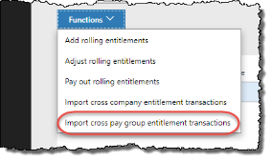
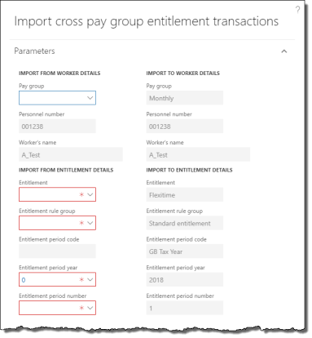
- Click Functions > Import cross pay group entitlement transactions to open the Import cross pay group entitlement transactions pane.
- On the Import cross pay group entitlement transactions pane, select the Pay group to import transactions from (source). The entitlement rules for the rolling entitlement must be set up for both the source and destination pay groups.
- Select the Entitlement rule group and the Entitlement to import.
- Specify the Entitlement period year and Entitlement period number of the entitlement to import. The Accruing period will automatically populate. All transactions within this period are imported to the destination pay group for the worker.
- Click OK to import the entitlement transactions.
When transactions are imported, any payment and earning references on those transactions are automatically removed and the reason code is set to a system-generated reason indicating which pay group it was imported from.

4.3.10 Assign Worker Garnishments
Benefit/deduction codes that are set as garnishments can be assigned to a worker. Garnishments are assigned individually to each worker. Benefit/deduction codes, garnishment types and garnishment sub-types must already be configured prior to assigning and processing garnishments.
When a garnishment deduction is assigned to a worker, their benefit/deductions on the Worker benefit/deductions form are automatically updated to include the garnishment.
To assign a garnishment to a worker:
- In the navigation pane, click Common > Anthology Payroll workers to open the Anthology Payroll workers list. Select the worker in the list.
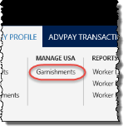
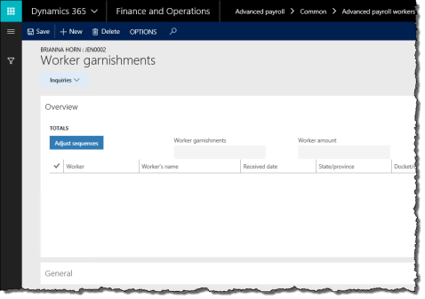
- On the ribbon, click AdvPay Profile tab > Manage USA section > Garnishments to open the Worker garnishments form.
- On the Overview tab, click New to create a new record.
- On the General tab, specify the Garnishment type code and, if applicable, the Garnishment sub-type code.
- Specify the Benefit/deduction code to assign the worker for the garnishment. Select the Benefit/deduction enrollment as applicable to the garnishment type or sub-type.
- The Received date defaults to the current system date and the benefit/deduction Start date defaults to the worker's pay group's current pay period end date. Change the Received date to the actual start date of the garnishment order as needed.
- Enter the following fields as desired or required by the garnishment:
  - Issued by state: if this is a state-level garnishment, enter the state issuing the order
  - Docket/case number: enter the docket or case number for the garnishment for informational and tracking purposes
  - Worker AP vendor: enter the AP vendor for the garnishment deduction if it is different from normal setup
  - AP vendor worker reference: enter any identifying information about the worker or docket number to be included in the transaction postings to AP
  - End date: enter an end date if the garnishment order has a specified end date
  - Note text: enter any additional information as needed
- Specify one of the following to determine the method of how the garnishment amount is calculated:
  - Worker calculation: a calculated amount that takes into account Consumer Credit Protection Act (CCPA) limits and federal/state legislative requirements (e.g.: US CCPA Garnishment)
  - Worker amount: a flat pay period amount that overrides limits
- If you are using a Worker calculation, specify the following parameters around the garnishment amount:
  - Amount type: either a Flat amount to be deducted each pay period or a Percentage of the worker's earnings
  - Pay period amount: if Amount type is Flat amount, enter the flat amount of earnings to be garnished per pay period. If Amount type is Percentage, enter the percentage of earnings to be garnished per pay period. Cannot be used if a Worker amount is entered.
- For garnishment orders that have a maximum total of earnings to be garnished (e.g.: creditor garnishments), enter the Total amount. The garnishment will stop once this limit is reached.
- If this garnishment is one of multiple garnishment orders for this worker, enter the following sequences accordingly. Lower number sequences are executed first:
  - Calculation sequence: the order in which the garnishment amount is calculated
  - Depletion sequence: the order in which the garnishment amount is deducted from the worker's disposable earnings
To set this garnishment to be higher priority sequence than all others, select it, enter 1 for Calculation sequence and click Adjust sequences. All other garnishment sequences are reordered. Alternately, you may set the Calculation sequence to its proper order among other garnishments and click Adjust sequences to reorder all other garnishments that are lower priority respectively.
- Click Save to save your changes.

4.3.10.1 View Garnishment Calculations
Anthology Payroll provides an inquiry that contains details on how it has calculated garnishment amounts depending on how your garnishment types and limits are configured. This inquiry can be used to trace calculations and troubleshoot any incorrect garnishment amounts.
To view garnishment calculations:
- In the navigation pane, click Inquiries > Garnishments to open the Worker garnishments inquiry.
- Locate and select the record containing the worker garnishment you wish to view. Use the filter controls to identify the Worker's name or Docket/case number, or other fields.
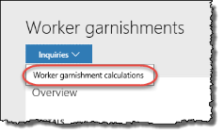
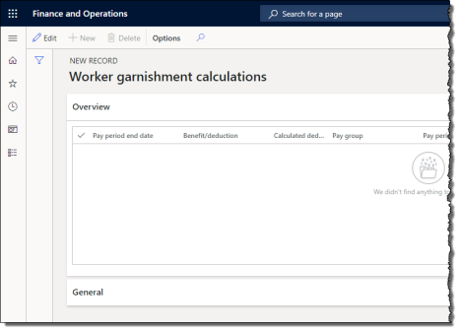
- Click Inquiries > Worker garnishment calculations to open the Worker garnishment calculations inquiry.
- You can view the calculations performed for the selected garnishment according to the Pay period end date. This inquiry shows the following information:
  - Pay period year
  - Pay period number
  - Pay period end date
  - Calculated deduction amount: final amount of the worker's wage garnishment in this pay period
  - Disposable income amount: worker's adjusted amount of disposable income in the pay period after deducting mandatory deductions and the minimum protected amount
  - Amount type: type of garnishment calculation
  - Requested garnishment amount: amount of wage garnishment to be taken in the pay period before accounting for insufficient wages
  - Processing notes: detailed notes on the variable amounts used to calculate the worker's garnishment amount
- Repeat as required for other worker garnishments. Close the form when finished.

4.3.11 Configure Worker Compensation
Anthology Payroll integration with the Human Resources (HR) module can include worker compensation plans, which control how a worker is paid in Anthology Payroll. This functionality is enabled through a general definition parameter in Anthology Payroll and is an implementation design decision for your company. If your implementation uses compensation plans in HR and the functionality is enabled, Anthology Payroll stores no worker salary information and instead reads that information from the HR module.
There are two types of compensation plans in HR, fixed and variable. Anthology Payroll interprets these plans in different ways to generate a worker's earnings:
- fixed compensation plans can be used to configure worker base wages, generated earnings, and wage additions
- variable compensation plans can be used to configure generated earnings
If a worker has multiple active compensation plans set as base wages, Anthology Payroll interprets the worker's salary as the compensation plan with the highest amount plus any compensation plans set as wage additions.
If your implementation of Dynamics and Anthology Payroll does not use compensation plans in the HR module, this section can be ignored.
Ensure that your Dynamics company is configured with the general definition parameter for compensation enabled before proceeding. If the parameter is not enabled, the corresponding Anthology Payroll fields on the compensation forms do not appear.

4.3.11.1 Set up Fixed Compensation Plans
Fixed compensation plans in the HR module can be used to represent a worker's base wages, generated earnings, or wage increases.
This section does include steps on how to set existing fixed compensation plans for Anthology Payroll use. This section does not include steps on how to set up fixed compensation plans in their entirety, as they are highly specific to your implementation of Dynamics and Human Resources.
To set up fixed compensation plans for Anthology Payroll use:
- In the Human resources navigation pane, click Compensation > Fixed compensation > Fixed compensation plans to open the Fixed compensation plans form.
- Select the compensation Plan to set up. Anthology Payroll only supports cash-based compensation types.
- Set the Anthology Payroll use field to one of the following, depending on the plan's use:
  - Base wage: this compensation plan is the worker's base wage salary amount. If a worker has more than one base wage compensation plan, the plan with the highest wage is displayed as their salary on their position form.
  - Generated earning: this compensation is a generated earning and can be used on one or more earning codes for enrolled or non-enrolled generated earnings.
  - Wage addition: this compensation plan represents a wage increase. If a worker has a base wage compensation plan and any wage addition compensation plans, their salary displayed on their position form contains a summation of their highest base wage and all wage additions.
- Click Save to save your changes.

4.3.11.2 Set up Variable Compensation Plans
Variable compensation plans in the HR module can be used to represent a worker's generated earnings and can be used as part of generated earning setup.
For variable compensation plans that are configured as a Percent of basis, the Variable award basis must be Fixed pay rate.
This section does include steps on how to set existing variable compensation plans for Anthology Payroll use. This section does not include steps on how to set up variable compensation plans in their entirety, as they are highly specific to your implementation of Dynamics and Human Resources.
To set up variable compensation plans for Anthology Payroll use:
- In the Human resources navigation pane, click Compensation > Variable compensation > Variable compensation plans to open the Variable compensation plans form.
- Select the compensation Plan to set up. Anthology Payroll only supports cash-based compensation types.
- Set the Anthology Payroll use field to one of the following, depending on the plan's use:
  - Generated earning: this compensation is a generated earning and can be used on one or more earning codes for enrolled or non-enrolled generated earnings.
- If this plan is a Percent of basis plan, set the Percent of basis use field to one of the following:
  - Worker: the worker's compensation from all their positions is summed and then multiplied by the percentage.
  - Position: the worker's primary position's compensation is multiplied by the percentage for worker-level generated earnings. The worker's position's compensation is multiplied by the percentage for position-level generated earnings.
- Click Save to save your changes.
For variable compensation plans that are set to use enrollments, workers must be enrolled in the variable compensation plan in order for the worker's generated earning to use the compensation plan. Additionally, no organizational overrides are permitted for plans that are used in Anthology Payroll apart from the Award amount which is a flat amount.

5 Process Pay
This section contains procedures on how to process regular pay every pay period. Before starting the regular pay process, ensure that you have:
- Updated all worker data

5.1 Regular Pay Processing Tasks
The regular pay process must be run for each pay group according to the appropriate pay period and each step is intended to be run in succession.
All of the necessary functions and forms for processing pay can be accessed from the ribbon on the Pay Groups list. The Pay Groups list is accessed from the navigation pane:
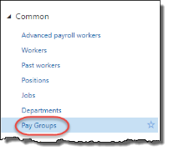
Some dialog boxes for functions in the pay process contain process counts for transactions in previous pay processes in the same pay period. These counts are a quick snapshot of the status of transactions in the current pay period for the function you are currently running. They are intended to provide more visibility into the status of transactions in the current pay period and allow you to quickly identify if anything has changed in an earlier step of the current pay process that you may not be aware of.

5.1.1 Create Time from Rotation
The create time from rotation procedure generates hours from workers with shifts/rotations. Time generated this way is automatically approved. If you have no hourly workers, you can skip to section 5.1.4.
To create time from rotation:
- In the navigation pane, click Common > Pay Groups to open the Pay Groups list. Select the pay group in the list.
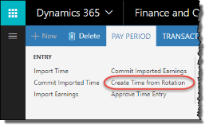
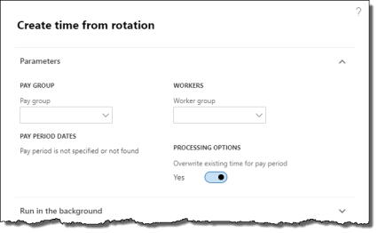
- On the ribbon, click Pay Period tab > Create Time from Rotation to open the Create time from rotation pane.
- In the Create time from rotation pane, ensure the Overwrite existing time for pay period option is checked.
- If required, specify a Worker group to run this process only for a subset of workers in the group for this pay group. This requires worker groups to be configured.
- Click OK to create time records from rotations.
- A popup message appears with a summary of the time records created.

5.1.2 Enter Time for a Worker
Sometimes, time must be entered manually for a worker. Use this procedure to enter exception time, such as overtime, vacation, or unpaid leave. Before time can be entered manually, you must first unapprove the time records that conflict with the exception time as those records were automatically generated and generated time is approved by default.
To unapprove time records:
- In the navigation pane, click Common > Pay Groups to open the Pay Groups list. Select the pay group in the list.
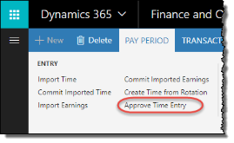
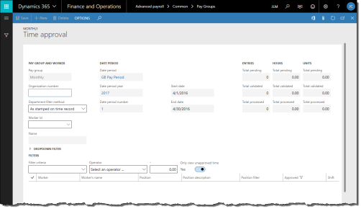
- On the ribbon, click Pay Period tab > Approve Time Entry to open the Time approval journal.
- Verify the End date of the date period corresponds to the desired (current) pay period.
- To view only time records for a specific worker, specify a Worker ID.
- Uncheck the Only view unapproved time option to view all approved time created from the Create time from rotation procedure.
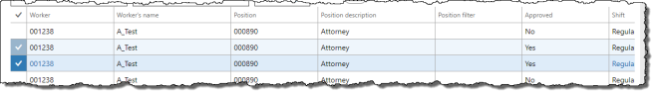
- In the Details pane, select the time records for the dates that you wish to unapprove. These are the time records for which you will modify to capture exception time. Alternatively, click the checkbox at the top-left corner of the Details pane to select all records if there is a possibility you may modify additional ones.
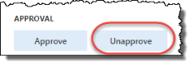
- Click Unapprove to unapprove the selected time.
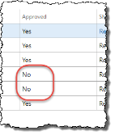
- In the Details pane, verify that the desired time records display No in the Approved field.
- Close the journal.
To enter time manually for a worker:
- On the ribbon, click Transaction tab > Enter Time to open the Worker time journal.
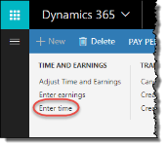
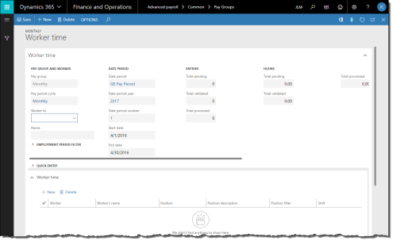
- To view only time records for a specific worker, specify a Worker ID.
- To modify a record, select it and modify the following fields as desired:
  - Shift: change the shift that the worker worked
  - Work date: change the date of the hours worked
  - Start time: change the time of day when the shift started
  - Work hours: change the number of hours the worker worked
NOTE: Only time records that are not approved can be modified.
- To create new time records, click New to create a new record. Specify the following fields for new records:
  - Worker
  - Shift
  - Work date
  - Start time
  - Work hours
NOTE: A popup message will warn you when two time records are in conflict.
- To delete a record, select it and click Delete.
- Repeat as necessary for additional time records.
- Click Save to save your changes.

5.1.3 Approve Time
Skip this step if you did not unapprove time or manually enter any time records.
To approve time:
- In the navigation pane, click Common > Pay Groups to open the Pay Groups list. Select the pay group in the list.
- On the ribbon, click Pay Period tab > Approve Time Entry to open the Time approval journal.
- By default, the Time approval journal shows all unapproved time for the current pay period in the Details pane. Verify the time records are accurate.
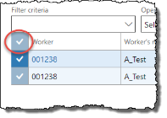
- By default, all unapproved time is already selected. If required, select all unapproved time records by clicking the checkbox in the top-left corner of the Details pane.
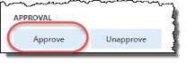
- Click Approve to approve all selected time records.
- Close the form.

5.1.4 Create Earnings from Time Records
The Time to earnings process creates the necessary earnings records from approved time records. This process also creates earnings for salaried workers. Earnings records are required to calculate pay.
To create earnings from time records:
- In the navigation pane, click Common > Pay Groups to open the Pay Groups list. Select the pay group in the list.
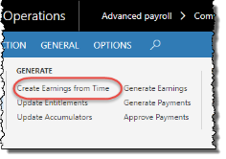
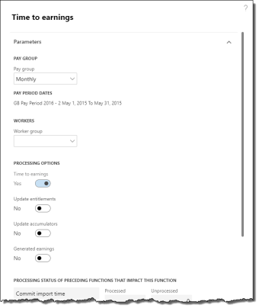
- On the ribbon, click Pay Period tab > Create Earnings from Time to open the Time to earnings pane.
- Verify the Pay period dates are accurate.
- If required, specify a Worker group to run this process only for a subset of workers in the group for this pay group. This requires worker groups to be configured.
- The Time to earnings option is automatically selected. Do not select any other options.
- If this process creates earning transactions from time transactions that have dimension and/or project values:
- Setting the Dimensions Override Organization Splits field to Yes:
- Uses values from the time transactions for earning transactions.
- Applies even if there is a relevant organization split for the worker's position assignment, position, or worker.
- Setting the Dimensions Override Organization Splits field to No:
- Uses values from the organization split for earning transactions.
- Ignores values from the time record.
- Ensure that there are no unprocessed records in previous pay processes. Click OK to create the earnings records.
- A popup message appears with a summary of the earnings records created.

5.1.5 Enter Earnings Manually
Some earnings must be entered manually as they are not part of regular earnings. For example, earnings that represent expenses and job allowances must be entered manually for a specific worker on any given pay period.
This step also describes how to review earning records before processing them. Existing earning records can also be modified provided that accumulators have not yet been updated for this pay period (see section 5.1.6).
To enter earnings manually:
- In the navigation pane, click Common > Pay Groups to open the Pay Groups list. Select the pay group in the list.
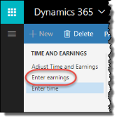
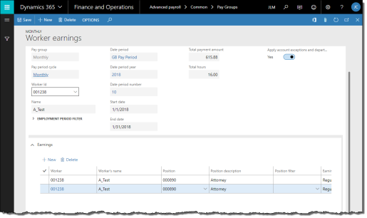
- On the ribbon, click Transaction tab > Enter Earnings to open the Worker earnings journal.
- To view only earning records for a specific worker, specify a Worker ID.
- Change the Rate of pay if the earning is to be paid a different rate for them.
- See the following sub-procedures according to the type of earning.

5.1.6 Update Entitlements, Accumulators, and Generated Earnings
The next step in the payroll process is to update entitlements, accumulators, and generated earnings. After this step is performed, time and earning records can no longer be directly modified—changes to time or earning records must be made in the Time/earning adjustments journal where changes are recorded using effective dating.
To update entitlements, accumulators, and generated earnings:
- In the navigation pane, click Common > Pay Groups to open the Pay Groups list. Select the pay group in the list.
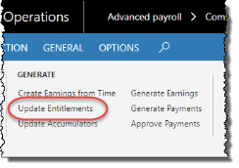
- On the ribbon, click Pay Period tab > Update Entitlements to open the Entitlement updates pane.
- Verify the Pay period dates are accurate.
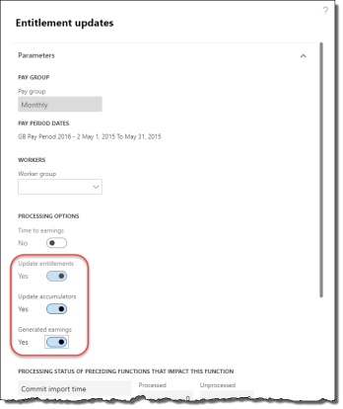
- The Update entitlements option is automatically selected. Select the Update accumulators and Generated earnings options.
- If required, specify a Worker group to run this process only for a subset of workers in the group for this pay group. This requires worker groups to be configured.
- Ensure that there are no unprocessed records in previous pay processes. Click OK to update entitlements, accumulators, and generated earnings.
- A message popup appears with a summary of the updates.

5.1.7 Check accumulated amounts
If your implementation is configured with the benefit/deductions and generated earnings checks that detect whether workers have been properly assigned the correct benefit/deduction codes and generated earnings enrollments based on their accumulator values in the pay period, you can run this process to perform the validation. This process checks the workers' accumulated amounts against your benefit/deduction and generated earnings setup to ensure that workers have been assigned the proper benefit/deductions and generated earnings they have accumulated amounts for, and returns a warning when this assignment is missing.
This step is optional during the pay process, but your system may be configured to make this checking step mandatory. This process requires that benefit/deductions and generated earnings checks be configured first.
To check accumulated amounts:
- In the navigation pane, click Common > Pay Groups to open the Pay Groups list. Select the pay group in the list.
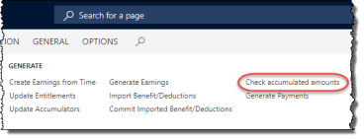
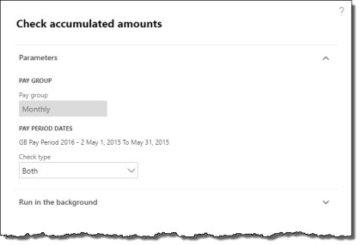
- On the ribbon, click Pay Period tab > Check accumulated amounts to open the Check accumulated amounts pane.
- Verify the Pay period dates are accurate.
- To check only Benefit/deductions or Generated earnings, select the appropriate option in the Check type field. Otherwise, to check both, leave the option as Both.
- Click OK to check accumulated amounts.
If exceptions were found during the checking process, you must pause the pay process and update worker benefit/deductions and/or generated earnings enrollments (see section 4.3) before proceeding with payment generation. This setup is done on the Worker benefit/deductions and Generated earning enrollments forms.

5.1.8 Assess Local Taxes
Depending on where your workers reside and where they work, you may withhold local taxes as part of the pay process. Local taxes withholding is optional for employers and your implementation of Anthology Payroll must be configured for it before this procedure will function.
Anthology Payroll uses a tax calculation engine web service provided by Symmetry Software to look up local tax rates for workers according to their addresses. Local taxes are then automatically withheld as deductions on the worker's pay statement.
To assess local taxes for a pay group:
- In the navigation pane, click Periodic > Pay Period > Local taxes assessment to open the Local taxes assessment pane.
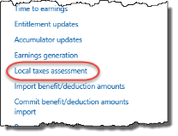
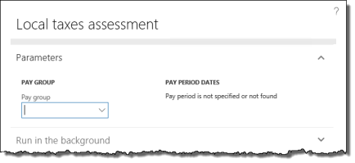
- Specify the Pay group to assess. Verify the Pay period dates are accurate.
- Click OK to assess local taxes for the selected pay group in the current pay period.
- A message popup appears with a summary of the updates.
The local tax assessment procedure creates many Anthology Payroll objects automatically. Some of these objects require additional setup information before they can be processed correctly. The local tax assessment procedure does the following:
- create benefit/deduction codes for the local taxes applicable
- add the local tax benefit/deduction codes to the US Local Taxes benefit/deduction group
- create earning groups for the local taxable earnings for each state assessed. The earning group names are XX Local Taxable Inc, where XX is the 2-character state identifier.
- add applicable earnings to the created earning groups. Eligible earnings are based on the state's taxable earnings accumulator.
- create local tax type rule group record and local tax code
- schedule a one-time deduction for each worker and each local tax in the current pay period
If this is the first time you are assessing local tax or you have hired new workers in states that have local taxes since the last time you assessed local tax, you must update the newly created benefit/deduction codes with the correct GL accounts for deductions that withhold employer-paid amounts. See next section.
At this point, it is recommended to view the Pay period benefit/deduction schedules form (Setup > Tables > Schedules > Pay period benefit/deductions) and verify that the correct local taxes were created for your workers. If there are any errors, you must update the worker's home address (see section 4.2.1) or work address (see section 4.1.1) and then run the local tax assessment again. If you have already processed payment with incorrect local taxes, please see section 5.2.9.

5.1.8.1 Set Accounting Information for Local Tax Benefit/deductions
You only need to complete this step if you assessed local taxes and it is either the first time you assessed local taxes or you have hired new workers in states where you withhold local taxes since the last time you assessed them. Additionally, you only need to set accounting information for local taxes where there is an employer-paid amount. Otherwise, this procedure can be skipped.
If you do not have the proper permissions to access the following functions, please contact your superuser or implementer for assistance.
To set accounting information for local tax benefit/deductions:
- In the Anthology Payroll navigation pane, click Setup > Tables > Benefit/deductions > Benefit/deductions to open the Benefit deductions form.
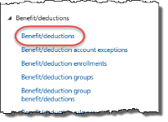
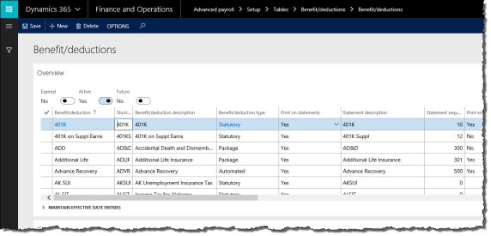
- On the Overview tab, locate and select the local tax Benefit/deduction that was created as part of the local tax assessment process. The benefit/deduction codes are in the following format:
XX TR <region name> <region code>
  - XX: 2-character state identifier
  - T: type of local tax (C for county, M for municipality, S for school district, E for earned income, L for local services, O for other)
  - R: R for resident tax, N for non-resident tax
  - <region name>: 6-character tax region name
  - <region code>: 7-digit region numeric code
- On the General tab, enter accounting information for each deduction code as needed.
- Click Save to save your changes.

5.1.9 Generate Payments
The next step is generating payments. Payment generation involves calculating gross earnings, total deductions, and net earnings.
To generate payments:
- In the navigation pane, click Common > Pay Groups to open the Pay Groups list. Select the pay group in the list.
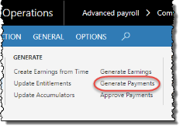
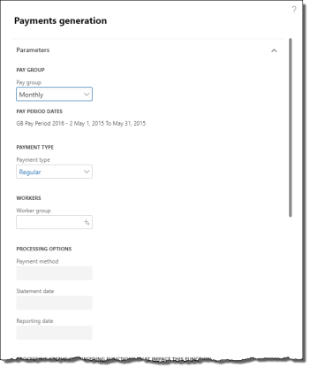
- On the ribbon, click Pay Period tab > Generate Payments to open the Payments generation pane.
- Verify the Pay period dates are accurate.
- If required, specify a Worker group to run this process only for a subset of workers in the group for this pay group. This requires worker groups to be configured.
- If you set a Worker group, you can change the Payment method, Statement date, and Reporting date as desired. These will override the defaults for this pay group and pay period. The standard validation rules apply for the Statement date and Reporting date.
- Leave the Payment type as Regular.
- Ensure that there are no unprocessed records in previous pay processes. Click OK to generate payments.

5.1.10 Print Pay Register
After generating payments, the pay register can be printed and reviewed. The pay register contains the pay details of every payment generated for every worker in the pay group. This step is optional.
To print the pay register:
- In the navigation pane, click Common > Pay Groups to open the Pay Groups list. Select the pay group in the list.
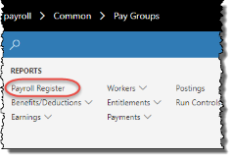
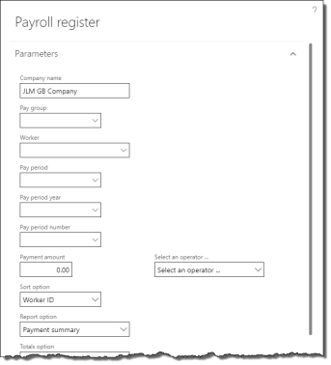
- On the ribbon, click General tab > Payroll Register to open the Payroll register pane.
- By default, the current pay period is selected. Change the Pay period year and Pay period number to change which pay period to display.
- Select a Sort option to change how records are ordered in the report.
- Select an appropriate Report option as desired to display totals and summary information on the report.
- Select a Totals option to include or exclude displaying zero-value payments in the report.
- Click OK to view the report.
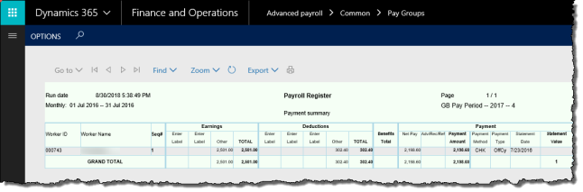
- In the report window, you can choose to print or export the report to another format (MS Word or Excel, for example).
- Review the pay register and verify the accuracy of the payments and deductions. Totals by pay element are on the final pages.
- Close the report window.

5.1.11 Approve Payments
When the payments are accurate, the following payment approval processes can be completed:
- create bank information, such as direct deposit EFT files
- prepare pay statements and generate payment print history
- produce worker check and direct deposit pay statement reports for the pay group
- produce individual check and direct deposit pay statements for specific workers (optional)

5.1.11.1 Create Bank Information
This payment approval process creates the EFT file for direct deposit payments. The EFT file can be submitted to your company's financial institution as a separate process.
To produce payments for individual workers, see section 5.1.11.4.
This function cannot be run as a batch process.
To create bank information:
- In the navigation pane, click Common > Pay Groups to open the Pay Groups list. Select the pay group in the list.
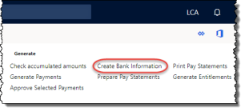
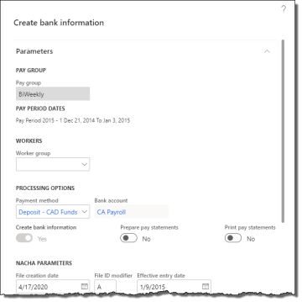
- On the ribbon, click Pay Period tab > Create Bank Information to open the Create bank information pane.
- If required, specify a Worker group to run this process only for a subset of workers in the group for this pay group. This requires worker groups to be configured.
- Specify the Payment method. The payment method must be a direct deposit method.
- To run subsequent payment approval processes after creating the bank file, select the Prepare pay statements and Print pay statements functions as desired. These are optional and can be run separately.
- If you selected a direct deposit payment method, change any of the following NACHA parameters as desired:
  - File creation date: date and time stamp of the EFT file. This is typically the current date. This date must be in the current pay period.
  - File ID modifier: NACHA file ID modifier located in the file header at position 34. Can be numeric or alphabetic. Used to differentiate between multiple files transmitted on the same day.
  - Effective entry date: NACHA file effective date included in the file header.
- Click OK to produce the bank file.
To download the direct deposit export file to your local computer, see section 5.1.12.

5.1.11.2 Prepare Pay Statements
This payment approval process populates the payment print history for each worker in the pay group and prepares their pay statements for printing.
To produce payments for individual workers, see section 5.1.11.4.
This function can be run as a batch process for off-loaded processing and improved performance.
To prepare pay statements:
- In the navigation pane, click Common > Pay Groups to open the Pay Groups list. Select the pay group in the list.
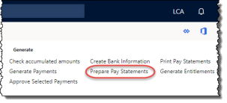
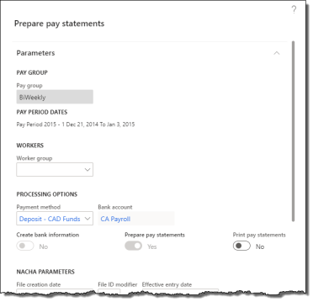
- On the ribbon, click Pay Period tab > Prepare Pay Statements to open the Prepare pay statements pane.
- If required, specify a Worker group to run this process only for a subset of workers in the group for this pay group. This requires worker groups to be configured.
- Specify the Payment method.
- To run subsequent payment approval processes after preparing pay statements, select the Print pay statements functions as desired. This is optional and can be run separately.
- If you selected a direct deposit payment method, change any of the following NACHA parameters as desired:
  - File creation date: date and time stamp of the EFT file. This is typically the current date. This date must be in the current pay period.
  - File ID modifier: NACHA file ID modifier located in the file header at position 34. Can be numeric or alphabetic. Used to differentiate between multiple files transmitted on the same day.
  - Effective entry date: NACHA file effective date included in the file header.
- Click OK to prepare the necessary back-end data for the pay group's payments for the pay period.

5.1.11.3 Print Payments for a Pay Group
Payments can only be printed after they have been prepared. Payments can be printed for an entire pay group at once, or individually.
To produce payments for individual workers, see section 5.1.11.4.
This function cannot be run as a batch process.
To print check or direct deposit payments:
- In the navigation pane, click Common > Pay Groups to open the Pay Groups list. Select the pay group in the list.
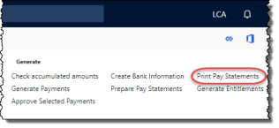
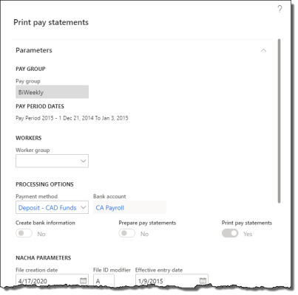
- On the ribbon, click Pay Period tab > Print Pay Statements to open the Print pay statements pane.
- If required, specify a Worker group to run this process only for a subset of workers in the group for this pay group. This requires worker groups to be configured.
- Specify the Payment method.
- If you selected a direct deposit payment method, change any of the following NACHA parameters as desired:
  - File creation date: date and time stamp of the EFT file. This is typically the current date. This date must be in the current pay period.
  - File ID modifier: NACHA file ID modifier located in the file header at position 34. Can be numeric or alphabetic. Used to differentiate between multiple files transmitted on the same day.
  - Effective entry date: NACHA file effective date included in the file header.
- Click OK to print the pay statements. If you selected a check-based payment method, the Check print pane appears. If you selected a direct deposit-based payment method, the Direct deposit print pane appears.
- Verify the Bank account and click OK to print the pay statements to your desired format according to your printer settings.

5.1.11.4 Approve Selected Payments
Anthology Payroll provides a journal for approving individual payments and producing the associated EFT files or checks and pay statements. This journal can also be used to reprint and retransmit check and direct deposit pay statements respectively.
If you have already created the bank file and printed payments for the entire pay group, you do not need to approve payments individually and can skip this procedure.
To approve individual payments for specific workers:
- In the navigation pane, click Common > Pay Groups to open the Pay Groups list. Select the pay group in the list.
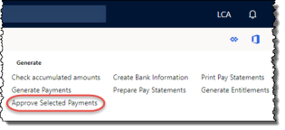
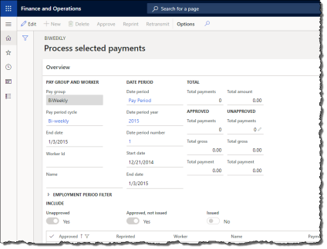
- On the ribbon, click Pay Period tab > Approve Selected Payments to open the Process selected payments journal.
- Select records to approve and process, as desired. All selected records must be of the same payment method (check or direct deposit). If you selected check-based payments, the Check print pane appears. If you selected direct deposit-based payments, the Direct deposit print pane appears.
- Verify the Bank account and click OK to approve the payments. Check-based payments can be printed from a print dialog. Direct deposit-based payments produce an EFT bank file and the pay statements can be printed from a print dialog.
- If your implementation is set up to email direct deposit PDF files, this procedure creates the files and distributes them according to your setup. You may still be prompted to print pay statements in the event that workers do not have email addresses set up or any email addresses are incorrect.
To download the direct deposit export file to your local computer, see section 5.1.12.

5.1.12 Download Files to Local Network
Export files (XML, CSV, etc.) that are produced by Anthology Payroll are typically stored on the server in a pre-configured location. In Dynamics 365, the server may be located on the cloud and not easily accessible. Instead, you can download the export files through the browser to your local environment and process them further.
To download export files to your local computer:
- In the navigation pane, click Periodic > Download files to local network to open the Download files to local network form.
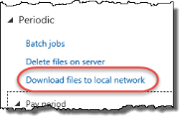
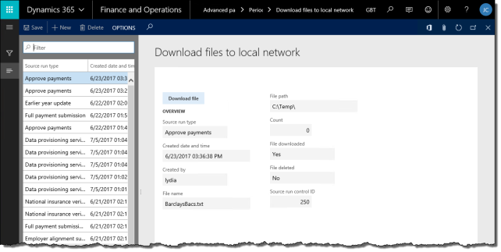
- In the list, locate and select the direct deposit file you just created.
- Click Download file to download the file to your local computer through the browser. File or export this file according to your implementation's requirements.

5.1.13 Export Pay Statements
Skip this step if you are not subscribed to the online payslip distribution service provided by Greenshades.
If you are subscribed to the online payslip distribution service provided by Greenshades, you can export the pay statements in XML format to the Greenshades Sync Server, which synchronizes the pay statement data to greenshadesonline.com. You must have already set up your Greenshades Sync Server in advance as Anthology Payroll only generates the XML file for synchronization.
To export pay statements:
- In the navigation pane, click Periodic > Pay period > Export pay statements to open the Export pay statements pane.
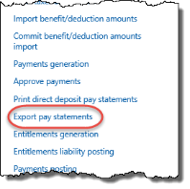
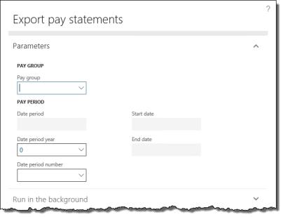
- Specify the Pay group.
- Select the Date period year. The current Date period number is automatically selected.
- Click OK to generate the pay statement data in XML format.
To download the direct deposit export file to your local computer, see section 5.1.12.

5.1.14 Generate Entitlements
After payments are approved, you can increment and update entitlements in preparation of the next pay period.
To generate entitlements:
- In the navigation pane, click Common > Pay Groups to open the Pay Groups list. Select the pay group in the list.
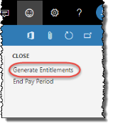
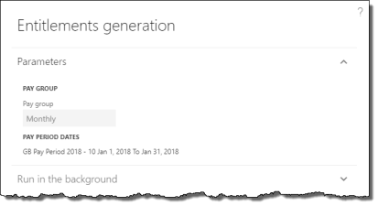
- On the ribbon, click Pay Period tab > Generate Entitlements to open the Entitlements generation pane.
- Click OK to generate entitlements.
- A popup message appears with a summary of the entitlements generated.

5.1.15 Post Payments, Liability, Benefits, and AP Invoice
When one or more payments have been approved in the current pay period, you must post the payment and benefits information to the General ledger and the benefits information to Accounts payable before you are able to close the pay period. Additionally, if your entitlements are set up to generate liabilities, they must also be posted to the General ledger. Transactions do not appear in the general ledger or accounts payable until they are approved.
To post payments, liability, benefits, and AP invoice:
- In the navigation pane, click Common > Pay Groups to open the Pay Groups list. Select the pay group in the list.
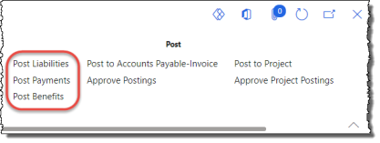
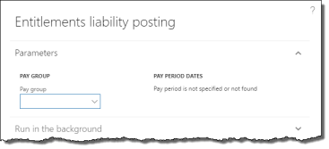
- On the ribbon, click Pay Period tab > Post Liabilities to open the Entitlements liability posting pane.
- Select the additional posting processes as desired to run them all in sequential order. Select Payments posting, Benefits posting, AP invoice posting, and Project posting as needed.
- Ensure that there are no unprocessed records in previous pay processes. Click OK to prepare transaction postings for the General Ledger and Accounts Payable. A popup message appears with a summary of the postings.

5.1.16 Approve Postings
Postings must be approved before they appear in the General ledger and Accounts payable modules.
To modify transaction postings before approving them, see section 5.2.11.
To approve postings:
- In the navigation pane, click Common > Pay Groups to open the Pay Groups list. Select the pay group in the list.
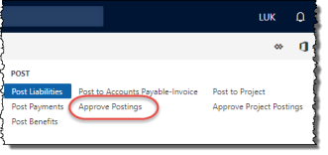
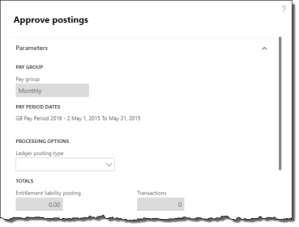
- On the ribbon, click Pay Period tab > Approve Postings to open the Approve postings pane.
- Specify the Ledger posting type to indicate which transactions to post. To post all types, leave this field blank. Review the Totals and verify they are accurate.
- Ensure that there are no unprocessed records in previous pay processes. Click OK to approve the postings.
- Repeat as required for other Ledger posting types.
Pay processing is now complete. If you have implemented the Project management and accounting module, you may proceed to approving project postings.

5.1.17 Post to Project
If your implementation is configured with project integration, earning transactions should be posted to the Project management and accounting module. First, project posting transactions must be generated and then approved to be transmitted to the other module. Project postings require a separate approval process.
If you have already completed this function as part of other transaction postings generated previously, you can skip this procedure.
To post transactions to project journals:
- In the navigation pane, click Common > Pay Groups to open the Pay Groups list. Select the pay group in the list.
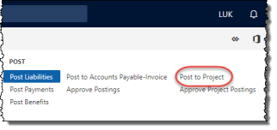
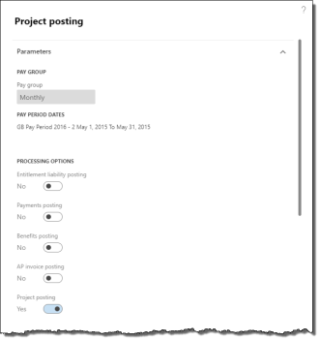
- On the ribbon, click Pay Period tab > Post to Project to open the Project posting pane.
- Click OK to post earning transactions to projects. A popup message appears with a summary of the postings.
All hours-based earnings are posted to the hours journal. All unit-based and amount-based earnings are posted to the expenses journal.
Any invalid information in worker earnings or deductions logs an exception during this process. An exception does not prevent the project posting transaction from being created, but it must be corrected before it can be approved by the following procedure. Corrections to project postings may be done in the Project postings journal.

5.1.18 Approve Project Postings
After generating project posting transactions, they must be approved before they are posted to the Project management and accounting module. Any exceptions generated during the previous process can be corrected before approval. If you have not yet generated project posting transactions, see the final step in section 5.1.15.
To modify project posting transactions before approving them, see section 5.2.12.
To approve project postings and create associated vouchers and journals:
- In the navigation pane, click Common > Pay Groups to open the Pay Groups list. Select the pay group in the list.
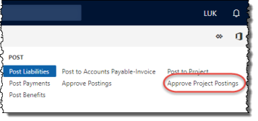
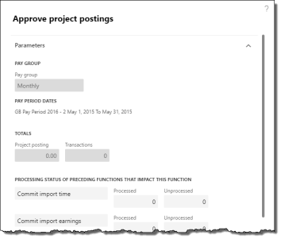
- On the ribbon, click Pay Period tab > Approve project postings to open the Approve project postings pane.
- Review the Totals and verify they are accurate.
- Ensure that there are no unprocessed records in previous pay processes. Click OK to post all the project transactions for the specified period to the Project management and accounting module, creating the necessary vouchers and journals. A popup message appears with a summary of the postings.

5.1.19 Close Pay Period
As the final step in the pay process, you must close the current pay period and start the next.
- In the navigation pane, click Common > Pay Groups to open the Pay Groups list. Select the pay group in the list.
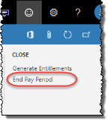
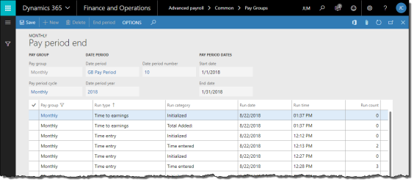
- On the ribbon, click Pay Period tab > End Pay Period to open the Pay period end journal. If the pay period is not yet ready to be closed, a number of exceptions may be logged and displayed.
- The form shows a summary of the tasks taken during this pay period. The tasks can be reviewed as desired. If the End period button is greyed out, there are still outstanding tasks that must be completed before the pay period can be closed.
- Click End period to close the current pay period and start the next one.

5.2 Occasional Pay Processing Tasks
This section describes pay processing tasks that are occasionally performed outside of the regular pay period processing.

5.2.1 Issue a Manual (Off-Cycle) Payment
In certain cases, a manual payment must be issued to a worker outside of a normal pay process. Usually, these payments involve non-standard payments like bonuses, refunds or corrections. They can also be used to issue regular pay early to a terminated worker. Manual payments can only be issued to one worker at a time.
Before issuing a manual payment, any exception time or earning records must be entered manually for the worker in question. For exception time, see section 5.1.2. For exception earnings, see section 5.1.5.
To issue a manual payment:
- In the navigation pane, click Common > Pay Groups to open the Pay Groups list. Select the pay group to which the worker belongs.
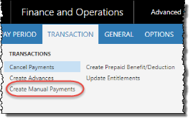
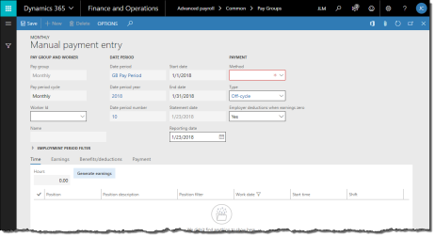
- On the ribbon, click Transaction tab > Create Manual Payments to open the Manual payment entry journal.
- Specify the Worker ID.
- Change the Reporting date if this payment is to be reported in a different pay period.
- Change the payment Method and Type as required. The Type indicates which earnings and benefit/deductions are processed by the payment (i.e.: Off cycle).
- If TimeLogiq scheduling is implemented, you can click the Import time from TimeLogiq button to bring time in from TimeLogiq. This populates the Time tab with the worker's time records recorded in the TimeLogiq scheduling module.
- For hourly workers, review the time records displayed in the Time tab.
NOTE: If any of the time records are incorrect, you must correct them in the Worker time journal (section 5.1.2) or the Time/earning adjustments journal (section 5.2.3)
- Click Generate earnings to create earning records.
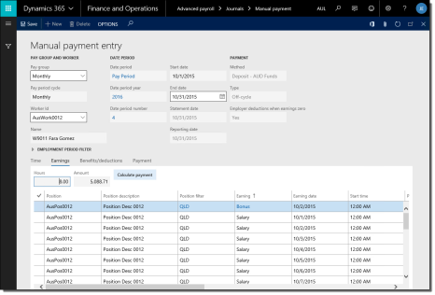
- Review the earnings records on the Earnings tab.
NOTE: If any of the earning records are incorrect, you must correct them in the Worker earnings journal (section 5.1.5) or the Time/earning adjustments journal (section 5.2.3).
- On the Earnings tab, if this worker works in a state where you withhold local taxes, click Local tax assessment to assess this worker for local taxes.
NOTE: if the local tax assessment creates new benefit/deduction codes that you have never withheld before and those deductions have employer-paid amounts, you must enter the accounting information for those codes prior to posting transactions for this payment. See section 5.1.8.1.
- On the Earnings tab, click Calculate payment to apply benefits and deductions to the earnings and produce a payment.
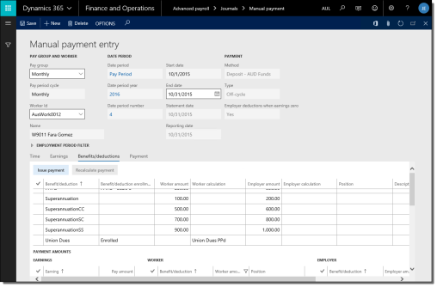
- Review the benefit/deductions on the Benefits/deductions tab. You can override benefit/deductions for this payment by modifying existing records, deleting, or adding new records. If you changed or added any benefit/deductions, you must click Recalculate payment to refresh the results.
- Click Issue payment to create the manual payment.
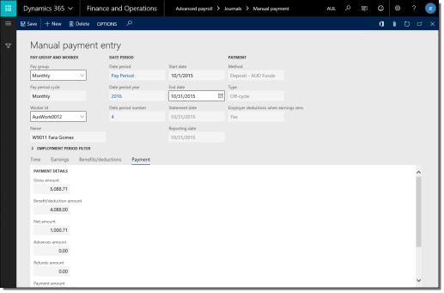
- Review the gross-to-net results on the Payment tab.
After the manual payment has been issued, it must be approved to generate a pay statement/check/direct deposit file. You can approve it immediately (section 5.1.11) or wait until the next pay period process.

5.2.2 Import Time and Shift Information
Depending on how your implementation is configured, you may need to import time transactions from a time and attendance system to Anthology Payroll for the purposes of processing pay. Anthology Payroll accepts imports in comma-separated values (CSV) format. The first line in the CSV should contain column headers. At minimum, the import file must contain: worker identification (e.g.: Worker ID), date information, number of hours worked or units produced, and a shift code.
NOTE: ensure that the last line in your import file is an empty row or the last record may not import correctly.
Please refer to 9.4 Appendix D: List of Time Import File Fields for a reference of the columns required in the import file. For more information on importing time, refer to the Import Time into Anthology Payroll whitepaper provided by Anthology Inc.
If you have implemented TimeLogiq scheduling alongside Anthology Payroll, this function is also how you bring in time records from TimeLogiq for pay processing in Anthology Payroll.
To import time transactions from a CSV file:
- Generate a spreadsheet containing the time transactions according to the required format and save it as a CSV file to the local disk.
- In the navigation pane, click Common > Pay Groups to open the Pay Groups list. Select the pay group in the list.
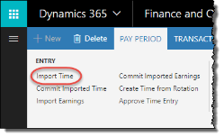
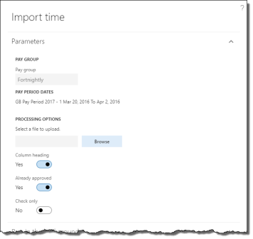
- On the ribbon, click Pay Period tab > Import Time to open the Import time pane.
- If TimeLogiq (formerly StaffRight) scheduling is implemented, deselect the Use TimeLogiq option that is checked by default.
- Browse for the file and select the time spreadsheet.
- Deselect Already approved if you want to manually approve the time transactions in a separate process after the import.
- Click Check only if you only want to verify that the import file is valid and do not want to import the time records.
- Click OK to import the time transactions.
To import time transactions from TimeLogiq scheduling:
- In the navigation pane, click Common > Pay Groups to open the Pay Groups list. Select the pay group in the list.
- On the ribbon, click Pay Period tab > Import Time to open the Import timepane.
- Check the Use TimeLogiq option to import time records from TimeLogiq.
- Specify an Import option of the type of time transactions to import from TimeLogiq.
- If desired, specify a Worker to import time for an individual worker from TimeLogiq.
- If desired, specify a Worker group to import time for a specific group of workers from TimeLogiq. This requires worker groups to be configured.
- Click OK to import the time transactions.
After importing time, you must commit them to Anthology Payroll. The commit process also gives you a chance to change or remove records if they were imported in error. To commit imported time:
- In the navigation pane, click Common > Pay Groups to open the Pay Groups list. Select the pay group in the list.
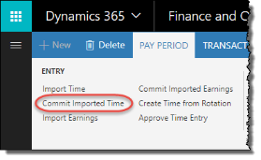
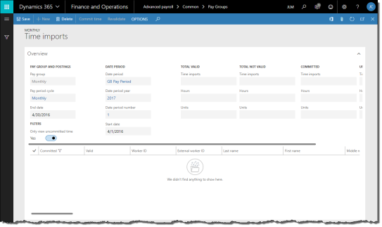
- On the ribbon, click Pay Period tab > Commit Imported Time to open the Time imports journal.
- By default, all uncommitted time transactions are selected. Review the imported time records as desired and deselect the time that you do not want committed. Make any necessary edits to individual time records. You may even delete any records that you do not want to keep. Click Revalidate to save your changes.
NOTE: records imported by the Anthology Payroll API (application programming interface) cannot be deleted in this journal.
- Click Commit time to save the imported time to Anthology Payroll. Close the form.
After committing the time transactions, you can view them or modify them as desired. The procedure to do this is described in section 5.1.2. After making any necessary modifications, imported time can be processed just like time generated from rotations. Proceed with the normal pay process or issue a manual payment for affected workers (section 5.2.1).

5.2.3 Adjust Time or Earnings after Pay is Processed
When an adjustment (re: correction) must be made to time or earnings after accumulators have been updated (section 5.1.6) or the pay period has closed (section 5.1.19), you must use the Time/earnings adjustments form to properly track the change.
To adjust time or earnings after pay has been processed:
- In the navigation pane, click Common > Anthology Payroll workers to open the Anthology Payroll workers list. Select the worker in the list.
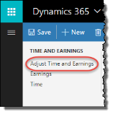
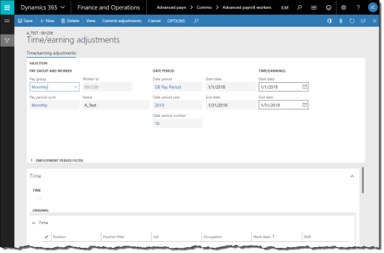
- On the ribbon, click Anthology Payroll Transactions tab > Adjust Time and Earnings to open the Time/earning adjustments journal.
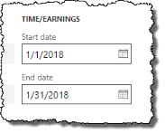
- In the Time/Earnings section, specify a date range of the pay period in which the correction must be made.
- If the worker has time records:
  - On the Time tab, click View to view the worker's time for that pay period.
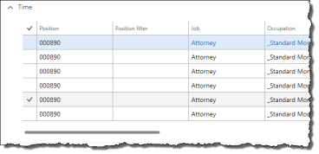
  - Identify any time records that must be corrected. Change the appropriate fields. The affected fields may be any of the following:
    - Work date
    - Shift
    - Start time
    - Work hours
  - Alternatively, you can click New to create a new record and update the above fields.
  - When changes are made to time records, the changes to records appear in the Adjusted pane.
- If the worker has earning records:
  - On the Earnings tab, click View to view the worker's earnings for that pay period.
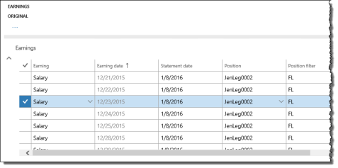
  - Identify any earnings that must be corrected. Change the appropriate fields. The affected fields may be any of the following:
    - Earning
    - Earning date
    - Hours
    - Rate of pay
    - Pay amount
    - Task if US work addresses are associated with tasks
    - Project if US work addresses are associated with projects
  - Alternatively, you can click New to create a new record and update the above fields.
  - When changes are made to earning records, the changes to records appear in the Adjusted pane.
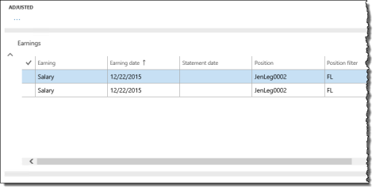
- Verify that the appropriate records are changed in the Adjusted pane of the form.
- If necessary, click Cancel to clear the form and start over. When complete, click Commit adjustments to save your changes. Close the form.

5.2.4 Import and Process Bonus Earnings
Bonus earnings can be imported into Anthology Payroll through a comma-separated values (CSV) file and then processed separately from regular pay. The first line in the CSV should contain column headers. At minimum, the import file must contain: worker identification (e.g.: Worker ID), date information, earning amount, and earning code.
Please refer to 9.3 Appendix C: List of Earnings Import File Fields for a reference of the columns required in the import file. For more information on importing earnings, refer to the Import Earnings into Anthology Payroll whitepaper provided by Anthology Inc.
It is recommended to process bonuses after a regular pay run. Taxes on bonus earnings typically depend on the worker's pay period salary to derive the annual salary amount.
To import bonus earnings from a CSV file:
- Generate a spreadsheet containing the bonus earnings according to the required format and save it as a CSV file to the local disk.
- In the navigation pane, click Common > Pay Groups to open the Pay Groups list. Select the pay group in the list.
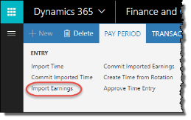
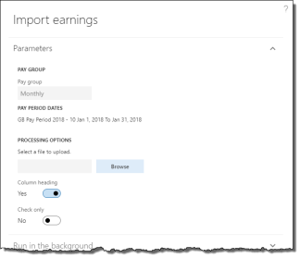
- On the ribbon, click Pay Period tab > Import Earnings to open the Import earnings pane.
- Browse for the file and select the bonus earnings spreadsheet.
- Click Check only if you only want to verify that the import file is valid and do not want to import the earnings records.
- Click OK to import the bonus earnings.
After importing the earnings, you must commit them to Anthology Payroll. The commit process also gives you a chance to change or remove earnings if they were imported in error. To commit imported earnings:
- In the navigation pane, click Common > Pay Groups to open the Pay Groups list. Select the pay group in the list.
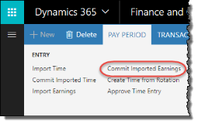
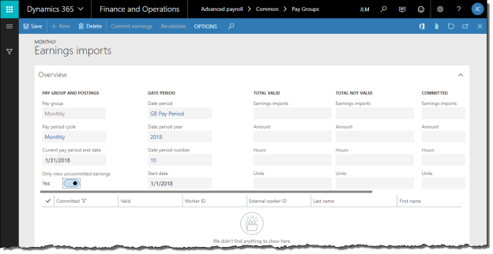
- On the ribbon, click Pay Period tab > Commit Imported Earnings to open the Earnings imports journal.
- By default, all uncommitted earnings are selected. Review the imported earning records as desired and deselect the earnings that you do not want committed. Make any necessary edits to individual earning records. You may even delete any records you do not want to keep. Click Revalidate to save your changes.
NOTE: records imported by the Anthology Payroll API (application programming interface) cannot be deleted in this journal.
- If the imported earning records have dimension and/or project values:
- Setting the Dimensions Override Organization Splits field to Yes:
- Uses values from the import records for earning transactions.
- Applies even if there is a relevant organization split for the worker's position assignment, position, or worker.
- Setting the Dimensions Override Organization Splits field to No:
- Uses values from the organization split for earning transactions.
- Ignores values from the import record.
- Click Commit earnings to save the imported earnings to Anthology Payroll. Close the journal.
After committing the earnings, you can view them or modify them as desired. The procedure to do this is described in section 5.1.5. Imported earnings can be processed just like regular pay period earnings.
To process bonus earnings:
- Update accumulators and entitlements (section 5.1.6).
NOTE: Do not update generated earnings unless the regular pay process has completed. This may cause generated earnings to generate twice if the bonus earnings are processed before regular pay.
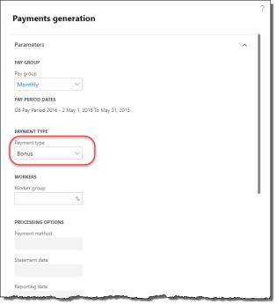
- Generate payments (section 5.1.9) and select a Payment type of Bonus.
- If required, specify a Worker group to run this process only for a subset of workers in the group for this pay group. This requires worker groups to be configured.
- If you set a Worker group, you can change the Payment method, Statement date, and Reporting date as desired. These will override the defaults for this pay group and pay period. The standard validation rules apply for the Statement date and Reporting date.
- Continue with the rest of the payroll process from section 5.1.9 onwards to print checks, submit direct deposits and post transactions to other AX modules.

5.2.5 Correct Direct Deposit Errors
Occasionally, a worker may inadvertently provide incorrect direct deposit information and this is not discovered until payments are generated or the electronic funds transfer (EFT) file is submitted to the financial institution and an error report is returned. To resolve this, you must cancel the original payment, correct the bank account information and create a manual payment and approve it, and obtain and submit the new EFT file. If the error is discovered before the EFT has been submitted to the financial institution, there is no need to issue a manual payment.
To correct direct deposit errors:
- In the navigation pane, click Common > Pay Groups to open the Pay Groups list. Select the pay group in the list.
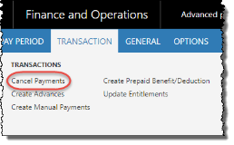
- On the ribbon, click Transaction tab > Cancel Payments to open the Cancel payments journal.
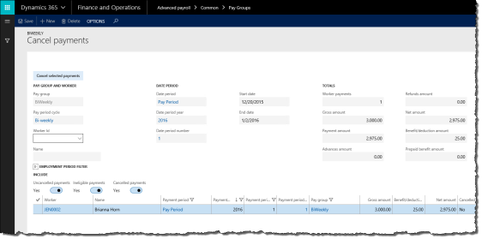
- On the Cancel payments journal, specify the Worker ID of the worker in question.
- If desired, filter the list of payments by Uncancelled payments, Ineligible payments, or Cancelled payments.
- Select the worker's payment and click Cancel selected payments to revert payment. A popup message appears with a summary of the cancelled payment.
- See section 4.3.1 for the procedure on modifying the worker's direct deposit information.
- See section 5.2.1 for the procedure on issuing a manual payment.
- See section 5.1.11.4 for the procedure on approving payments and submitting the EFT file.

5.2.6 Import and Commit Benefit/Deduction Amounts
Benefit and deduction amounts can be imported from a CSV. If there are numerous miscellaneous benefit/deductions to be entered, importing them may save time and work. Refer to 9.5 Appendix E: List of Benefit/deduction Amounts Import Fields for a reference of the columns required in the import file.
If benefit/deductions are being imported, they must be done before generating payments (section 5.1.9) as these imported amounts may impact taxes in the current period.
Imported benefit/deductions are imported as one-time deductions and appear in the Worker benefit/deduction schedules form for each associated worker.
To import benefit/deduction amounts:
- Generate a spreadsheet containing the benefit/deduction amounts according to the required format and save it as a CSV file to the local disk.
- In the navigation pane, click Common > Pay Groups to open the Pay Groups list. Select the pay group in the list.
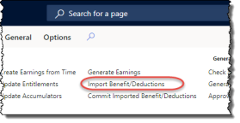
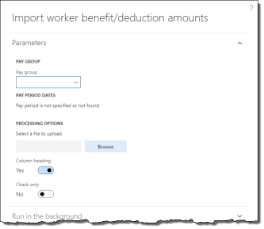
- On the ribbon, click Pay Period tab > Import Benefit/Deductions to open the Import worker benefit/deduction amounts pane.
- Browse for the file and select the benefit/deduction amounts spreadsheet.
- Click Check only if you only want to verify that the import file is valid and do not want to import records.
- Click OK to import the benefit/deduction amounts.
After importing the benefit/deduction amounts, you must commit them to Anthology Payroll. The commit process also gives you a chance to change or remove amounts if they were imported in error. To commit imported benefit/deductions:
- In the navigation pane, click Common > Pay Groups to open the Pay Groups list. Select the pay group in the list.
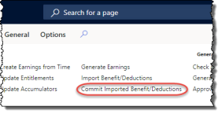
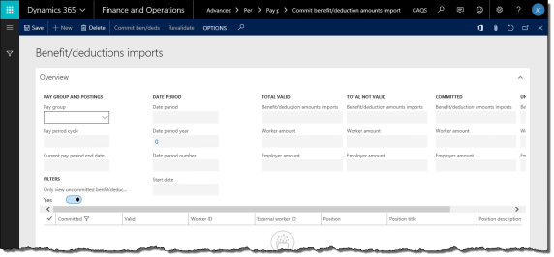
- On the ribbon, click Pay Period tab > Commit Imported Benefit/Deductions to open the Benefit/deductions imports journal.
- By default, all uncommitted benefit/deduction amounts are selected. Review the imported benefit/deduction amount records as desired and deselect the ones that you do not want committed. Make any necessary edits to individual amount records. You may even delete any records you do not want to keep. Click Revalidate to save your changes.
NOTE: records imported by the Anthology Payroll API (application programming interface) cannot be deleted in this journal.
- Click Commit ben/deds to save the imported benefit/deduction amounts to Anthology Payroll. Expand the form window if necessary to see the button. Close the journal.
- Proceed with payment generation and other regular pay period processing tasks (section 5.1.9).

5.2.7 Revise Past Payments
Anthology Payroll provides a function for recalculating a past payment due to retroactive benefit or deduction changes, such as benefit/deduction setup corrections.
Revised payments do not alter any existing payments and do not cancel or produce checks or direct deposits, but instead create refund or recovery amounts to be reconciled in the current pay period.
To generate revised payments:
- In the navigation pane, click Common > Anthology Payroll workers to open the Anthology Payroll workers list. Select the worker in the list.
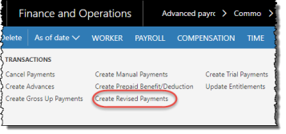
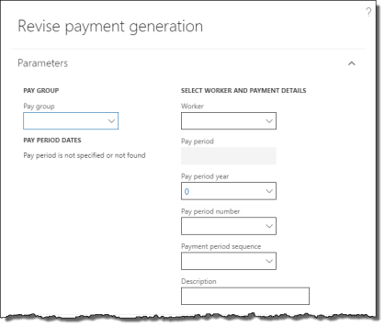
- On the ribbon, click Anthology Payroll Transactions tab > Create Revised Payments to open the Revise payment generation pane.
- Specify a Pay group to generate revised payments for.
- Specify a Worker to generate revised payments for. Leave this field blank to revise payments for the entire Pay group.
- Specify the Pay period year and Pay period number of the past pay period containing the payment to revise. All payments from that point onward are subsequently recalculated. You can only revise payments for pay periods that are no more than one year in the past from the current pay period.
- Specify a Payment period sequence of the past payment if the past pay period contained multiple payments.
- Enter a Description for the revised payment generation for your own tracking purposes.
- Click OK to generate revised payments.
Payments that are revised contain either refunds to the worker or recovery amounts for the employer. Refunds can be paid out to the worker in the current pay period through the regular pay process (section 5.1.11) or through a manual payment (section 5.2.1). Recovery amounts are recovered as benefit/deductions on the worker's next payment.

5.2.8 Issue Gross-up Payments
Gross-up payments are payments to workers where you can specify the exact net amount they receive after deductions. Anthology Payroll then calculates the gross earnings amount before deductions and gives them to specified workers. You may use this functionality to issue a $1000 bonus to a worker after deductions, for example.
You can issue gross-up payments to one worker at a time or import gross-up payment amounts for multiple workers within a worker group.

5.2.8.1 Import Gross-up Payment Amounts
If you are issuing gross-up payments for multiple workers in the same pay group, these amounts must be imported from an external file. Additionally, a worker group must be set up for the workers you are importing amounts for.
Please refer to 9.7 Appendix G: List of Gross-up Payment Amount Import Fields for the import file specification for gross-up payment amounts.
If you are issuing a gross-up payment to a single worker, see section 5.2.8.3.
To import gross-up payment amounts:
- In the navigation pane, click Journals > Gross up payments > Import gross up target amounts to open the Import gross up target amounts pane.
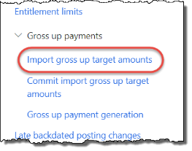
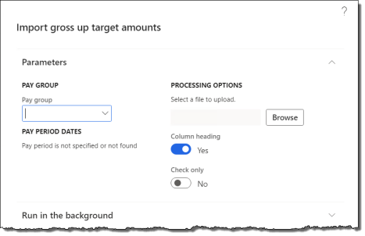
- Specify the Pay group you are importing for. Verify the Pay period dates for the pay group.
- Browse and select the import file.
- Select or deselect any processing options:
  - Column heading: deselect if the first row in the import file is not column headings
  - Check only: select to verify the import file only. No gross up payment amount records are imported.
- Click OK to import the file. An alert appears with a summary of the import process.

5.2.8.2 Commit Imported Gross-up Payment Amounts
After importing gross-up payment amounts, you must commit them to Anthology Payroll. The commit process also gives you a chance to change or remove records if they were imported in error. To commit imported gross-up payment amounts:
- In the navigation pane, click Journals > Gross up payments > Commit import gross up target amounts to open the Gross up target amounts imports journal.
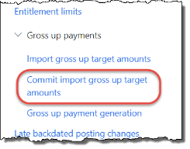
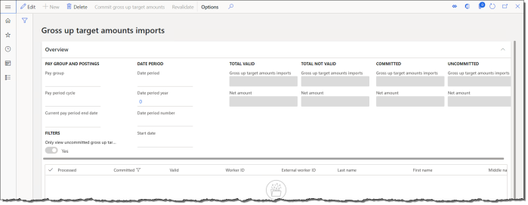
- Specify the Pay group to display pending imported gross-up payment amounts.
- By default, all uncommitted payment amounts are selected. Review the imported gross-up payment records as desired and deselect those that you do not want committed. Make any necessary edits to individual records. You may even delete any records you do not want to keep, provided they are not processed yet. Click Revalidate to save your changes.
- Click Commit gross up target amounts to save the imported gross-up amounts to Anthology Payroll. Close the journal.

5.2.8.3 Issue Gross-up Payments to a Single Worker or a Worker Group
Gross-up payments can be issued to a single worker at a time, or to all workers belonging to a worker group. To issue gross-up payments to a worker group, the group must be configured beforehand and gross-up payment amounts must first be imported (see section 5.2.8.1) and committed (see section 5.2.8.2) for the group. All workers in a worker group must belong to the same pay group.
To issue gross-up payments:
- In the navigation pane, click Journals > Gross up payments > Gross up payment generation to open the Gross up payment generation pane.
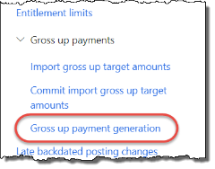
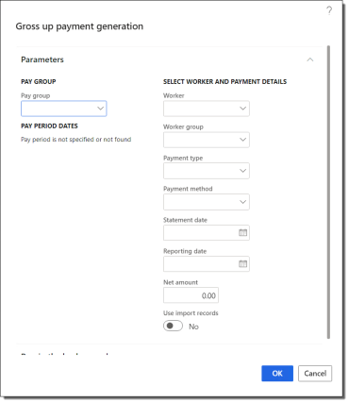
- Specify the Pay group. Verify the Pay period dates are correct for the current pay period.
- Specify an individual Worker or a Worker group.
- Select the Gross Up Payment Payment type.
- Enter a Reporting date override as desired.
- If you are issuing a payment to a single worker, enter the Net amount to issue to them. This is the amount the worker is paid after deductions. If you are issuing payments to multiple workers, select the Use import records option.
- Click OK to generate the gross up payment(s).
After gross-up payments are issued, they must be approved to generate the pay statements. You can approve them individually (see section 5.1.11.4) or wait until the next pay period process.

5.2.9 Correcting Address Information
If you process US local taxes and part-way through the pay process, you discover that one or more workers had incorrect address information and their local taxes assessment generated some incorrect deductions, you can correct this provided the pay period has not yet been closed.
This procedure is for correcting worker addresses and local tax calculations after payments have been generated. If payments have not yet been generated in the current pay period, simply correct the worker's home address (see section 4.2.1) or work address (see section 4.1.1) and then run the local tax assessment again.
To correct worker address information and local taxes assessment after payments are generated:
- Cancel the payment containing the incorrect local taxes assessments. See section 5.2.5 for the procedure on cancelling payments.
- For each affected worker, correct their addresses. For the home (primary) address, see section 4.2.1. For the work address, see section 4.1.1. If you are using tasks or projects to record work addresses, see section 5.2.3 to adjust earning records and select the correct task or project.
- Run the local taxes assessment procedure again after the address(es) are corrected. Ensure that you have non-zero earnings for the current period before running the assessment. See section 5.1.8.
- Proceed with the remainder of the pay period process. Alternatively, you can issue manual payments for individual workers (see section 5.2.1).
To correct local tax deductions in a previous, closed pay period, see section 5.2.7.

5.2.10 Process Retroactive Pay
Retroactive pay consists of reconciliatory earnings that can be calculated for workers who have received a pay rate increase that occurs in the past. The earnings for the pay rate increase are calculated retroactively and then paid out in the current pay period.
Processing retroactive pay requires multiple procedures including the following:
- Set up a retroactive run
- Generate retroactive earning records
- Review retroactive earning records

5.2.10.1 Set up a Retroactive Run
A retroactive run calculates the retroactive earnings that the worker is owed (or owing) due to a pay rate change in the past. The calculation is based on existing earning transactions and any earning differences are generated and paid out in the current pay period.
To set up a retroactive run:
- In the navigation pane, click Setup > Tables > Payroll > Retroactive runs to open the Retroactive runs form.
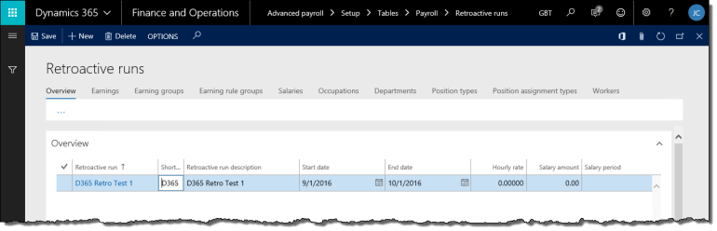
- On the Overview tab, click New to create a new record.
- On the General tab, enter a name for the Retroactive run. Enter a Retroactive run description as desired.
- Enter the Start date and End date of the period for which to calculate retroactive earnings. The date range should include all earning dates to review for potential rate changes. If the date range includes dates with no earnings (such as future dates), retroactive pay is not calculated for those dates.
- Select the Earning date type, which determines what time is stamped on the retroactive earnings.
- Select the Salary type for the earnings to be generated.
- Select Yes for Include accumulator based to include accumulator-based earnings in the retroactive pay calculation.
- Enter the Minimum amount and Maximum amount of the retroactive earning. If you are decreasing a rate, ensure the minimum is an appropriate negative value.
- Specify any of the following as needed:
  - Earning: if specified, retroactive earning transactions are generated with this code. Leave blank to generate retroactive earning transactions with the original earning code, or the retroactive earning code configured during implementation
  - Earning date: if specified, all retroactive earnings are stamped with this date. The Earning date type must be set to Use summary date if using this date.
  - Department: if specified, retroactive earning transactions are generated with this department. Leave blank to generate retroactive earning with the original earning's department.
  - Ledger account: if specified, retroactive earning transactions are charged to this account. Leave blank to charge retroactive earning transactions to the original earning's account.
- Specify one of the following:
  - a new Hourly rate to override earning records that have an hourly rate
NOTE: when using an Hourly rate override, ensure to select the appropriate earning codes in the next step. For example, it is illogical to apply a $25 hourly rate to a $1/hour earning code for evening shift premiums.
  - a Percentage amount to override all types of earning records. Earnings are multiplied by the percentage specified. For example, to specify a 5% increase, enter 105. To specify a 5% decrease, enter 95.
  - no Salary overrides to use only the effective-dated salary changes on worker position records.
- Determine the filter criteria for this retroactive run. On each tab corresponding to the type of data to filter by, select the items that are applicable to this retroactive run. You can select multiple items from multiple tabs. Selected earnings can be based on:
  - Earning codes
  - Earning groups
  - Earning rule groups
  - Salaries
  - Occupations
  - Departments (Organizations)
  - Position types
  - Position assignment types
  - Workers
NOTE: if no selections are made for a data type, the retroactive run will apply to all entries of that type.
- Click Save to save your changes.

5.2.10.2 Generate Retroactive Earning Records
To generate retroactive earning records:
- In the navigation pane, click Periodic > Other > Retroactive earnings > Retroactive earnings generation to open the Retroactive earnings generation pane.
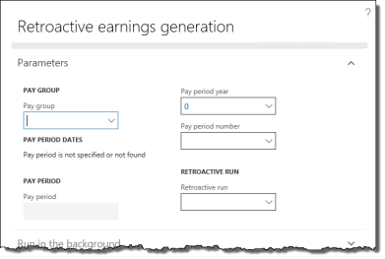
- Specify the Pay group to generate retroactive earnings for.
- Verify the Pay period number and Pay period year in which to generate retroactive earnings. The year and number correspond to the current pay period, but you may change it to a future one.
- Specify the Retroactive run code to execute and click OK to generate the retroactive earnings.

5.2.10.3 Review and Accept Retroactive Earning Records
To review and accept (or delete) retroactive earning records:
- In the navigation pane, click Periodic > Other > Retroactive earnings > Approve/change retroactive earnings to open the Worker retroactive earnings journal.
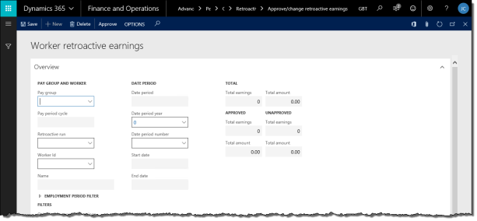
- Specify a Pay group. All retroactive earning records for this pay group appear in the list. Totals appear at the top.
- To filter the list on a single retroactive run or a worker, specify the Retroactive run or Worker Id respectively.
- Select the desired earnings to approve and click Approve to commit them as earning records on the specified Earning date. You may modify fields as required.
- To delete earnings, select them and click Delete to delete them.
- Close the form.
After accepting the earning records, they will appear as part of the normal pay process in the current pay period. Proceed with the rest of the normal pay process (section 5.1.6).

5.2.11 Modify Posting Transactions
Posting transactions can be modified prior to approving them to be posted. Previously, this function was part of the pay process, but now it can be performed at any time in the pay period. Posting transactions must still be approved before they are posted to the General ledger and Accounts payable modules (see section 5.1.16).
To modify posting transactions:
- In the navigation pane, click Common > Pay Groups to open the Pay Groups list. Select the pay group in the list.
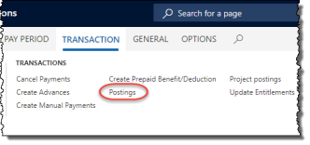
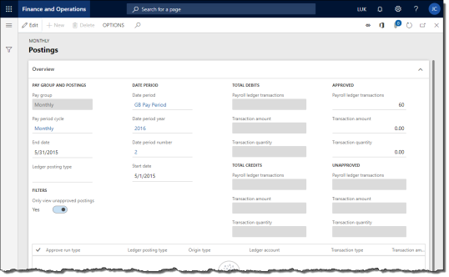
- On the ribbon, click Transaction tab > Postings to open the Postings journal.
- To filter the list of posting transactions by type, specify a Ledger posting type.
- Change the Ledger account for any transactions as needed. Only posting transactions that are not yet approved and posted can be modified.
- To delete a transaction record, select it in the list and click Delete. A dialog popup confirms your action.
- Click Save to save your changes.

5.2.12 Modify Project Posting Transactions
Project posting transactions can be modified prior to approving them to be posted. Previously, this function was part of the pay process, but now it can be performed at any time in the pay period. Project posting transactions must still be approved before they are posted to the Project management and accounting module (see section 5.1.18).
To modify project posting transactions:
- In the navigation pane, click Common > Pay Groups to open the Pay Groups list. Select the pay group in the list.
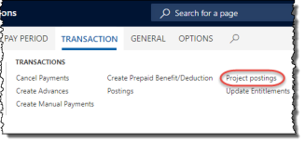
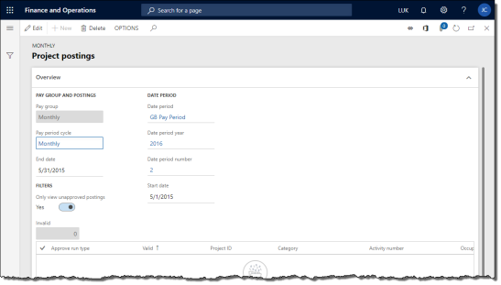
- On the ribbon, click Transaction tab > Project postings to open the Project postings journal.
- For any transaction records marked as invalid (Valid field is No), verify the following fields are correct:
  - Project ID
  - Category
  - Activity number
Change these fields accordingly and click Save to save your changes. The journal will attempt to re-validate your changes. Repeat until there are no more invalid records.
- To delete a transaction record, select it in the list and click Delete. A dialog popup confirms your action.
- Click Save to save your changes.

5.2.13 Create Trial Payments
Trial payments are a sandbox functionality where you can create fictional payments to workers using manually entered data or, depending on how far along you are in the pay process of the current pay period, actual transactional data records in Anthology Payroll. You can only create trial payments for one worker at a time and for the current pay period.
You can use trial payments to model "what if" scenarios regarding worker salary changes and your benefit/deduction and accumulator setup.
To create a trial payment:
- In the navigation pane, click Common > Anthology Payroll workers to open the Anthology Payroll workers list. Select the worker in the list.
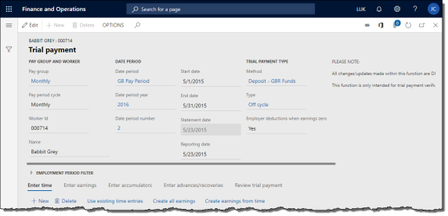
- On the Anthology Payroll Transactions tab, click Create Trial Payments to open the Trial payment journal.
- If desired, change the End date to the next pay period if the current has already been processed.
- Change the payment Method and Type as required. The Type indicates which earnings and benefit/deductions are processed by the payment.
- On the Enter time tab, you can (entering time is optional):
  - click Use existing time entries to copy existing time records for this worker in this pay period to the journal. This overwrites any current data on the tab.
  - click New to create a new time record
  - change any time records as desired
  - click Create all earnings to generate earning records from the time records on the Enter time tab and add to them any salary earnings from the worker's salary information (if any) and proceed to the Enter earnings tab
  - click Create earnings from time to generate earning records from only the time records on the Enter time tab and proceed to the Enter earnings tab
  - skip entering time altogether and proceed to entering earnings on the Enter earnings tab
- On the Enter earnings tab, you can:
  - click Use existing earning entries to copy existing earning records for this worker in this pay period to the journal. This overwrites any current data on the tab.
  - click New to create a new earning record
  - change any earning records as desired
  - click Update accumulators to update accumulators with the effects of the earnings on this tab and proceed to the Enter accumulators tab
- On the Enter accumulators tab, you can:
  - click Use existing accumulator entries to copy existing accumulator values for this worker in this pay period to the journal, if the accumulator update process has been run for this period. This overwrites any current data on the tab.
  - click New to create a new accumulator amount
  - change any accumulator amounts as desired
- On the Enter advances/recoveries tab, you can (entering advances/recoveries is optional):
  - click Use existing advance entries to copy existing pay advance amounts for this worker in this pay period to the journal. This overwrites any current data on the tab.
  - click Use existing advance recovery entries to copy existing advance recovery amounts for this worker in this pay period to the journal. This overwrites any current data on the tab.
  - click New to create a new advance or recovery amount
  - change any advance or recovery amounts as desired
- Click Calculate trial payment on either the Enter accumulators or Enter advances/recoveries tab to calculate the benefit/deduction amounts and apply gross-to-net calculations.
- On the Review trial payment tab, you can:
  - click New to create new benefit/deduction amounts
  - modify any benefit/deduction amounts as desired
  - click Recalculate trial payment button to recalculate gross-to-net after modifying benefit/deduction amounts
  - review the benefit/deductions taken and the worker's net pay
- Close the form when finished. No data in the Trial payments journal is preserved.

6 Year-End Tasks
This section contains procedures for annual maintenance tasks.

6.1 Import Statutory Deductions
Every year, Anthology Inc. produces and releases a spreadsheet containing the updated statutory tax deductions for the coming tax year for every localization of Anthology Payroll. If your implementation uses these statutory deductions for your given jurisdiction, you may wish to download and import the spreadsheet.
Contact Anthology Inc. for the latest version of the Statutory Deductions Spreadsheet. Installation instructions are included with the spreadsheet.

7 Reporting
This section contains procedures for viewing statutory and non-statutory reports.

7.1 Create 940 Annual Federal Unemployment Report
940s are created annually for reporting FUTA (Federal Unemployment Tax Act) returns. The 940 creation process includes creating a transmission file for 940s intended for upload to the IRS. The process uses third-party software, Greenshades, to submit the report.
To create a 940 submission file:
- In the navigation pane, click Periodic > Year end > 940 creation to open the 940 creation pane
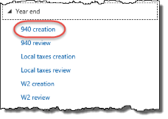
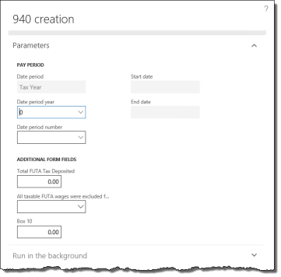
- Specify a Date period of Tax Year and select the current (or previous) year in the Date period year and Date period number fields.
- Enter Total FUTA Tax Deposited for the year, including any overpayment applied from a prior year. This is equivalent to Box 13 on the 940 form.
- Select an option for All taxable FUTA wages were excluded from state unemployment tax. This option is used in Box 9 on the 940 form.
- If All taxable FUTA wages were excluded from state unemployment tax is No, enter your total taxable FUTA wages into the Box 10 field. Otherwise, leave this amount as zero. This is equivalent to Box 10 on the 940 form.
- Click OK to generate the 940 submission form.
To download the XML file to your local computer, see section 5.1.12.
The 940 submission file must be filed from the Tax Filing Center. Refer to section 7.7.3 for submitting the 940 from TFC.

7.2 Create 941 Quarterly Federal Tax Return
Depending on your filing requirements, the 941 Quarterly Federal Tax Return may require some additional filing steps. As of Q2 2020, the 941 Worksheet 1 was added to supplement Form 941 tax filing to report qualified sick and family leave amounts. If your organization requires reporting on these amounts the 941 Worksheet 1 must be generated prior to generating the 941 XML report file.
This section includes procedures for the following:
- Generate 941 Worksheet 1 amounts
- Create 941 XML File

7.2.1 Generate 941 Worksheet 1 Amounts
The 941 Worksheet 1 was added in Q2 2020 to allow for filing and reporting of wages that qualify for sick and family leave, and employee retention credits offered by the federal government as a result of the COVID-19 pandemic. Most of the amounts reported by this worksheet must be configured by your Anthology Payroll implementer via the 941 export format. Other amounts must be entered directly on the form.
You may also override some amounts of the worksheet depending on your business scenario. This form allows you to enter these override amounts and set them before generating the 941 report.
To generate 941 worksheet 1 amounts:
- In the navigation pane, click Periodic > Quarterly > 941 worksheet to open the 941 worksheet form.
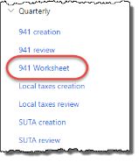
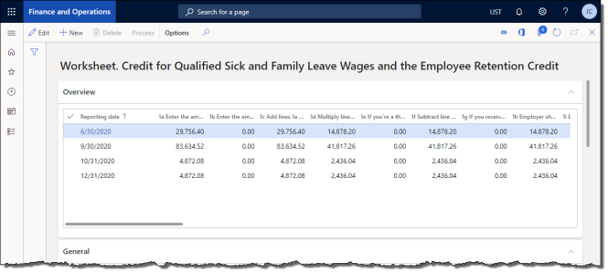
- On the Overview tab, select the record with the corresponding Reporting date for your current quarter (or month if you are required to file monthly).
- On the General tab, view the fields that are automatically populated from configured accumulators. Each field corresponds to a line on the 941 Worksheet 1. Enter amounts for the following sections as applicable for your business scenario:
Step and Line Number | Description and Guidance
Step 1 Line 1e | If you're a third-party payer of sick pay that isn't an agent and you're claiming credits for amounts paid to your employees, enter the employer share of social security tax included on Form 941, Part 1, line 8 (positive number)
Step 1 Line 1g | If you received a Section 3121(q) Notice and Demand during the quarter, enter the amount of the employer share of social security tax from the notice
Step 1 Line 1i | Enter the amount from Form 941, line 11a (credit from Form 8974)
Step 1 Line 1j | Enter the amount to be claimed on Form 5884-C, line 11, for this quarter
Step 2 Line 2a | If the Calculated 2a Qualified sick leave wages reported on Form 941, Part 1, line 5a(i), column 1 field includes earnings that exceed the maximum annual OASDI wage base in the year, enter this amount that excludes any qualified sick leave and family leave earnings exceeding the annual OASDI wage base. This will alter the amount reported in line 2a(ii).
Step 2 Line 2e | If the Calculated 2e Qualified family leave wages reported on Form 941, Part 1, line 5a(ii), column 1 field includes earnings that exceed the maximum annual OASDI wage base in the year, enter this amount that excludes any qualified sick leave and family leave earnings exceeding the annual OASDI wage base. This will alter the amount reported in line 2e(ii).
Misc 13b | Enter the amount of the employer share of social security tax that you're deferring for the quarter
Misc 13f | Enter the total advances received from filing Form(s) 7200 for the quarter
- If you entered any of the amounts above, click Process to recalculate items on the form according to the amounts you entered.
Review each line item on the worksheet form. These items will be reported on the 941 when the XML file is created (see following section).

7.2.2 Create 941 XML File
941s are created quarterly for reporting federal income tax returns. The 941 creation process includes creating a transmission file for 941s intended for upload to the IRS. The process uses third-party software, Greenshades, to submit the report.
NOTE: if you are reporting items on the 941 Worksheet 1 Credit for Qualified Sick and Family Leave Wages and the Employee Retention Credit, the worksheet must be completed prior to creating the XML file. See the preceding section.
To create a 941 submission file:
- In the navigation pane, click Periodic > Quarterly > 941 creation to open the 941 creation pane.
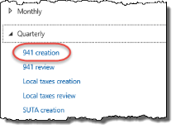
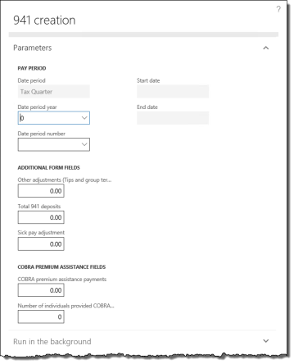
- Specify a Date period of Tax Quarter and select the current (or previous) quarter in the Date period year and Date period number fields.
- Enter any Other adjustments (Tips and group term life insurance) for the quarter. This is equivalent to Box 9 on the 941 form.
- Enter the Total 941 deposits amount for the quarter, including any overpayment applied from prior quarters and other forms. This option is used in Box 11 on the 941 form.
- Enter the Sick pay adjustment amount for the quarter. This option is used in Box 8 on the 941 form.
- Leave the COBRA fields blank. COBRA is no longer reported on the 941.
- Click OK to generate the 941 submission form.
To download the XML file to your local computer, see section 5.1.12.
The 941 submission file must be filed from the Tax Filing Center. Refer to section 7.7.4 for submitting the 941 from TFC.

7.3 Create SUTA Quarterly State Unemployment Report
SUTA (State Unemployment Tax Act) reports are created quarterly for reporting state unemployment premiums. Each SUTA report is specific to a state. The SUTA creation process includes creating a transmission file for state unemployment reports intended for upload to the IRS. The process uses third-party software, Greenshades, to submit the report.
To create a SUTA submission file:
- In the navigation pane, click Periodic > Quarterly > SUTA creation to open the SUTA creation pane.
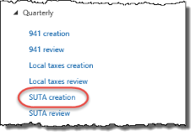
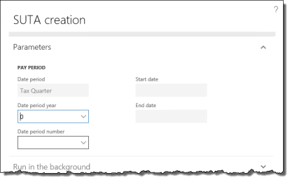
- Specify a Date period of Tax Quarter and select the current (or previous) quarter in the Date period year and Date period number fields.
- Check the Check this box to add new export format fields for this form option if you have recently updated the export format fields on the Format fields form.
Note: more information on export format fields can be found in the Anthology Payroll US Localization Configuration Guide.
- Click OK to generate the SUTA report submission.
To download the XML file to your local computer, see section 5.1.12.
The SUTA report submission file must be filed from the Tax Filing Center. Refer to section 7.7.5 for submitting the from TFC.

7.4 Create W-2s
W-2s can be generated when the last pay period of the tax year is closed. W-2s are generated from existing payroll data. There are various processes around W-2s:
- Create W-2 listing report
- Create W-2 submission file

7.4.1 Create W-2 Listing Report
The W-2 listing report shows a summary of worker W-2 data for a specified year. The report can be reviewed and printed as desired. Successfully running the listing report is also a good indication that W-2s can be properly run.
To run the W-2 listing report:
- In the navigation pane, click Reports > USA reports > W2 listing to open the W2 listing pane.
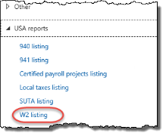
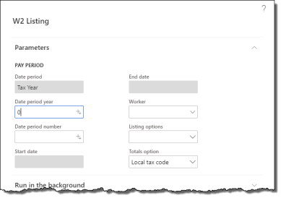
- Specify a Date period of Tax Year and select the current (or previous) year in the Date period year and Date period number fields.
- Specify any Listing options as desired. Specify the type of label to be used for summarizing local taxes in the Totals option as desired.
- Click OK to view the report.

7.4.2 Create W-2 Submission
The W2 creation process includes creating a transmission file for W-2s intended for upload to the IRS. The process uses third-party software, Greenshades, to create and submit the report.
To create a W-2 submission file:
- In the navigation pane, click Periodic > Year end > W2 creation to open the W2 creation pane.
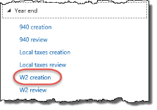
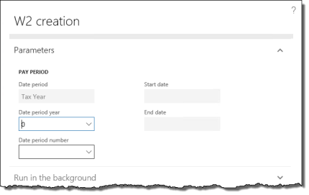
- Specify a Date period of Tax Year and select the current (or previous) year in the Date period year and Date period number fields.
- Click OK to generate the W-2 submission form.
To download the XML file to your local computer, see section 5.1.12.
The W-2 submission file must be filed from the Tax Filing Center. Refer to section 7.7.6 for submitting the W-2 from the Filing Center.

7.5 View Certified Payroll Projects Report
The Certified Payroll Projects report allows you to certify that your company is paying its workers prevailing wage rates, through cash and/or benefits, on federally funded construction projects in accordance with the Davis-Bacon act. This report can, for example, be used to fill out Form WH-347, published by the US Wage and Hour Division. Depending on which states you have workers in, you may have other requirements.
The Certified Payroll Projects report is a week-based report that reports on all earnings earned within the week period. All workers who belong to a weekly pay group and have earnings related to a certified payroll project are included in the report.
To view the Certified Payroll Projects report:
- In the navigation pane, click Reports > USA reports > Certified payroll projects listing to open the Certified payroll projects listing pane.
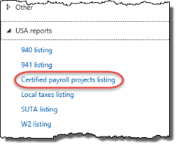
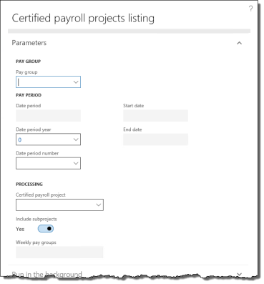
- Specify the Pay group to run the report for.
- Specify the Date period year and Date period number of the pay period for which to run the report. All earnings within this period are included in the report, including earning adjustments made in this time frame.
- Specify the Certified payroll project to view wage rates for.
- Select whether to Include subprojects or not. If included, project data is summarized for all subprojects under the selected project. If not included, only the hours of the main project are displayed.
- Click OK to generate the report.
To download the XML file to your local computer, see section 5.1.12.

7.6 Create Local Taxes Reports
Local taxes withheld from your workers can be reported for your organization on a monthly, quarterly, or yearly basis. The process uses third-party software, Greenshades, to submit the report. The file produced is in XML format.

7.6.1 Report Monthly Local Taxes
To create a monthly local taxes import file:
- In the navigation pane, click Periodic > Monthly > Local taxes creation to open the Local taxes reporting pane.
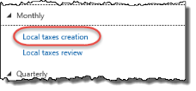
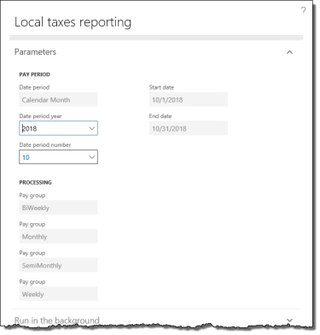
- Specify the Date period year and Date period number fields of the month to generate local taxes data from.
- Click OK to generate the local taxes report submission.
To download the XML file to your local computer, see section 5.1.12.
The local taxes report submission file must be filed through the Tax Filing Center. Refer to section 7.7 for submitting from TFC.

7.6.2 Report Quarterly Local Taxes
To create a quarterly local taxes import file:
- In the navigation pane, click Periodic > Quarterly > Local taxes creation to open the Local taxes reporting pane.
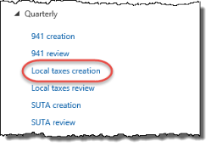
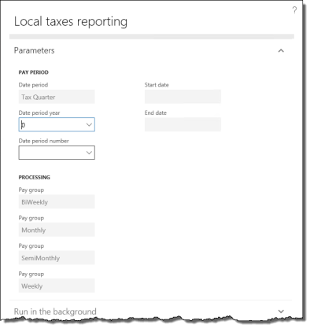
- Specify the Date period year and Date period number fields of the quarter to generate local taxes data from.
- Click OK to generate the local taxes report submission.
To download the XML file to your local computer, see section 5.1.12.
The local taxes report submission file must be filed through the Tax Filing Center. Refer to section 7.7 for submitting the from TFC.

7.6.3 Report Year-end Local Taxes
To create a year-end local taxes import file:
- In the navigation pane, click Periodic > Year end > Local taxes creation to open the Local taxes reporting pane.
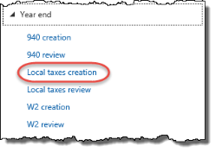
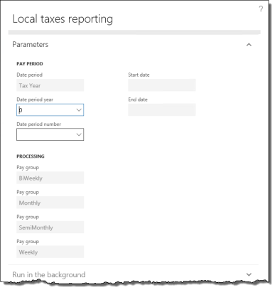
- Specify the Date period year and Date period number fields of the year to generate local taxes data from.
- Click OK to generate the local taxes report submission.
To download the XML file to your local computer, see section 5.1.12.
The local taxes report submission file must be filed through the Tax Filing Center. Refer to section 7.7 for submitting the from TFC.

7.7 Greenshades Tax Filing Center
The Greenshades Tax Filing Center (TFC) manages all form filings and submissions from Anthology Payroll to the IRS and respective government organizations. Additional documentation on the TFC is provided by Greenshades, but this section contains general information on submitting the various forms through the Filing Center.
The Tax Filing Center must be installed locally on your workstation and opened manually. You can then import XML files downloaded from Dynamics 365 to the TFC, which would aid you in filing your returns electronically. Additionally, you may distribute year-end forms to your employees from greenshadesonline.com, which is launched from within TFC.
To install the TFC on your local environment, please contact your system administrator for a copy of the software, or Anthology Payroll Client Services for the appropriate installation instructions.
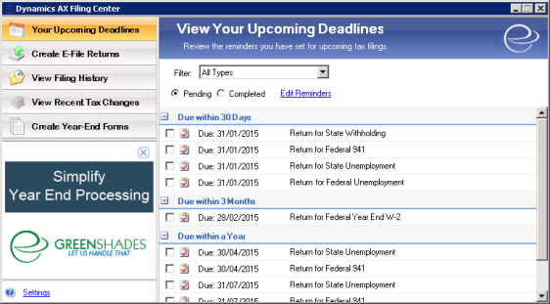
Additional documentation on the TFC can be found at:
http://www.greenshades.com/download-tax-filing-center.php

7.7.1 Change E-File Storage Location
The data that Greenshades Filing Center transmits and processes is sensitive, and care should be taken in determining the location where it stores your electronic files. It is recommended to use a secure central location on a network share. It is not recommended to store the files on a local client computer.
To check or change the current storage location:
- In the Greenshades Filing Center, click Settings to open the Settings dialog.
- In the Settings dialog, click the Advanced tab.
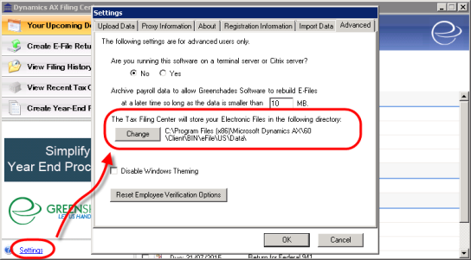
- On the Advanced tab, view or change the location where the Greenshades Filing Center stores electronic files as desired.
- Click OK to save your changes.

7.7.2 Upload XML Submission Files
Statutory reports produced by Anthology Payroll are in an XML format. These files must be uploaded to the Greenshades TFC before they can be filed.
To download produced statutory reporting XML files to your local computer, see section 5.1.12.
To upload XML submission files to the TFC:
- In the Greenshades Filing Center, click Settings to open the Settings dialog.
- In the Settings dialog, click the Import Data tab.
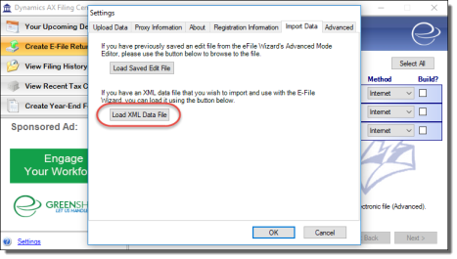
- On the Import Data tab, click Load XML Data File and browse to and select the XML file to import from your local computer.
- Repeat the above step for additional XML files as needed.
Note - Ensure that transactions involving individuals residing or working in Pennsylvania accurately report local tax information in the Local Tax XML file, including Worksite nodes and references as per Greenshades guidelines. Transactions related to individuals residing or working in Pennsylvania should be accurately reported in the Local Tax XML file, incorporating Worksite nodes and references as outlined in Greenshades guidelines.

7.7.3 Review and Submit 940s
After the 940 submission file has been created, it can be reviewed and submitted through the Tax Filing Center.
To upload the XML submission file to the TFC, see section 7.7.2
To review or submit 940s:
- In the Tax Filing Center, click Create E-File Returns to open the E-File Wizard.
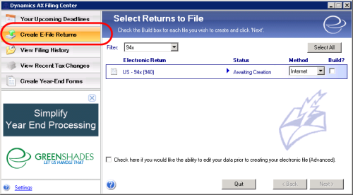
- On the Select Returns to File dialog, select 94x in the Filter field to view pending 940 reports.
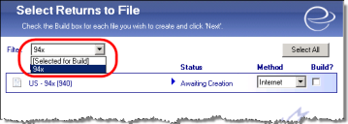
- Check the Build? option for the US - 94x (940) Electronic Return. Click Check here if you would like the ability to edit your data... to open an editor prior to completing the e-file record. The editor will allow you to make any changes to amounts or other reporting fields as needed. Click Next to proceed to the advanced editor, which opens in a new window.
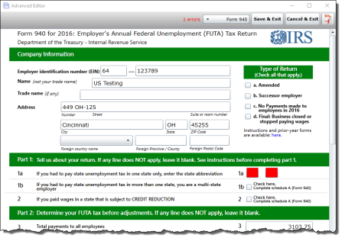
- On the Advanced Editor window, change fields on the form as desired before proceeding with filing. Values in the form are generated from Anthology Payroll and Greenshades. Errors are highlighted in red and must be resolved before proceeding.
- After making edits, click Save & Exit to return to the wizard. You may also download a PDF copy for your own records.
- On the Review Built Files dialog, click the Click to Begin Filing link for the US - 94x (940) Electronic File to begin filing your 940 report. If your report had errors, click to view the errors. Click Back to return to the previous screen and rebuild and reopen the editor to resolve errors, if any.
- On the View Totals dialog, you can view, print, or save a copy of the e-file. Reconcile these totals against those you are expecting to file. Click Next to proceed through the prompts to complete your filing. You must provide your company's identification to proceed.
You may save a copy of the 940 for your own records from TFC.

7.7.4 Review and Submit 941s
After the 941 submission file has been created, it can be submitted through the Tax Filing Center.
To upload the XML submission file to the TFC, see section 7.7.2
To review or submit 941s:
- In the Tax Filing Center, click Create E-File Returns to open the E-File Wizard.
- On the Select Returns to File dialog, select 94x in the Filter field to view pending 941 reports.
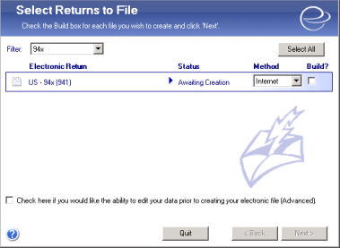
- Check the Build? option for the US - 94x (941) Electronic File. Click Check here if you would like the ability to edit your data... to open an editor prior to completing the e-file record. The editor will allow you to make any changes to amounts or other reporting fields as needed. Click Next to proceed to the advanced editor, which opens in a browser window.
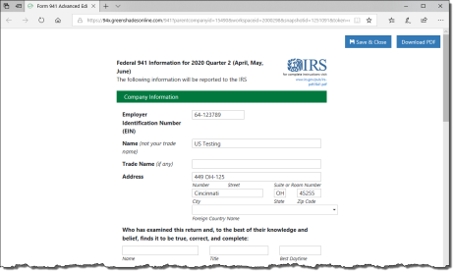
- On the Advanced editor window, view the 941 form. You may change the fields as desired before printing or submitting the form. Values in the form are generated from Anthology Payroll and Greenshades. Note that the submitted version of the form appears like the official 941 and not like it appears on the screen.
- After making edits, click Save & Close to return to the wizard. You may also download a PDF version of your form for your own records.
- On the Review Built Files dialog, click the Click to Begin Filing link for the US - 94x (941) Electronic File to begin filing your 941 report. If your report had errors, click to view the errors. Click Back to return to the previous screen and rebuild and reopen the editor to resolve errors, if any.
- On the View Totals dialog, you can view, print, or save a copy of the e-file. Reconcile these totals against those you are expecting to file. Click Next to proceed through the prompts to complete your filing. You must provide your company's identification to proceed.
You may save a copy of the 941 report for your own records from TFC.

7.7.5 Review and Submit SUTA Reports
After the SUTA submission file has been created, it can be reviewed and submitted through the Tax Filing Center. Note that the process to gather data for the SUTA report may be a lengthy process depending on the size your database.
To upload the XML submission file to the TFC, see section 7.7.2
To review or submit SUTA:
- In the Tax Filing Center, click Create E-File Returns to open the E-File Wizard.
- On the Select Returns to File dialog, select Suta in the Filter field to view pending SUTA reports.
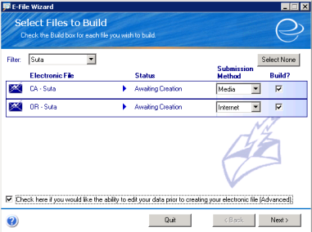
- Check the Build? option for the XX - SUTA Electronic File where XX is the 2-character state identifier. Each state has its own required SUTA format and data. While the SUTA form is not actually displayed in the wizard, there are several opportunities to view summaries or overall totals. During implementation (and especially during parallel testing), look for discrepancies between these results and your legacy system. Knowledge of the export format fields used for SUTA may assist you in troubleshooting any problems you find.
- Click Check here if you would like the ability to edit your data... to open an editor prior to completing the e-file record. The editor will allow you to make any changes to amounts or other reporting fields as needed. Click Next to proceed.
- On the Advanced editor window, view the SUTA form. You may change the fields as desired before printing or submitting the form. Values in the form are generated from Anthology Payroll and Greenshades.
- After making edits, click File > Done Editing to return to the wizard. You may also click File > Save a Copy to save a copy of your changes to your local computer.
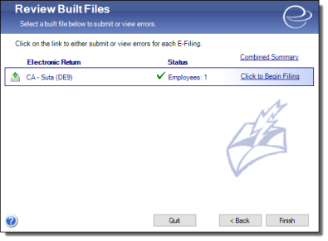
- On the Review Built Files dialog, click the Click to Begin Filing link for the corresponding Electronic File to begin filing your SUTA report. If your report had errors, click to view the errors. Click Back to return to the previous screen and rebuild and reopen the editor to resolve errors, if any.
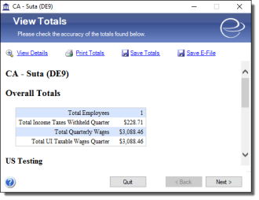
- On the View Totals dialog, you can view, print, or save a copy of the e-file. Reconcile these totals against those you are expecting to file. Click Next to proceed through the prompts to complete your filing. You must provide your company's identification to proceed.
You may save a copy of the SUTA report for your own records from TFC.

7.7.6 Submit and Distribute W-2s
After the W-2 submission file has been created, it can be submitted through the Tax Filing Center. You may also choose to distribute it through greenshadesonline.com.
Distribution of the W-2 year-end forms is completed on downloadmyform.com, a Greenshades site. You can view more documentation about downloadmyform.com at this link. Distribution can be completed in two ways: a) online, or b) download and printing. Distribution online through downloadmyform.com is an additional service not included with the Anthology Payroll licensing.
To upload the XML submission file to the TFC, see section 7.7.2
To submit your W-2 through the TFC:
- In the Tax Filing Center, click Create E-File Returns to open the E-File Wizard.
- On the Select Returns to File dialog, select W-2 in the Filter field to view pending W-2 reports.
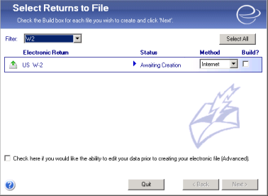
- Check the Build? option for the US W-2 Electronic Return. Click Check here if you would like the ability to edit your data... to open an editor prior to completing the e-file record. The editor will allow you to make any changes to amounts or other reporting fields as needed. Click Next to proceed to the advanced editor, which opens in a new window.
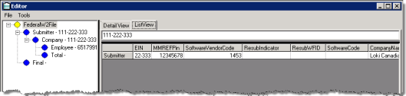
- In the Editor, view the W-2 form. You may change the fields as desired before printing or submitting the form. Values in the form are generated from Anthology Payroll and Greenshades.
- After making edits, click File > Done Editing to return to the wizard. You may also click File > Save a Copy to save a copy of your changes to your local computer.
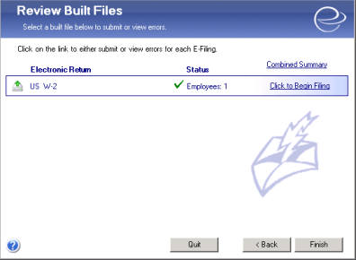
- On the Review Built Files dialog, click the Click to Begin Filing link for the US W-2 Electronic File to open the View Totals dialog. If the report has errors, click the corresponding link to resolve them. If the Enter Missing Information dialog appears, enter corresponding information as needed to continue with building the e-file.
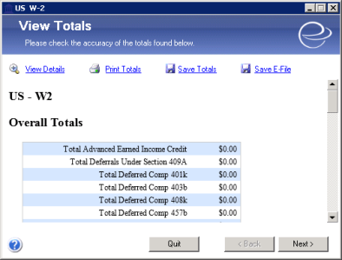
- On the View Totals dialog, you can view, print, or save a copy of the e-file. Reconcile these totals against those you are expecting to file. Click Next to proceed.
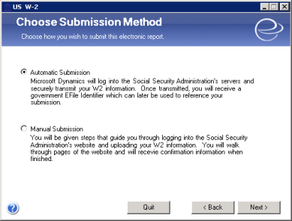
- On the Choose Submission Method dialog, select your method of submission and proceed through the prompts to submit your W-2 report. You must provide your company's identification to proceed.
To distribute the W-2s to your employees:
- In the Tax Filing Center, click Create Year-End Forms to open the Year-End Forms wizard.
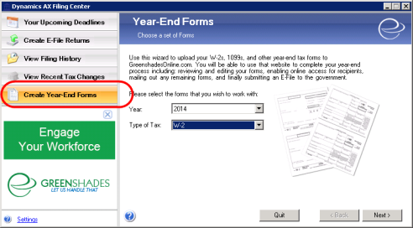
- On the Year-End Forms dialog, select W-2 in Type of Tax. Verify the Year. Click Next to proceed.
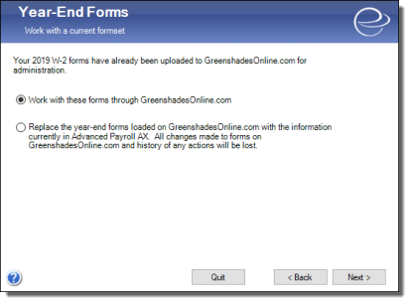
- On the next screen, select the Work with these forms... option if your year-end forms are already uploaded to greenshadesonline.com. Click Next to open greenshadesonline.com in a new browser window and continue with your form creation. If you made changes to your W-2 forms from within the TFC, select the Replace the year-end forms... option and click Next to proceed to upload your latest W-2 submission file to greenshadesonline.com. You can also upload your file from greenshadesonline.com.
- On greenshadesonline.com, log in with your greenshades account.
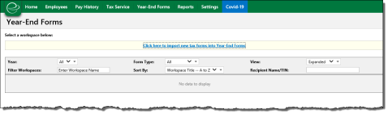
- If you need to upload your W-2, click the Click here to import new tax forms... hyperlink at the top of the page to open the Import Forms Wizard in a new window. Otherwise, select your W-2 form to file and click the option to begin filing.
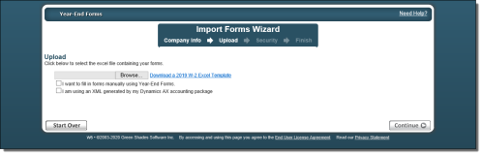
- If you are not uploading a new W-2, skip to the next step. If you are uploading a new W-2, on the Import Forms Wizard, select your company and the Year and Form Type to import. Click Continue to proceed to select your import file. On the Upload screen, check the I am using an XML generated by my Dynamics AX accounting package option and browse to and select your XML file produced from Anthology Payroll. Proceed through the rest of the wizard by selecting users in your company who can view the forms and finalizing the upload. The upload may take several minutes.
- When distributing your W-2, you will be redirected to downloadmyform.com. Proceed through the prompts to complete your form generation.
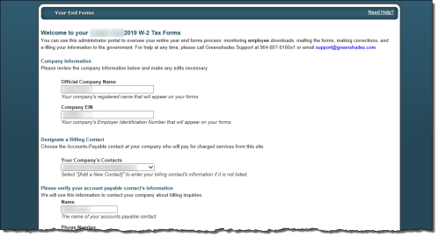
- Review your company's information on the welcome page. Verify your contact information and proceed.
- Select an option for Formset Archiving depending on your organization's requirements and continue.
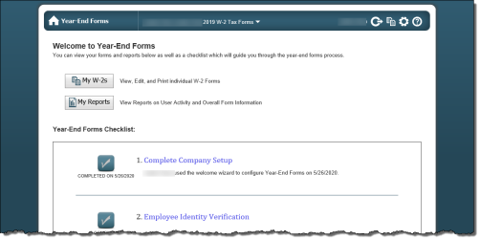
- On the Welcome to Year-End Forms homepage, verify that you have completed the items on the Year-End Forms Checklist. From the homepage, you can access several functions:
  - My W-2s: view, edit and print individual W-2 forms.
  - My reports: view reports on user activity and other metadata
  - Complete Company Setup: complete and validate your company's contact information. Needs to be completed only once.
  - Employee Identity Verification: validate the contact information for your employees.
  - Resolve Warnings with your Forms
  - Verify W-2 Form Totals: reconcile your W-2 form totals with your expected results.
  - Email Employees with links to W-2 Forms
  - Distribute any remaining W-2s to your Employees: you can choose to distribute electronically, which would incur a fee from Greenshades, or to download and print the remaining W-2s and distribute manually.
  - E-File Federal W-2 Return: submit your W-2s electronically through downloadmyform.com, following the on-screen prompts. For more information on this process, see https://cdn.greenshadesonline.com/DMF/Help/E-File%20Federal%20Returns.htm.
For more information about downloadmyform.com, go to https://www.downloadmyform.com/Docs/DMFOverview.aspx.

8 Terminating Workers
This section contains procedures for terminating a worker. Use these procedures when you receive notification from Human Resources that a worker is terminating. Ensure that you have the worker's termination date and details of any severance terms.
The general termination process is:

8.1 Check for Earnings after Termination Date
Anthology Payroll does not allow you to pay a worker for earnings that are dated after the worker's termination date. Earnings can have the same date as the termination date.
To negate earnings dated past termination dates, use the Time/earning adjustments journal (section 5.2.3). Use the following exceptions:
- In the Time/Earnings section, specify a Start date of the day after the worker's termination date. Specify an End date of the current pay period end date.
- Ignore the Time tab.
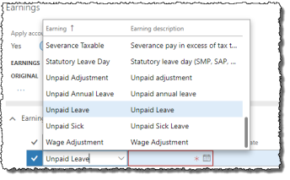
- If any salary earnings appear on the Earnings tab, change the Earning code for those earnings to Unpaid Leave.
- If any other earnings dated after the termination date appear on the Earnings tab (i.e.: generated earnings), then either delete them or change the Earning date for them to the worker's termination date, as appropriate. You may also need to adjust the Pay amount of those earnings.

8.2 Terminate the Worker
If the worker is terminating from all companies, you must terminate the worker record. If the worker is terminating from one company, but may still be active in other companies, you must end the worker's position assignment in the company they are terminating from.
To terminate the worker from all companies:
- In the navigation pane, click Common > Anthology Payroll workers to open the Anthology Payroll workers list. Select the worker to terminate.
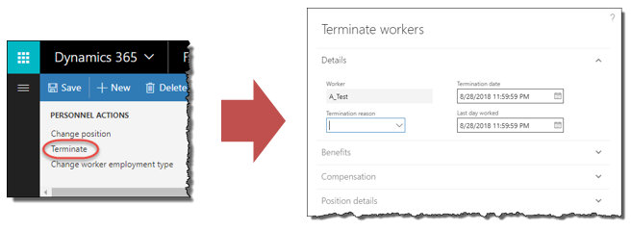
- On the Work tab of the ribbon, click the Terminate button to open the Terminate workers pane.
- Specify the Termination date and the Last day worked if they are not the current date.
- Select a Termination reason.
- Specify termination options for the Compensation and Benefits management sections as desired, depending on your implementation requirements.
- If you want to retire the position, check the Retire position checkbox in the Position details section and specify the Retirement date. Set this date to the same date as the Termination date. This means the position would no longer be available to be assigned to a worker. If you expect the worker to be rehired in the future, you may not want to retire the position.
- Click Terminate workers to terminate the worker from all companies. You do not need to end the worker's position assignment (below).
To end the worker's position assignment from a single company:
- Ensure you are in the correct company in which the worker's position is ending.
- Refer to the first procedure in section 4.1.2 for the procedure on ending the worker's position.
The worker will still be active and can be assigned positions in other companies.

8.3 Pay Out Entitlements
Workers may have outstanding entitlements that must be paid out or overdrawn entitlements that must be recovered.
Additionally, since vacation entitlements are awarded for the year at the beginning of the year, the entitlement bank may require adjustment before being paid out. This is typical for workers that are terminated mid-year.
To adjust entitlement balances before paying them out:
- In the Human resources navigation pane, click Common > Past Workers to open the Past Workers list. Select the worker.
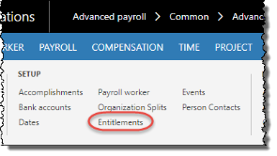
- On the ribbon, click Anthology Payroll Profile tab > Entitlements to open the Worker entitlements form.
- On the Worker entitlements form, select the entitlement to adjust and click Functions > Adjust entitlements to open the Adjust entitlements pane.
- Change the Accrued hours, Taken hours, or both as desired.
- Specify an Adjustment reason code of Termination.
- Click OK to adjust the entitlement bank and proceed to the next procedure.
To pay out vacation or overtime entitlement balances:
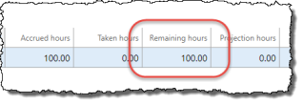
- On the Worker entitlements form, verify if the worker has any Remaining hours (or Remaining amount) on any of their entitlements. If there are none, then no further action needs to be taken, but you should check to see if the worker has overdrawn entitlements.
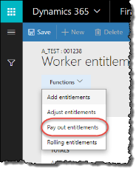
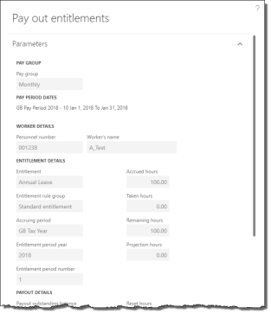
- If the worker has Remaining hours, select the entitlement to pay out and click Functions > Pay out entitlements to open the Pay out entitlements pane.
- Ensure that Payout outstanding balance is set to Yes.
- Specify a Payout reason code of Termination.
- Verify the Pay period end date as the current pay period. If the current pay period has already been processed and you want to include this earning in the next pay period, change this date to the next pay period end date.
- Click OK to pay out the worker's entitlement balance and create the earnings records for the worker.
- Repeat for any additional entitlement balances the worker may have.

8.4 Enter Severance Pay
Severance pay is simply entered as an earning on the Worker earnings journal. Not all terminations have severance pay.
To enter a severance earning:
- In the Human resources navigation pane, click Common > Past Workers to open the Past Workers list. Select the worker.
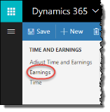
- On the ribbon, click Anthology Payroll Transactions tab > Earnings to open the Worker earnings journal.
- On the Earnings tab, click New to create a new record.
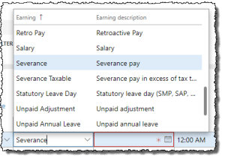
- Specify Severance for the Earning field.
- Specify the worker's termination date in the Earning date field.
- In the Pay amount field, specify the amount of severance pay.
- Click Save to save your changes. The severance pay earning will appear on the worker's final pay statement.

8.5 Process Final Payment
The procedure for processing the final payment is the same for issuing a manual payment for the worker. Verify the worker's earnings and time records are up-to-date and see section 5.2.1 for the procedure.
The manual payment will pay salary up to and including the termination date, but not after. Any outstanding deductions in arrears will be taken to the extent possible.

9 Appendices

9.1 Appendix A: List of Benefit/deductions
XX refers to the two-character state identifier.
Rule Group | Benefit/deduction | Description | Enrollments | Applicable to
Standard ded'n rules | 401K | 401K |  | Automatic
Standard ded'n rules | 401K on Suppl Earns | 401K on supplementary earnings |  | Automatic
Standard ded'n rules | ADD | Accidental death and dismemberment | _Not Enrolled; Enrolled | Individual, as needed
Standard ded'n rules | Additional Life | Additional life insurance | _Not Enrolled; Enrolled | Individual, as needed
 | Advance Recovery | Recovery of advances |  | Automatic
Standard ded'n rules | CA SDI | California disability insurance | _Not Enrolled; Enrolled | Individual, as needed
Standard ded'n rules | CA SUT | California unemployment training tax | _Not Enrolled; Enrolled | Individual, as needed
 | Charity | Charity donations |  | Individual, as needed
Standard ded'n rules | Dental Plan | Dental plan | _Not Enrolled; Couple; Family; Single | Individual, as needed
Standard ded'n rules | Dependent Life | Dependent life insurance | _Not Enrolled; Couple; Family | Individual, as needed
Standard ded'n rules | Employee Purchases | Employee Purchases from cafeteria or store |  | Individual, as needed
Standard ded'n rules | Extended Health | Extended health insurance | _Not Enrolled; Enrolled | Individual, as needed
Standard ded'n rules | FUTA | Federal unemployment insurance |  | Automatic
Standard ded'n rules | Group Life | Group life insurance | _Not Enrolled; Enrolled | Individual, as needed
Standard ded'n rules | HI SDI | Hawaii disability insurance | _Not Enrolled; Enrolled | Individual, as needed
Standard ded'n rules | Long Term Dis | Long-term disability | _Not Enrolled; Enrolled | Individual, as needed
Standard ded'n rules | ME SUI CSSF Tax | Maine competitive skills scholarship fund | _Not Enrolled; Enrolled | Individual, as needed
Standard ded'n rules | Medicare | Medicare |  | Automatic
Standard ded'n rules | Medicare Addl | Additional Medicare |  | Individual, as needed
 | Misc Deductions 1 | Miscellaneous deductions 1, to be modified |  | Individual, as needed
 | Misc Deductions 2 | Miscellaneous deductions 2, to be modified |  | Individual, as needed
 | Misc Deductions 3 | Miscellaneous deductions 3, to be modified |  | Individual, as needed
 | Misc Deductions 4 | Miscellaneous deductions 4, to be modified |  | Individual, as needed
 | Misc Deductions 5 | Miscellaneous deductions 5, to be modified |  | Individual, as needed
 | Negative Net Recover | Negative net recovery |  | Automatic
Standard ded'n rules | NJ SDI | New Jersey disability insurance | _Not Enrolled; Enrolled | Individual, as needed
Standard ded'n rules | NM WCPA | New Mexico workers' compensation personal assessment | _Not Enrolled; Enrolled | Individual, as needed
Standard ded'n rules | NY FLI | New York paid family leave insurance plan | _Not Enrolled; Enrolled | Individual, as needed
Standard ded'n rules | NY SDI | New York disability insurance | _Not Enrolled; Enrolled | Individual, as needed
Standard ded'n rules | OASDI | Social security insurance |  | Automatic
Standard ded'n rules | OASDI on Tips | Social security insurance on tip income |  | Automatic
Standard ded'n rules | OR Trans Tax | Oregon Transit Tax | _Not Enrolled; Enrolled | Individual, as needed
Standard ded'n rules | OR WCF | Oregon workers' compensation fund | _Not Enrolled; Enrolled | Individual, as needed
Standard ded'n rules | Pension | Pension plan | _Not Enrolled; Enrolled | Individual, as needed
Standard ded'n rules | RI SDI | Rhode Island disability insurance | _Not Enrolled; Enrolled | Individual, as needed
Standard ded'n rules | Short Term Dis | Short-term disability | _Not Enrolled; Enrolled | Individual, as needed
 | Taxable Benefit 1 | Taxable benefit (non-cash) 1, to be modified |  | Individual, as needed
 | Taxable Benefit 2 | Taxable benefit (non-cash) 2, to be modified |  | Individual, as needed
 | Taxable Benefit 3 | Taxable benefit (non-cash) 3, to be modified |  | Individual, as needed
Standard ded'n rules | Union Dues | Union dues | _Not Enrolled; Enrolled | Individual, as needed
 | USA FIT Add Tax | Additional federal income tax |  | Individual, as needed
Standard ded'n rules | USA FIT | Federal income tax | Head of Household; Married; Single; alien status variants | Automatic
Standard ded'n rules | USA FIT Suppl Tax | Federal income tax on supplemental income |  | Automatic
Standard ded'n rules | WA IIP | Washington industrial insurance premium | _Not Enrolled; Enrolled | Individual, as needed
Standard ded'n rules | XX SIT | XX state income tax, one for each applicable state | Various | Individual, as needed
 | XX SIT Add Tax | XX state additional income tax, one for each applicable state |  | Individual, as needed
Standard ded'n rules | XX SIT SUPPL | XX state income tax on supplemental income, one for each applicable state | _Not Enrolled; Enrolled | Individual, as needed
Standard ded'n rules | XX SUI | XX state unemployment insurance, one for each state | _Not Enrolled; Enrolled | Individual, as needed

9.2 Appendix B: List of Calculation Variables
XX refers to the two-character state identifier.
Calculation variables that state Rate counter in the Override? field should only have the Rate counter field specified in the Worker calculation variables form.
Calculation Variable | Calculation Variable Item | Override? | Item Description
401k Extra Age Amt | Catch Up Limit | Override amount | Personal catch-up contribution limit if employee is over age 50. Should not exceed maximum.
401k Percentage | 401K Percentage | Override amount | Employee's contribution percentage to 401K per pay period. Interpreted as an integer.
AL Personal Exempt | filing status | Use default | Worker's personal exemption amount for filing status in Alabama
Allowance 1 PPd Amt | Allowance 1 PPd Amt | Override amount | Custom allowance amount
Allowance 2 PPd Amt | Allowance 2 PPd Amt | Override amount | Custom allowance amount
Allowance 3 PPd Amt | Allowance 3 PPd Amt | Override amount | Custom allowance amount
Allowance 4 PPd Amt | Allowance 4 PPd Amt | Override amount | Custom allowance amount
Allowance 5 PPd Amt | Allowance 5 PPd Amt | Override amount | Custom allowance amount
AZ SIT Rate | TIER # | Use default | Worker's Arizona state income tax rate
CT Reduced Amount | CT Reduced Amount | Override amount | Box 3 of CT-W4
DE STD Deduction | filing status | Use default | Standard deduction for worker's filing status in Delaware
GA Pers Allown MFS | GA Pers Allown MFS | Use default | Personal allowance for Married filing separately filing status for Georgia state income tax
GA STD Deduction | filing status | Use default | Standard deduction for filing status for Georgia state income tax
GA STD Mar BC | GA STD Mar BC | Use default | Standard deduction for Married filing jointly filing status with both spouses claiming for Georgia state income tax
IA Pers Std Ded | personal allowances claimed | Use default | Standard deduction for number of personal allowances claimed in Iowa
IL Allowance Line1 | IL Allowance Line1 | Rate counter | Number of personal allowance in Illinois, line 1
IL Allowance Line2 | IL Allowance Line2 | Rate counter | Number of personal allowance in Illinois, line 2
KY Tax Credit | KY Tax Credit | Rate counter | Personal tax credit for Kentucky state income tax
MD Local Tax Rate | local county | Use default | Local income tax rate for worker in Maryland
MD SUPPL Rate | local county | Use default | Local supplementary income tax rate for worker in Maryland
ME NONRES ANNWAGE IN | resident status | Use default | Annual taxable wage increase for non-resident workers in Maine
MS Pers Exemption | MS Personal Exemptn | Override amount | Personal exemption amount for worker in Mississippi
MS STD Deductions | filing status | Use default | Standard deduction for filing status in Mississippi
OR WCF Salaried Hrs | OR WCF Salary Hrs | Override amount | Worked hours subject to workers' compensation in Oregon
Sick annual hrs | Sick annual hrs | Override amount | Annual accrual in hours for sick leave
Vacation annual hrs | Vac annual hrs | Override amount | Annual accrual in hours for vacation leave
W4 Allowance | W4 allowances | Rate counter | W-4 allowances claimed for federal income tax
WA IIP Employee Rate | WA IIP Employee Rate | Override amount | Industrial insurance employee rate in Washington state
WA IIP Employer Rate | WA IIP Employer Rate | Override amount | Industrial insurance employer rate in Washington state
XX Dep Allown | XX Dep Allown | Rate counter | Dependent allowance for XX state income tax
XX Dependents | XX Dependents | Rate counter | Number of dependents claimed for worker in XX state
XX Exemptions | varied | Rate counter | Worker's personal exemption amount in XX state. May include filing status.
XX Pers Allown | XX Pers Allown | Rate counter | Personal allowance for XX state income tax
XX W4 Allowance | XX W4 Allowance | Rate counter | W-4 allowances claimed for use in XX state income tax

9.3 Appendix C: List of Earnings Import File Fields
Field name | Description | Required
Worker ID | The worker identifier in Anthology Payroll. | Yes
External Worker ID | The worker identifier in Human Resources. Ignored if Worker ID exists. | No, if Worker ID exists. Otherwise, Yes.
Last Name | The worker's last name. Ignored if Worker ID exists. | No, if Worker ID exists. Otherwise Yes.
First Name | The worker's first name. Ignored if Worker ID exists. | No, if Worker ID exists. Otherwise, Yes.
Middle Name | The worker's middle name. Ignored if Worker ID exists. | No, if Worker ID exists. Otherwise, Yes.
National ID | The worker's government-issued identification number. Ignored if Worker ID exists. | No, if Worker ID exists. Otherwise, Yes.
Position | The worker's position ID that identifies the position that the earning applies to. | No
Position Description | The worker's position description that identifies the position that the earning applies to. Ignored if Position exists. | No
Position Title | The worker's position description that identifies the position that the earning applies to. Ignored if Position exists. | No
Date | The date for the earnings record. | Yes
Year | The year component of the date for the earnings record. Ignored if Date exists. | No, if Date exists. Otherwise, Yes.
Month | The month component of the date for the earnings record. Ignored if Date exists. | No, if Date exists. Otherwise, Yes.
Day | The day component of the date for the earnings record. Ignored if Date exists. | No, if Date exists. Otherwise, Yes.
Earning | The earning code that the worker's earning is charged to. | Yes
Earning Description | The description of the earning code that the worker's earning is charged to. Ignored if Earning exists. | No, if Earning exists. Otherwise, Yes.
Amount | The earning amount to be paid to the worker. | Yes
Amount Sign | Indicator of whether the amount is being accumulated or reversed. | No
Ledger | The ledger code that the earning is charged to. | No
Ledger Description | The description of the ledger that the earning is charged to. Ignored if Ledger exists. | No
Please refer to the Import Earnings Guide document or the Anthology Payroll Help System for further description on the validation rules of each field and for the full list of import fields.

9.4 Appendix D: List of Time Import File Fields
Field name | Description | Required
Worker ID | The worker identifier in Anthology Payroll. | Yes
External Worker ID | The worker identifier in Human Resources. Ignored if Worker ID exists. | No, if Worker ID exists. Otherwise, Yes.
Last Name | The worker's last name. Ignored if Worker ID exists. | No, if Worker ID exists. Otherwise Yes.
First Name | The worker's first name. Ignored if Worker ID exists. | No, if Worker ID exists. Otherwise, Yes.
Middle Name | The worker's middle name. Ignored if Worker ID exists. | No, if Worker ID exists. Otherwise, Yes.
National ID | The worker's government-issued identification number. Ignored if Worker ID exists. | No, if Worker ID exists. Otherwise, Yes.
Position | The worker's position ID that identifies the position that the time applies to. | No
Position Description | The worker's position description that identifies the position that the time applies to. Ignored if Position exists. | No
Position Title | The worker's position description that identifies the position that the time applies to. Ignored if Position exists. | No
Date | The date for the time record. | Yes
Year | The year component of the date for the time record. Ignored if Date exists. | No, if Date exists. Otherwise, Yes.
Month | The month component of the date for the time record. Ignored if Date exists. | No, if Date exists. Otherwise, Yes.
Day | The day component of the date for the time record. Ignored if Date exists. | No, if Date exists. Otherwise, Yes.
Start Time | The time the worker started. | No
Start Hour | The hour component of the time that the worker started. Ignored if Start Time exists. | No, if Start Time exists.
Start Minute | The minute component of the time that the worker started. Ignored if Start Time exists. | No, if Start Time exists.
End Time | The time the worker finished the shift. | No
End Hour | The hour component of the time that the worker finished the shift. Ignored if End Time exists. | No, if End Time exists.
End Minute | The minute component of the time that the worker finished the shift. Ignored if End Time exists. | No, if End Time exists.
Hours | The number of hours the worker worked, as a decimal number. | No, if Start Time and End Time exist. Otherwise, Yes.
Shift | The shift code to which the worker's time is charged. | No
NOTE: ensure that the last line in your import file is an empty row or the last record may not import correctly.
Please refer to the Import Time Guide document or the Anthology Payroll Help System for further description on the validation rules of each field and for the full list of import fields.

9.5 Appendix E: List of Benefit/deduction Amounts Import Fields
Field name | Description | Required
Worker ID | The worker identifier in Anthology Payroll. | Yes
External Worker ID | The worker identifier in Human Resources. Ignored if Worker ID exists. | No, if Worker ID exists. Otherwise, Yes.
Last Name | The worker's last name. Ignored if Worker ID exists. | No, if Worker ID exists. Otherwise Yes.
First Name | The worker's first name. Ignored if Worker ID exists. | No, if Worker ID exists. Otherwise, Yes.
Middle Name | The worker's middle name. Ignored if Worker ID exists. | No, if Worker ID exists. Otherwise, Yes.
National ID | The worker's National Insurance number. Ignored if Worker ID exists. | No, if Worker ID exists. Otherwise, Yes.
Benefit/deduction | The Benefit/deduction code in Anthology Payroll for the imported amount. | Yes
Benefit/deduction description | Description of the specified benefit/deduction code. Ignored if Benefit/deduction exists. | No
Worker amount | The benefit/deduction amount paid by or a deducted from the worker. | Yes, if Employer amount is not specified.
Worker amount sign | Indicator of whether the amount is positive or negative. | No
Employer amount | The benefit/deduction amount paid by the employer on the worker's behalf. | Yes, if Worker amount is not specified.
Employer amount sign | Indicator of whether the amount is positive or negative. | No
Worker calculation | Calculation, if applicable, that determines the worker amount. Must match existing calculation in Anthology Payroll. | No
Worker calculation description | Description of the specified worker calculation. | No
Employer calculation | Calculation, if applicable, that determines the employer amount. Must match existing calculation in Anthology Payroll. | No
Employer calculation description | Description of the specified employer calculation. | No
Payment type | Type of payment (e.g.: Regular, Cancellation, etc.) associated with this benefit/deduction amount. | No
Payment type description | Description of the specified payment type. | No
Please refer to the Import Benefit/deductions Guide document or the Anthology Payroll Help System for further description on the validation rules of each field and for the full list of import fields.

9.6 Appendix F: List of Wage Increment Import Fields
Ensure that all non-numeric fields are encapsulated in double-quotes (") in the import file. E.g.: "Last Name", "First Name", etc.
Field name | Description | Required
Worker ID | The worker identifier in Anthology Payroll. | Yes
External Worker ID | The worker identifier in Human Resources. Ignored if Worker ID exists. | No, if Worker ID exists. Otherwise, Yes.
Last Name | The worker's last name. Ignored if Worker ID exists. | No, if Worker ID exists. Otherwise Yes.
First Name | The worker's first name. Ignored if Worker ID exists. | No, if Worker ID exists. Otherwise, Yes.
Middle Name | The worker's middle name. Ignored if Worker ID exists. | No, if Worker ID exists. Otherwise, Yes.
National ID | The worker's government-issued identification number. Ignored if Worker ID exists. | No, if Worker ID exists. Otherwise, Yes.
Position | The worker's position ID that identifies the position that the wage increment applies to. | No
Position Description | The worker's position description that identifies the position that the wage increment applies to. Ignored if Position exists. | No
Date | The date for the wage increment record. | Yes
Year | The year component of the date for the wage increment record. Ignored if Date exists. | No, if Date exists. Otherwise, Yes.
Month | The month component of the date for the wage increment record. Ignored if Date exists. | No, if Date exists. Otherwise, Yes.
Day | The day component of the date for the wage increment record. Ignored if Date exists. | No, if Date exists. Otherwise, Yes.
Salary type | The period type of the worker's salary. Acceptable values are: Pay period, Monthly, Annual, Weekly, Daily. | No, if Salary grid and Salary step number exist. Otherwise, Yes.
Salary amount | New amount the worker earns per period (Salary type) including the wage increment. | No, if Salary grid and Salary step number exist. Otherwise, Yes.
Hourly rate | New hourly rate the worker earns including the wage increment. | No, if Salary grid and Salary step number exist. Otherwise, Yes.
Salary grid | The worker's salary grid. | No
Salary step number | New salary step to assign to the worker. If specified as zero, the step defaults to the worker's next highest salary step in their salary grid. | No

9.7 Appendix G: List of Gross-up Payment Amount Import Fields
Ensure that all non-numeric fields are encapsulated in double-quotes (") in the import file. E.g.: "Last Name", "First Name", etc.
Field name | Description | Required
Worker ID | The worker identifier in Anthology Payroll. | Yes
External Worker ID | The worker identifier in Human Resources. Ignored if Worker ID exists. | No, if Worker ID exists. Otherwise, Yes.
Last Name | The worker's last name. Ignored if Worker ID exists. | No, if Worker ID exists. Otherwise Yes.
First Name | The worker's first name. Ignored if Worker ID exists. | No, if Worker ID exists. Otherwise, Yes.
Middle Name | The worker's middle name. Ignored if Worker ID exists. | No, if Worker ID exists. Otherwise, Yes.
National ID | The worker's government-issued identification number. Ignored if Worker ID exists. | No, if Worker ID exists. Otherwise, Yes.
Net amount | The gross-up payment amount to be paid to the worker after deductions are applied. This amount must be greater than zero. | Yes

